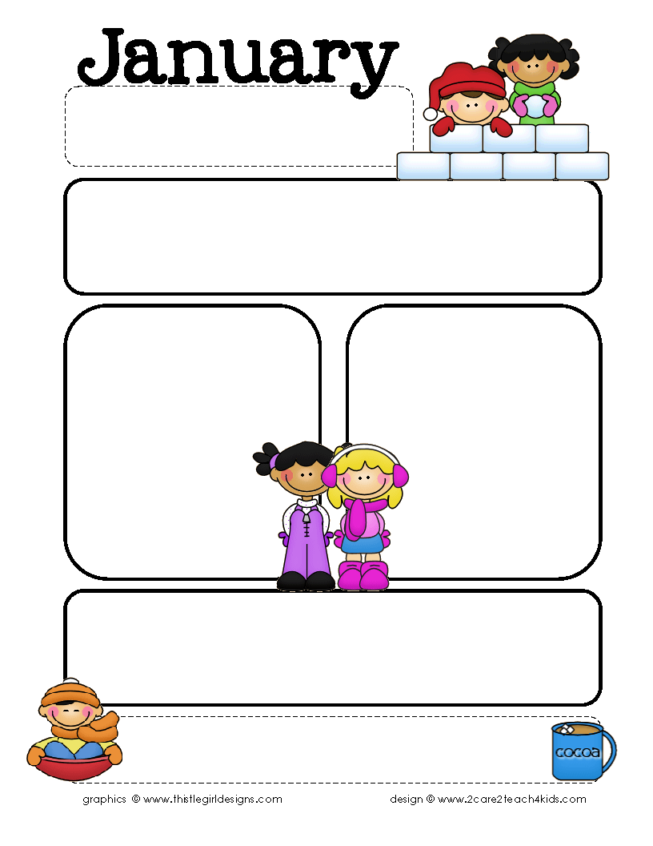

Providence Baptist Church Preschool

294 Seven Farms Drive, Daniel Island, SC 29492

[www.pbcpreschool.com](http://www.pbcpreschool.com) 843-971-5275

[preschool@providencecharleston.org](mailto:preschool@providencecharleston.org) fax 843-971-6862

Happy New Year! We hope you had a wonderful holiday! We are so excited to be back at school. This month, we will have lots of fun with our Winter themes of Weather, Nursery Rhymes, Senses, Polar Bears and Penguins. We will also talk about respect and differences when we study Martin Luther King, Jr. In January, we have one day off of school for MLK, Jr. day on Monday, January 16.

Registration for the 2017-18 school year for current families will begin Monday, January 23. Registration materials will go home that day in folders and will be posted on the website. Registration for new families will begin on Monday, January 30.

Themes and Bible Stories

Jan. 4-6 New Year/Winter Weather & Clothes,

Search for the King, Matthew 2:1-12

Jan. 9-13 Nursery Rhymes, Jesus’ Talk with His

Teachers, Luke 2:39-52

Jan. 17-20 Human Body/Senses/Respect/

MLK, Jr; Come to the River,

Matthew 3:13-17

Jan. 23-27 Polar Bears/Penguins,

Change the Water, John 2:1-12

Jan 30-Feb. 3 Groundhog Day/ Hibernation,

Born Anew, John 3:1-21

Focus Skills

Color: Purple

Shape: Square

Opposite: Hot/Cold

Letters: L M N

Numbers: 1’s and 2’s-6 and 7

3’s and 4’s- 11, 12, and 13

Bible Verse: “God so loved the

world that he gave his

only Son.” John 3:16

Important Upcoming Dates…

* No school on Mon., Jan. 16 for MLK, Jr. Day
* Pizza Days are Thurs., Jan. 19 and Fri., Jan. 20
* Registration…Mon., Jan. 23 for current families and Mon., Jan. 30 for new families. More information will be coming home soon!

Friendly reminders…

*Please wait until as close to 9:00 to drop off your child so that teachers have time to prepare.

*During this cold and flu season, please keep children home if they are running a fever or have a cough

and/or runny nose. We don’t want to spread germs to other children and teachers. Thank you!!!