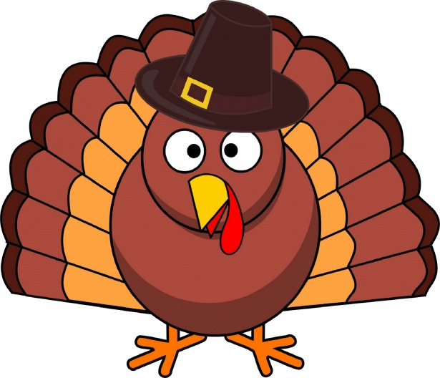
November
We are having a great time and continuing to learn new things! We will have two new friends joining us this month! The Monkey class would like to say, “thank you” for everyone’s help with the Halloween party.

Parent Reminders: Make sure you’re taking home your child’s tote every Friday! Please be sure you’re checking your child’s folder every day to see what we are doing in the classroom! It’s getting colder so we need our hats. If your child need diaper cream I will need an updated doctors note.

Weekly Themes: 4th - 8th Scarecrows Backpack snack Competition, Winning class gets an Ice cream party!
11th - 15th Turkeys
18th - 22nd Manners
25th - 29th Thanksgiving

Important Dates: November 28th -Thanksgiving Closed
November 29th is Black Friday only open if 15 children sign up!

