The Challenge From the Lightweight
Backpacking Movement
(Provided by: HighCountryExplorations.com)

The unexamined gear may not be worth toting!
—Charles Lindsey, The Lightweight Backpacker.net

What makes you an ultralight backpacker is the whole package: your gear, your technique, your style, your philosophy, your stewardship, your mindset, your simplicity.”
—Ryan Jordan, leader in the lightweight backpacking community

A lot of people say, but I can handle the weight. So could I, when I was younger and dumber. But now my knees creak, and I want to have more fun—not show off my machismo. Carrying more than you need to will catch up with you in some way, shape, or form. You will sprain an ankle or strain a muscle, get altitude sickness, or fail to move fast enough on summit day and need to retreat. I had a guy bail on a climb once because he got badly sunburned. The real issue was he carried too much into base camp and it took him longer than normal to hike in, and that’s what caused his sunburn! I don’t know how many times I’ve almost had to turn around near a summit because my client was too tired, only to pick up his pack and find out he’s carrying a piano!
—Gary Scott, “Fast and Light with Gary Scott: Lightweight Backpacking and Climbing Strategies” Backpacking.com

Central Issues Addressed in This Article
What is the best way to define “lightweight backpacking”? Should I adopt a lightweight backpacking philosophy and, if so, what motivations are most persuasive? If adopted, how far should I go with this philosophy? How far can I go to lighten my pack without compromising personal safety, functionality and comfort?

Historical Perspectives on the Lightweight Movement
There are many terms floating around referring to this movement, often without consistent usage: “pack light,” “lightweight packing,” “ultralight,” “sub ultralight,” “super ultralight,” “extreme ultralight,” “mega-light,” “uberlight,” “gram-geek,” gram-weenie,” and “minimalist” name most of them. In this article, I will use the phrase “lightweight packing (-packer)” and its abbreviation (LWP) as an umbrella term covering the whole range, unless otherwise noted. I have chosen the LWP phrasing because it is relatively neutral and should, therefore, allow for a more objective analysis of this topic.
The LWP movement has been around in different forms for many years; it is not new. John Muir was one of the original practitioners of superultralight hiking in the United States often going out for days or weeks with little on his back or in his satchel. In the mountaineering world, the “fast and light” alpine ascents of Messner, Bonatti and Twight are well known. In the horse-packing world, the “light packing” approach is receiving increased attention. Light packing with animals utilizes lightweight backpacking equipment with a goal of limiting each group to no more than one or two packhorses or mules per party rather than carrying most of the creature comforts with a full pack string. On the contemporary hiking scene, probably the best-known proponent of the LWP philosophy is Ray Jardine, especially in his classic text, Beyond Backpacking: Guide to Lightweight Hiking (now updated and revised as Trail Life: Ray Jardine’s Lightweight Backpacking, 2009). Even though Jardine’s book focuses primarily on long-distance “thru-hiking” and sometimes pushes lightweight techniques to their outer limits, the sympathetic reader will find challenges on many levels to conventional ways of thinking. Since Jardine’s book appeared, there has been a proliferation of things “lightweight” and “ultralight.” Web sites on the Internet, articles in outdoor magazines, books espousing LWP gear and techniques, and gear manufacturers touting this philosophy are just a few of its manifestations. Lightweight outdoor gear has become a mass-market product. It is now being produced by a number of manufacturers and is getting increasing attention at outdoor recreation shows.
Whether lightweight packing is a passing fad or a revolution among the backpacking community is a difficult question to answer. What is true is that the movement has thrown down the gauntlet to the traditional hiking and backpacking community. By its very existence, the movement challenges beginning and experienced hikers alike, prodding each of us to examine all manner of assumptions and beliefs about our ways of being and styles of travel in the wilderness.

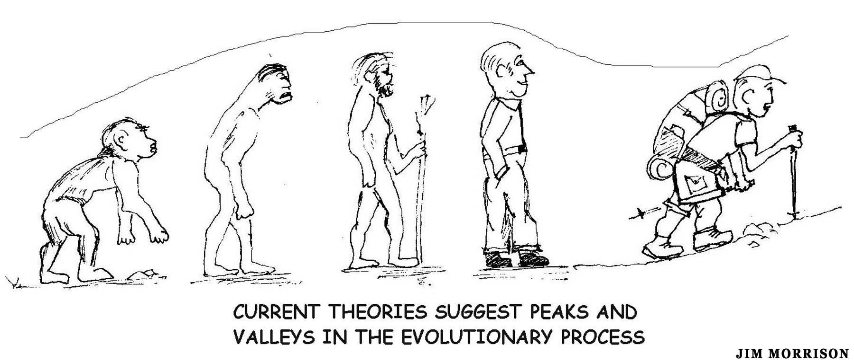

Operational Definitions and Lightweight Terminology
Before going further, some definitions and clarifications are in order. The most common way of defining LWP is to focus on base pack weight. Even though there are no universally accepted definitions, following is a typical breakdown for three-season backpacking that includes the pack but excludes consumables (mainly water, food, fuel):

- Extreme ultralight/minimalist (XUL) = below 4 pounds of base pack weight
- Super or Sub-ultralight (SUL) = below 5 pounds
- Ultralight (UL) = below 10 pounds
- Lightweight (LW) = below 20 pounds
- Conventional/traditional weight = below 30 pounds
- Heavyweight = 30 pounds or more of base pack weight.

The above base pack weight computations probably originated from long-distance hikers who have to replenish food and other consumable items as they progress. Regarding this approach, note how much the backpacking culture has changed! Years ago it was common to find heavyweight backpackers (“iron men” or “mountain men”) carrying 60 pounds or more. Himalayan porters reportedly carry loads in excess of 100 pounds.
A second common way to define these concepts is by using the ratio of total pack weight to body weight. For example, a common definition of LWP is a total pack weight of 15% or less of one’s body weight. With this standard, a 175-pound person could carry and wear 26 pounds (total packed weight) and be classified as LWP. In contrast, a conventional or standard weight pack is often given as 20-30% of ideal body weight. This equates, on the 30% end for a 175 pounder, to 53 pounds total pack weight. A heavyweight pack is then anything over 30%. Note that these ratios usually are interpreted to apply to the lean or ideal body weight of a person who is reasonable fit. The more body fat one carries, the lower the percentage. Then there is the consumables factor. If this second method is used, consider calculating the average percentage on a specific trip with gradually reducing consumables. For example, in the beginning it could be 20% and end with 10%, giving an average of 15% of body weight (the upper end of a LWP).
Note that this second approach uses “total pack weight” compared to “base pack weight” in the first approach. This second approach is quite problematic on several points. For example, what method should be used to determine ideal, lean body weight? What does it mean to be fit and in shape? Should age, body type, frame size or gender be taken into account? What standards should be applied to the person who spends weeks or months in the wilderness humping heavy loads?
Sometimes the LWP will fudge the definitions (thereby distorting the results) by excluding clothing worn and items carried in pockets or in the hands (e.g., trekking poles). This distortion has led many LWP proponents to expand the definitions by dropping the word “pack” and replacing it with “from-the-skin-out” (FSO) weight. With this expansion, the two standard approaches then become “base weight carried from-the-skin-out” (without consumables) and “total weight carried from-the-skin-out” (including consumables). This expansion makes sense because all of the carried weight must be transported up and down the hills, not just what is in the pack. Another modification to the two standard approaches would factor in carried body weight or body fat (especially that above ideal "fightin' weight). This factor is important and needs to be acknowledged, but it complicates the whole business so much as not to be useful.
Another distortion of LWP definitions is the advocate who regularly attempts to borrow from others. Instead of LWP, the better descriptive phrase is “moocher.” [Thanks to Carol Brawny Wellman for alerting me to this problem.]

All approaches to defining LWP are somewhat arbitrary. This is partly because there are no universally accepted definitions and partly because of the fluid cutoff points (e.g., is “light” base weight under 20 or 15 or 10 pounds?). Although somewhat arbitrary, these two ways of defining LWP should be useful starting points, both in this article and with your own analyses and pack weight comparisons.

Lightweight Packing Principles, Values and Philosophies
As Ryan Jordan reminds us in the quote at the beginning of the article, LWP is not just the amount of weight carried, but it is also a philosophy, a movement, a way of being in the backcountry (and in the frontcountry?). The primary challenge from the lightweight backpacking movement is for us to give up our “back and spirit breaking” backpacks, sometimes expressed as getting “beyond backpacking” (Ray Jardine, Beyond Backpacking: Guide to Lightweight Hiking). We should do this for the freedom of movement and lightness of spirit that is only possible with a lightweight pack. The LWP philosophy is to strive for maximum enjoyment while in the wilderness. Surprisingly, lightweight packing advocates often claim that we can increase our safety and physical well being by adopting this philosophy.
A subsidiary belief is that humans are not beasts of burden and should not carry heavy packs without good reason. Thoughtful and careful planning is valued over brawn and brute strength. An ancillary LWP theme is not only seeking lighter weight gear, but also gear with smaller volume, higher quality and higher performance. Even though higher quality does not logically follow from “lightweight,” it is usually part of the LWP philosophy. Another common theme is to seek clothing and gear that will serve multiple purposes. Regarding clothing, a common standard is to only carry as many clothes as you can effectively wear at one time (i.e., few if any duplicates).
Going light means taking only what you really need and leaving most of the comforts and conveniences of modern civilization behind. It means using the least to achieve the most. For many LWP advocates, it means accepting the difficult challenge of decreasing pack load without significantly decreasing comfort. Going light does not mean eliminating the essentials, but encourages debate about exactly what the “essentials” are for any situation and how little they can weigh. For the LWP, it means not packing for every contingency. Ray Jardine goes one step further in his philosophy: “If I need it and don’t have it, then I don’t need it.” (Jardine, Beyond Backpacking, page 46)
The LWP movement challenges us to go beyond the contemporary “leave no trace” and “minimum impact” movements. On this level, they challenge us to tread lightly on the earth and get more in tune with the wilderness environment.
Most of those in the movement are opinionated, but not dogmatic in their philosophies and beliefs. LWP is usually seen as only one approach to wilderness travel among many. For example, a LWP enthusiast could easily enjoy car camping. The phrase, “hike your own hike” (HYOH) is heard often from this group.

Claimed Benefits and Motivations of Lightweight Packing: Thumbnail Sketches
Given the above statement of LWP values and philosophy and beliefs, what are the specific reasons and motivations and benefits for lightweight hiking and backpacking, especially in the ultra (UL), super ultra (SUL) and extreme ultralight (XUL) range? Below is a comprehensive “thumbnail” summary of these reasons and motivations synthesized from a variety of sources and sprinkled here and there with direct quotes from the advocates.

Easier on Body: LWP is easier on the joints, ligaments and muscles. It reduces the chance of certain kinds of injuries, especially scrapes and bruises from falls, sprained and strained backs, ankles and knees. It can keep one from aggravating old injuries. It may allow hiking to a ripe old age that would not be possible with heavier packs. The LWP approach means more enjoyment and less physical discomfort unless the LWP decides to strive for 30-plus-mile trail days.

Lessens Fatigue: A separate but related motivation is that the LWP will usually be less tired when getting to their destination. Part of this benefit is the result of being able to walk upright instead of hunched over. A more upright stance allows one to expand the lungs more and breathe more easily. In the words of one LWP (quoted in Backpacker magazine, April 1993), “We were less tired at night, had more energy during the day, ate less, and laughed more. We woke up early and eager to start hiking.” Conventionalists (defenders of more traditional pack weights) will often argue that carrying a heavy pack is a great conditioner to lessen fatigue for future trips. While there is some truth to this, the better way to get in shape for future trips is to walk and hike lots of miles carrying a pack that is only marginally heavier than normal. Carrying a heavy pack, besides being quite fatiguing, will condition the wrong muscles and joints; it might even damage them if taken to the extreme.

Safer Hiking and Backpacking: LWP enhances safety. Not only will a lighter pack reduce the chance of injuries from stress and falls, but it will also provide other safety benefits. For example, it will allow one to more safely negotiate difficult terrain and to get down to lower elevations and protected areas more quickly in case of stormy weather. Less fatigue means less chance of making poor decisions that might lead to real emergencies. More energy will mean being better able to deal with emergencies if they do happen. Taken together, these combinations mean safer hiking.

Development of Skills and Knowledge: Conventionalists often carry too many “essentials” when they could learn to improvise if necessary. Put another way, carrying a lighter pack with less gear encourages development of skills and knowledge rather than a reliance on gear.

More Freedom and Flexibility: A light pack provides a lot of freedom. It allows one to go further and through more rugged terrain—without suffering! It allows reconnaissance without always having to return to one’s pack. It negates the idea of “lay days” to recuperate from backbreaking labors. A lighter pack allows longer daily travel distances, putting more of the wilderness within reach. Now with a three-day weekend, it is possible to see countryside that would have required a week off from work using traditional backpacking techniques. In one weekend, one can traverse an entire mountain range. Getting further into the wilderness provides the experience of less crowded trails and more solitude. The ability to travel further can extend backpacking into the shoulder seasons of early spring and late fall, where previously the shorter days were an impediment to any serious trip. In summary, a lighter load opens up new possibilities and a new conception of what might be possible.

Easier Reconnaissance and Better Decision Making: A light pack provides the freedom to do some reconnaissance without always having to return to one’s pack. With a heavier pack one is sometimes tempted to carry the pack on scouting jaunts and then making poor decisions because of not wanting to backtrack.

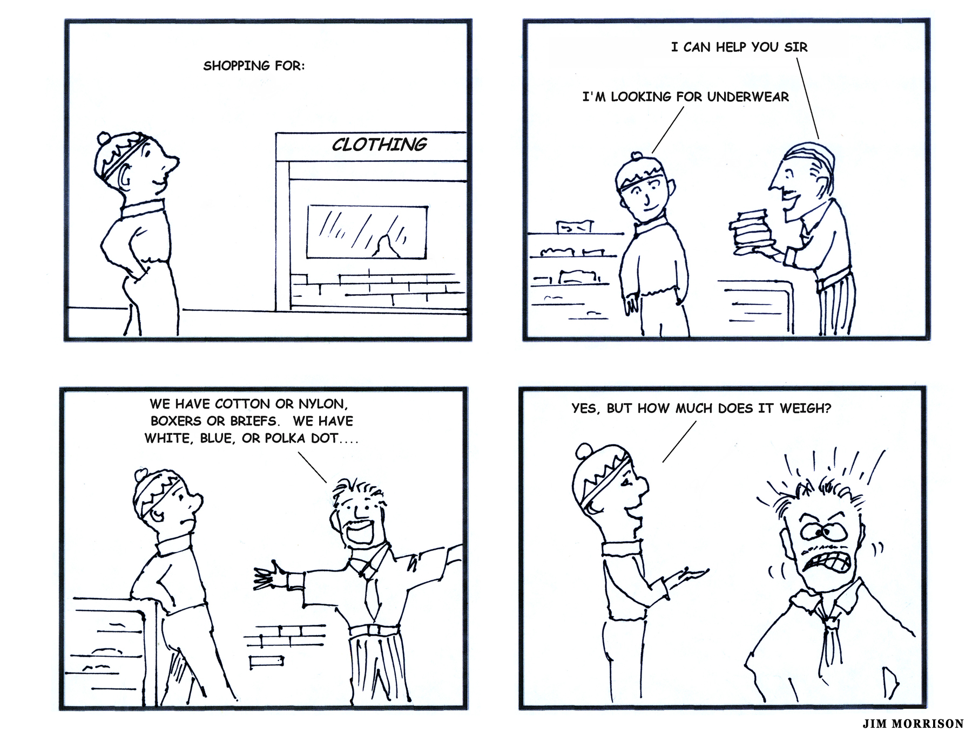

More Time Off-Trail in the High Country: For those who like to go off-trail, LWP will enable more vistas and summits to be visited and more time spent enjoying them. For one anonymous LWP advocate,
Lighter and less gear has gotten me mostly off the trails. That is the single biggest deal for me, to wander around and not follow a track. I can't tell you what a difference that makes. Some people report how much faster or further they can go. I tend to go slower, cover less ground, snoop around more, grab some mushrooms, wet a line, see more wildlife. No need to set up a base camp and ditch the pack, it all comes along.

More Food to Stay Longer: Going lighter on basic gear will allow me to carry more food (also more nutritious food) which means I can stay out in the wilderness for a longer period before resupply.

Simplicity: LWP allows a high degree of simplicity. My LWP gear list is short enough I can have my stuff packed and ready for a weekend or a weeklong trip in a couple of hours. This allows me to get out on a whim when I suddenly find myself with an open schedule. I can get up and be on the trail in well under an hour where others take an hour or two. Also, I don't spend much time dealing with gear while on the trail. The gear is simple, so I can spend more time hiking or exploring. I also don't have to worry about adjusting this strap or that belt because they don't exist. This simplicity allows me to experience more of the wilderness. A quote expressing this priority comes from Ryan Jordan, a leader in the LWP community:
The real benefit of a kit like this is not in its ‘ultra light weight’ or maximum ‘weight: functionality’ metric. Certainly the weight of this kit could be reduced, and the function increased, by selecting different items than the ones shown here. However, after experimenting with this type of exploring for a few years now, I've found more solace in maximizing the simplicity of the kit than minimizing its number of ounces religiously.

Less Materialistic and More Wild:

The idea is that we do not want anything too big. We want enough, just enough. Less does not indicate poverty but the power of personal restraint, a very satisfying concept and practice . . . To enter the wilderness is to dispossess ourselves of the burden of possessions, to slip smooth and clean as Houdini from the thousand invisible chains of stuff. Once inside, we become, however briefly, part of the wild — lithe, lighthearted and free, loping across the landscape. So next time you’re getting ready to head out, identify every single thing you doubt you’ll need. Then forget it.
—Mark Jenkins, “Are We Not Men?” Outside Magazine, April 2000

Break a Vicious Cycle: In the words of an unknown author (quoted in Backpacker magazine, April 1993):

Is backpacking a form of punishment? Are we beasts of burden? There’s a vicious cycle involved here. The more stuff we take, the more exertion necessary to bear it. The more exertion, the more food we feel we need to keep up our strength. The more stuff we take the heavier the boots and pack needed to haul it. The only way to break this style is to begin thinking in terms of an ultralight wilderness style.

Make Room for Other Passions: Whether it is rock climbing, photography or seeing my kids or grandkids enjoy the wilderness, LWP makes room in my pack for the gear necessary to enjoy my other passions. Of course, the extra gear carried will usually negate many of the other motivations espoused above, but sometimes tradeoffs are necessary.

Make Room for the Trash of Others: Lightweight packs usually have room to add the garbage left by others. Doing this good deed is usually done towards the end of so that a light pack is enjoyed most of the trip.

Intellectual Challenge: The whole LWP concept is good for the mind. It provides a real intellectual challenge: balancing weight, volume, comfort, safety, simplicity and cost. One of the biggest challenges is to decrease load without decreasing comfort. The lighter the pack the greater the challenge. Much of the intellectual challenge begins before the trip researching, analyzing options and refining gear lists. What to take and what to leave home?

The challenge is often carried into the field. For example, setting up a 6-10 ounce tarp into an effective shelter is a lot more challenging than setting up a 4-6 pound, freestanding tent. Or, what tricks can I use to sleep warm with my minimalist gear? Most ultralight backpackers take great pride in their gear selection and their abilities. Even when an experiment doesn’t work out, most advocates are ready to go back to the drawing board and experiment with new gear and skill combinations. Granted, those going for the ultra, superultra or extreme LWP categories often get “anal” about it (e.g., cutting out labels from clothing, straps from packs and edges off maps), but such strict discipline can be the key to successfully meeting these challenges.

Build Relationships with Gear Designers:

One of the more esoteric benefits of going light is the ability to build relationships with the people who design and make your gear. It is unlikely that the average hiker will be able to pick up the phone and easily get hold of a major manufacturer's equipment designer for a gear discussion. But since much of the cutting-edge ultralight gear being produced is coming out of cottage manufacturers, you get the opportunity to ask detailed questions of the people making the equipment. In many cases, you have real input into the design of the next generation of ultralight backpacking gear. Many ultralight products on the market today bear the mark of individual enthusiasts who asked for tweaks to suit their own needs. If you value the diversity of small business, going lighter provides you ample opportunity to support smaller shops.
—Glen Van Peski, ultralight gear designer, as quoted in Lightweight Backpacking and Camping: A Field Guide to Wilderness Hiking Gear, Techniques, and Style

Some might argue that the whole LWP movement is a ploy of gear manufacturers (plus the magazines and other media in which these manufacturers advertise) to get us to buy new, lighter (and often more expensive) models of standard gear that has been serving us well. It is true that gear manufacturers and advertisers have recently jumped on the LWP bandwagon, trying to convince us that we need their latest vastly improved lightweight model. But the LWP movement cannot be so easily dismissed.

Less Impact on the Environment: Besides having less impact on limbs and ligaments, a lighter load can result in a reduced impact on the environment. Many LWP practitioners use their ability for enhanced distances and greater flexibility to practice stealth camping. Practitioners of LWP don’t need to camp near water. Their lighter loads allow them to enjoy dinner near a water source and then hike for a few more miles thereby avoiding overuse of the waterside sites and opening up pristine vistas from their stealth site. Stealth camping combined with proper “Leave No Trace” ethics, can greatly reduce both the footprint and the impact. Even though the environment probably doesn’t care, consider that the LWP can feel less intrusive, can feel they are walking more softly and making a smaller footprint on the earth.

Connections With the Wilderness: When not burdened down with a heavy pack, we become more aware of the patterns of life around us and how we interact with them. LWP allows us to develop closer connections with our surroundings while en route to our destination and when we arrive.

___________________________________

The above thumbnail sketches come from many sources and contain as much variety as there are different personalities in the LWP movement. But most advocates would agree with the following generalization: implementing LWP philosophies and techniques will considerably increase the overall enjoyment and result in higher quality wilderness experiences. However, most advocates will also qualify this by saying that it is not for everyone or for every trip. One often heard generalization is that once the full benefits and possibilities of LWP have been experienced, it is difficult to go back to more traditional and conventional styles of wilderness travel.

Reader Participation: Lightweight Motivations
First, consider circling four or five thumbnails in the previous section that have the highest priority and the most weight (pun intended) given your own personality and desires. Second, construct a “no compromise—can’t go without” list of gear items exempt from most attempts at reduction. Third, write down your pack weight goals using the definitions provided in an earlier section (e.g., LW, UL, SUL).

Gearing Down into the Ultralight and Super-Ultralight Range
Assuming serious consideration is being given to experimenting with “uberlight” pack weights (UL = ultralight, SUL = super ultralight, EXL = extreme ultralight), what is the best way to achieve this goal? Following is a sample of UL and SUL gear choices (for moderate, summer weather conditions). I start with what are usually the four heaviest items carried or worn: shelter, sleeping gear, footwear, pack.

[Note: even though the primary focus of this article is UL backpacking kits, the suggestions offered should provide ideas on how a traditional backpacker might gear down a bit.]

Serious Reductions With the Four Heaviest Items
Shelter: Camp in a sheltered area using a lightweight tarp (a one person size weighing 4-8 ounces) made from silnylon, silicone-coated spinnaker cloth or cuben-fiber material. Use readily available rocks, branches, sticks, and/or trekking poles for support. Add another 2-3 ounces for a variety of tie down cords, guy line tensioners and a few stakes.

Sleeping Gear: Ultralightists often use down or synthetic sleeping quilts without hoods, zippers or other enhancements. Assuming moderate temperatures, quality lighter weight quilts are available in the 12-18 ounce weight range. Lightweight three season sleeping bags are available in the 16-24 ounce range. Some are constructed as wearable bags for around camp. Regular bags and quilts can be worn around camp to eliminate an insulated jacket or parka. Ultralight sleeping bags/quilts are supplemented by wearing all of one’s clothing to bed (including wind breakers and storm shell clothing) as needed. Bags and quilts are sometimes supplemented with a lightweight, breathable bivy sack (6-8 ounces) to expand the comfort range. The bivy sack also functions as a ground cloth. A torso sized sleeping mat (weighing 2-6 ounces) and a 2-3 ounce ground sheet completes the basic ultralight sleeping package. Add your favorite sleeping pill (weightless) for those who do not sleep well on a thin mat or are too tired to search out a soft sleeping site.

Footwear: Following the commonly accepted wisdom that every pound on your feet is equal to 5-6 pounds on your back, ultralightists usually wear lightweight trail shoes or sandals in the 12-24 ounce/pair weight range. Adding quality insoles (2-3 ounces) and lightweight socks (two pair totaling 3-5 ounces, wearing only one pair at a time) completes the footwear package.

Packing: Frameless rucksacks made from the lightest weight materials (e.g., silnylon, silicone-coated high-tenacity spinnaker cloth or cuben fiber) are the ultralightist pack of choice. Frames, sternum straps and hip are not necessary if carrying pack weights in the ultralight range. Frameless or lightly framed packs adequate to carry a total pack weight (including consumables) of up to 18 pounds are available weighing 3-8 ounces. Frameless or lightly framed packs with a load carrying capacity of up to 30 pounds are available weighing 18-26 ounces. Add a plastic pack liner for weather protection and a few ultralight stuff sacks for organization (another 2-3 ounces).

Other Significant Reductions
Clothing: To keep warm, keep moving. Follow the practice of continuous hiking with regular, but brief rest stops throughout a full 12-16 hour hiking day. If it gets too cold for the clothing you have (or you stop for the day), set up your tarp, crawl into your sleeping bag/quilt and prepare a hot drink. Let your sleeping bag/quilt be your extra insulation. With this regimen, thin base layers (tops and bottoms = 10-16 ounces total), thin outer storm shell layers (tops and bottoms = 10-16 ounces total) combined with a lightweight insulating top (4-7 ounce vest or an 8-9 ounce pull-over jacket) will suffice for experienced ultralighters in moderate climates. Clothing should be quick drying (usually while on the trail), because no changes of clothing are carried. The overriding principle: No extra clothes; one set is used for both hiking and sleeping. If these clothes need to be cleaned, storm gear is worn.

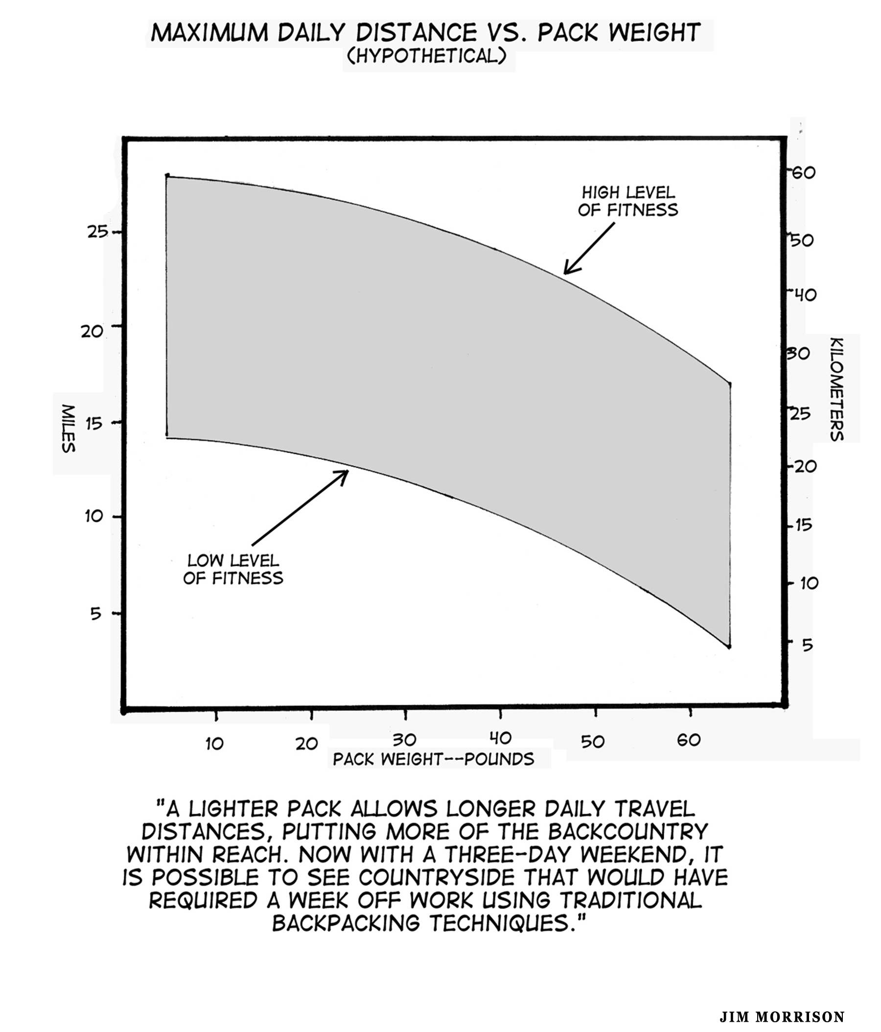
Hydration: Water is very heavy (approximately 2 lbs per liter). Carefully scrutinize the planned route for water sources and don’t get uptight about being waterless for several hours. Depending upon the terrain and weather, ultralightists often carry no more than 1/2 liter, preferring to “camel up” at water sources. When there is a need to treat the water use water treatment chemicals (like chlorine dioxide) to treat newly obtained water to get one to the next water source. Though a little heavier, UV light purification technology is beginning to supplement chemical treatments (which are then relegated to backup status). A SteriPen purifier (4 ounces) takes 48 seconds to treat a half-liter. Carry collapsible water containers (0.5-1.0 ounces per liter of empty weight each) for when the situation demands more water.

[Caution: going without water for several hours is not a problem, but chronic dehydration is. Deep dehydration can take two or three days to recover and will seriously affect one’s health, mood and general well being.]

Food and Cooking: Carrying light packs means consumption of fewer calories. Ultralightists usually get by with 1.0-1.5 pounds of food per day (but considerably more food on high mileage jaunts). Even though a starvation diet is not usually a part of the ultralight philosophy, plan on losing a few pounds on longer trips. Don’t get concerned if go a day or two with little or no food. Carry only cold food or fast-prep hot food that requires no cooking. Only occasionally (or in emergency) heat water for hot drinks. Heating water is usually done with simple alcohol or solid fuel tablet stoves weighing 3-6 ounces (stove, pot, lid and utensil). Fuel for this minimalist cooking can weigh as little as 0.5 ounces per day per person.

Personal and Essential Items: Minimal first aid, medications, personal hygiene, sun protection, bug protection, etc. can be paired down to 4-8 ounces total.

For more ideas on reducing pack weight, pick up a copy of Lighten Up by Don Ladigin.

_______________________________

Warning!!! Inexperienced hikers should experiment gradually and not attempt these kinds of severe reductions all at once!

_______________________________

Ultralightists usually pack for moderate conditions, but moderate conditions can deteriorate to more extreme conditions. The sensible ultralightist deals with unanticipated severe weather conditions by changing plans: postponing the trip, holing up, heading down out of the high country or cutting the trip short with a forced march back to the trailhead.
The above is only a short overview of the art and science of ultralight backpacking. Many spend lifetimes paring their gear and honing their skills and equipment.
In general terms, the ultralighter needs to develop an extremely disciplined gear list and the ability to deal with some discomfort. The above are only examples of gear and strategies commonly utilized by experienced ultralighters. Many variations and modifications are possible depending upon your experience level, climate, required comfort levels, goals for specific trips and equipment budget (ultralight gear can be quite expensive).

Critics of the Lightweight Philosophy Speak for Themselves
This article is primarily an exploration of lightweight hiking philosophies and motivations and techniques. But this movement does come with its critics. Here is a sample of what some are saying.

[Going ultralight] as a challenge and experimental test . . . must have been great fun. As a practical procedure for normal mountain use I suggest it would be neither . . . . Some of the genuine, practicing enthusiasts tend, while extolling undoubted advantages, to gloss over uncomfortable facts. The pleasure in carrying a lighter load . . . is not the whole truth, so help me God. Backpacking is not all traveling. It is sleeping and loitering and eating, for example. So backpacking pleasure is also comfortable sleep, cozy warmth at all times and perhaps a few heavy luxuries . . . not to mention a full belly. I note that many light-gear enthusiasts seem to skimp on the food . . . Finally, remember that real pleasure demands, above all, gear that has enough reserve strength (and sometimes reserve items too to tide you over those inevitable occasions when Murphy’s Law—‘If things can go wrong, they will’— exerts its stern way).
—Colin Fletcher, The Complete Walker III, page 30

It is interesting to note that Fletcher, in a subsequent edition (The Complete Walker IV, page 33), moderates his critique a bit by taking out the reference to “reserve strength.” But he still chides the LWP movement with labels like “Gossamer Gallop” and “Unbearable Lightness.” In this spirit, he coins his own ultralightist principle: “Gossamerize every item toward vanishing point.” (The Complete Walker IV, page 29)

Here is a more recent critique in a similar vein to Fletcher’s:

I don’t want to be lumped in with the strap-cutters who’d rather slurp cold Ramen than carry a three ounce stove. I like to think we’ve evolved beyond that kind of uncivilized behavior. Naturally the [Social] Climber favors featherweight and the cutting-edge—anything seamless, siliconized, LED or titanium leaves me feeling a bit randy . . .. You can’t let this ounce-counting business get the better of you. Next thing you know, you’re leaving your favorite plush socks or the single malt at home. Spending time in the outdoors is all about finding pleasure, not forsaking it.
—“Social Climber,” Backpacker magazine May 2006

Here is an interesting critique appearing on the Backpackinglight.com Forum under the heading of “How light is light enough?”

So here’s my question. At what point does reducing pack weight stop being about practical weight reduction and start becoming an exercise in gram counting for gram counting’s sake. Don’t get me wrong. I’m in awe of people who take multi-day backpacking trips with a 5 lb (or lighter) pack. If you are reducing pack weight (and the amount of gear that you carry) to see how light you can go or to test your limits, that’s an admirable goal, but from a physiological standpoint, is there a difference between the amount of energy that you expend carrying an 8 lb pack vs. a 5 lb pack? Dan McHale [customized pack builder], on his letter page brings up an excellent point. If you calculate the weight of your body, clothing and pack weight including consumables, the percentage difference of a few pounds is much less than 1%. Can your body really feel that at the end of a day?
—Ryan Faulkner

Finally, a critique about marathon-like mileages:

Jardinians are a breakaway sect of ironman backpackers who follow the concepts of Ray Jardine. He has written a book on how to pack light and travel 20-30 miles a day. We met eight Jardinians [while hiking the Pacific Crest Trail in Washington State]. All but one was a broken, limping wreck. Mostly foot problems such as fallen arches and foot sized blisters. Dehydration and fatigue were also taking their toll. We did meet one dude from Chilliwack, B.C. who was on the first day of his Jardinian Quest and doing fine. He had already gone 20 miles by noon and planned 16 more that afternoon. While I certainly admired his physical conditioning, I felt ill at ease at the prospect of making the PCT a massive iron man contest.
—David Cossa, “PCT Part 1—Penwicle,” Peninsula Wilderness
Club newsletter, Bremerton, Washington, October 1999

Some critics characterize LWP advocates as being “anal” (e.g., cutting handles off toothbrushes, labels from clothing, edges off maps). Some eat all cold food, carry no toothbrush and take no sleeping bag (sleeping only in their insulated clothing). While there are extremists in any endeavor, this movement cannot be so easily dismissed. Many criticisms of LWP focus on the issue of safety and survival. Because safety and survival is such an important consideration, I have created a separate in depth article to explore the finer points of this subject: “Wilderness Safety—Debate Between the Ultralightists and the Traditionalists.”
The philosophy of comfort, also an underlying issue raised by the LWP challenge, is explored in depth in another article, “Maximizing Comfort and Minimizing Discomfort in the Wilderness.”
Author’s History with Lightweight Packing
Because I lived on a just-above-poverty-level income in my early hiking years, gear expense was the main criteria for collecting outdoor gear. I did not have the time to make my own and usually allowed myself one major purchase per year. At first, Army surplus was the rule, not only because it was cheap but also because it was often the only thing available. Surplus usually meant heavy. Later on, my experience as a climbing ranger in Mount Rainier National Park and with the Central Washington Mountain Rescue Council pushed me more in the direction of safety, carrying what I might need to take care of most any emergency. Combining surplus gear with the emphasis on safety usually meant an even heavier pack. As a young buck, I took great pride in how much I could carry. In my later and more affluent years, expense and safety gave way to focusing more on quality and comfort. But like most, I have often been guilty of carrying a pack full of quality and comfortable gear that was far too heavy to fully enjoy my outings. In the early years when backpacking with small children, I did experiment a bit with lightweight gear (e.g., a three-person, single-walled, coated nylon, experimental tent by JanSport weighing less than four pounds). At that time I had little understanding of the full range of LWP possibilities and its overall philosophy.
In the past few years, I have accepted the LWP challenge and continue to experiment with reducing pack weight. I regularly backpack with a 10-12 pound base pack weight and a total carried weight for weeklong trips (including consumables and worn items) of less than 28 pounds. For short overnights and weekenders, I experiment with forays into the “ultralight” range.
I have accepted the LWP challenge for a number of reasons. One is to examine my basic goals and philosophy of being in the high country. I am fascinated with the many possibilities that open up when adopting a full-scope LWP philosophy. I am especially fascinated with lightweight gear options that do not significantly compromise comfort and safety. Overall, I love the personal challenge and creativity that is involved with accepting this challenge.

Should I Become an Ultralighter?—Consider Adopting a “Situationalist Ethic”
Extreme ultralight? Superultralight? Ultralight? Lightweight? Conventional? Heavyweight? Which of these philosophies makes the most sense and best fits my style? Instead of adopting just one of these philosophies or styles, consider adopting most of them. Theoretically at least, one person could qualify for most of these labels or definitions, depending on the time of year, the location, the goals of the trip, etc. In other words, why not adopt a “Situationalist” philosophy? The Situationalist packs according to all the variables, especially the conditions that will likely be encountered. The Situationalist packs according to need, not to hit some target weight. Here are most of the situations that should have an impact on pack weight, for the situationalist:

- Time of year, current weather patterns and weather predictions

- Goals and target activities (e.g., leisurely with lots of time around camp or more aggressively with lots of miles to cover each day; doing mainly day trips from base camp or carrying full packs most of the time)

- Distance from the trailhead; proximity of escape routes if weather turns bad

- Length of time out in backcountry

- Type and difficulty of the terrain (e.g., the amount of off trail travel above the treeline)

- Size, strength and experience of the party

- Knowledge of first aid, wilderness survival techniques

- Knowledge of the terrain

- Knowledge, skill and experience level with backpacking in general and with LWP techniques specifically

- Personal responsibilities to a group (e.g., team leader; most experienced first aider; close friend)

- Height, weight and body fat

- Age and gender

- Metabolism and warmth needs (some can get by with little food or clothing)

- Safety and functionality of dual use items (e.g., a poncho tarp for shelter and storm gear; extra socks for mittens and pack strap padding)

- Level of physical conditioning

- Physical or mental problems being dealt with; predominant mental attitude and comfort zone

- Amount of time, money and energy to research, purchase and experiment with LWP gear and techniques

With these considerations in mind (wow–a lot of them), an extreme or super ultralight (minimalist) approach might work well in hot and dry climates (e.g., the Southwestern desert regions). A “superultralight” or “ultralight” approach might work well in mid-summer in lower elevations (e.g., hiking the Appalachian Trail), especially involving experienced wilderness travelers in good physical condition. Such approaches are probably not appropriate when planning a multiday, solo trek in the fall on the exposed northern sections of the Pacific Crest Trail (PCT) or the Continental Divide Trail (CDT) when driving rain and snowstorms could pin one down for several days.
Why do I use the phrase “Situationalist Ethic” as the title for this section? It is because most hikers and backpackers do have family, friends, coworkers, etc., who care very much about what happens to them, and whose lives would be seriously impacted if the worst happens. In addition, there is the impact on emergency personnel if one gets into serious trouble. Because of these potential impacts and conflicts, this is very much an ethical matter that deserves careful consideration—rather than trying to conform to some idealistic and unrealistic definition or standard. For loved ones, perception is often as important as reality. In other words, can you convince your loved ones that you have the gear, skills, experience and mental toughness to deal with emergency situations that might come up?

Final Thoughts About Lightweight Packing

You know you've achieved perfection in design, not when you have nothing more to add, but when you have nothing more to take away.
—Antoine de Saint-Exupery

LWP is a movement in progress with fluid definitions and principles. Those on the frontiers are continuing to define what is possible and to push past imagined barriers. It is similar to years past when no one thought it possible to break the four-minute mile barrier or the ten-second barrier in the 100 meter dash in track and field. What is possible is often dictated by the culture surrounding the specific sport or recreation. But there are always a few willing to challenge the cultural status quo. The LWP movement is helping all of us redefine the boundaries.
If you decide to adopt LWP philosophies, motivations and techniques, do it gradually. Experiment on each trip to see what works and does not work for you. Experiment when the conditions are ideal and then when conditions are less than ideal. As you get more experience, push to the limits of your comfort zone and beyond (necessary to find out your own limits). However, as you lighten up, keep safety and security firmly in mind, but do not become obsessed with them (obviously a fine line). Whatever you do, try to get beyond the “just in case” mentality by acknowledging that safety and security are mostly a matter of skill and knowledge and experience, not a function of gear.
If safety and functionality are paramount, consider eliminating both the “target weight” and “target percentage” concepts (the two common approaches used to define LWP) from your thinking. A quote from an unknown source captures the thinking behind this recommendation.

I often wonder why people focus on arbitrary numbers and not on comfort, function and safety. How much comfort and safety are you willing to give up in order to achieve your weight goal? If you come up with an ideal gear list for your trip's requirements and it happens to weigh 12.2 pounds [instead of your targeted 10 pounds] are you going to leave something behind? Does it not make more sense to pack your gear to meet your needs rather than to meet a number on a scale? No doubt one of your needs is to keep your pack light. But I see that as a concept more than as a number.

Following this recommendation should result in at least four specific behaviors:

(1) do not weigh your pack at the start of a trip;

(2) remove all total weight calculations from your gear lists;

(3) imbed target weights for selected lines or items on your gear lists (i.e., how can I accomplish the same thing with less weight?);

(4) do not attempt to compare pack weights with fellow hikers or with what has been carried on previous trips.
One example of the third behavior (i.e., imbed target weights) is to substitute an ultralight, water-resistant wind jacket (to provide dead air space and warmth and to shed light drizzle) in place of an extra insulation layer. Another example is to use a sleeping pad that provides the desired padding only in critical areas rather than the entire pad. Yet another is to gradually condition your feet and legs to use lighter and lighter trail shoes.
This article began with questions like the following: What is the best way to define “lightweight backpacking”? Should I adopt a lightweight backpacking philosophy and, if so, what motivations are most persuasive? If adopted, how far should I go with this philosophy? How far can I go to lighten my pack without compromising personal safety and comfort? It should be clear that only you can answer these questions depending on your own style and circumstances. It also depends greatly on your safety and comfort needs, both physically and emotionally. It depends a lot on how far you are willing to get out of your present comfort zone. My final advice: continue to experiment to see what works for you.

*********************************

Legal Disclaimer: Nothing in this website article can substitute for experience, careful planning, the right equipment, and appropriate training. There is inherent danger hiking and backpacking and viewers must assume full responsibility for their own actions and safety. The Author will not be responsible for the safety of those who visit this site.

