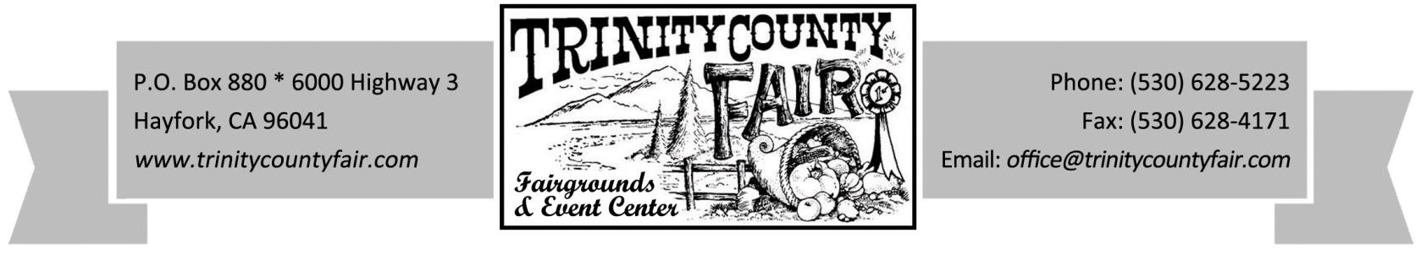
“It’s the Good Ol’ County Fair” August 12th – 14th, 2016
COMMERCIAL / CONCESSION REGISTRATION FORM
COMPANY NAME:

OWNER/OPERATOR:

MAILING ADDRESS:

CITY/STATE/ZIP: PHONE:

SELLER PERMIT # TAXPAYER ID / SOCIAL SECURITY #:
Required by State Board of Equalization

PREFERED LOCATION (subject to availability): [ ] Commercial Building [ ] Outside Space

[ ] COMMERCIAL INDOOR ($150 flat fee per 10’x10’ booth space)
[ ] COMMERCIAL INDOOR ($300 flat fee per 10’x20’ booth space)
[ ] COMMERCIAL INDOOR ($450 flat fee per 10’x30’ booth space)

[ ] COMMERCIAL OUTDOOR* ($75 flat fee per 10’x10’ booth space)
[ ] COMMERCIAL OUTDOOR* ($100 flat fee per 10’x20’ booth space)
[ ] COMMERCIAL OUTDOOR* ($150 flat fee per 10’x30’ booth space)
[ ] COMMERCIAL OUTDOOR* ($500 flat fee per 10’x over 30’ booth space)
* Add $50 for OUTDOOR SPACE with electrical (limited availability)

[ ] FOOD & BEVERAGE CONCESSION S ($225 or 20%, whichever is greater)

Please list all products to be sold, being specific. Any food or drink items to be given away must be listed for approval by Management. Items must be on your contract for contract to be Legal & Valid. We reserve the right to delete items from this list.

(If more room is needed, back of sheet may be used or menu may be attached)

DO YOU HAVE INSURANCE?
[ ] Yes, I will provide Certificate
[ ] Yes, through WFA/CFSA - CERTIFICATE #

[ ] No, I would like to Purchase Insurance - Fee Enclosed ($109.00 Commercial / $134.00 Concessions)

Please return this form as soon as possible, as space is reserved based on availability.

