REGULAR MEETING
NOVEMBER 18, 2021

The Regular Meeting of the Town Board of the Town of Hampton, County of Washington and the State of New York was held at the Town Hall, 2629 State Route 22A, Hampton, New York, also via Zoom and live streaming on the You Tube Channel for “Town of Hampton New York” on the 18th day of November 2021.

Due to the Corona Virus, occupancy inside the Town Hall is limited at this time. Supervisor O’Brien did provide a link to join the meeting via Zoom.

PRESENT: David K. O’Brien------------Supervisor
Donald Sady-----------------Councilman - absent
Tamme Taran----------------Councilwoman
Andrea Sweeney------------Councilwoman - absent
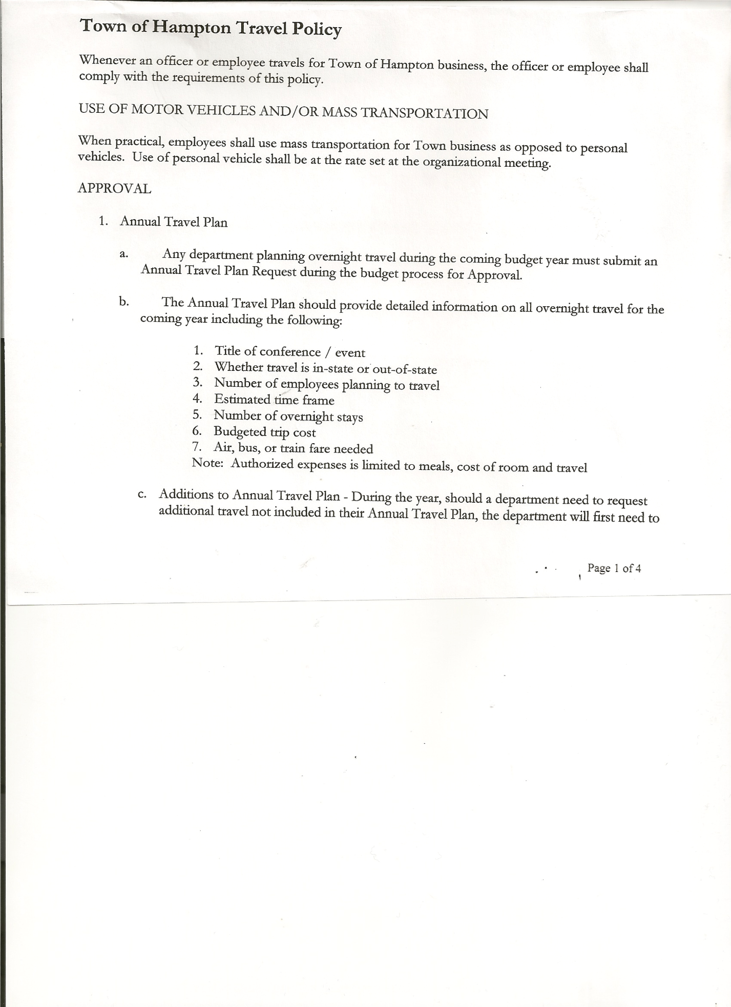
Michael Pietryka------------Councilman
Rebecca Jones---------------Town Clerk
Camilla Shaw----------------Tax Collector/Deputy Town Clerk - absent
Herbert Sady, Jr.-------------Highway Superintendent

Planning Board Member(s):… Bonnie Hawley, Chair and Matthew Pratt
Others present at the Town Hall: Artie Pratt

The Regular Meeting was called to order by Supervisor O’Brien at 7:30pm, followed by the Pledge of Allegiance. Location of Fire Exits were given. Quorum of board members present.

Supervisor O’Brien asked for a moment of silence in memory of Robert Hilder, Ben “Butch” Jones and Trudy Ballard.

RESOLUTION NO. 108-2021
APPROVAL OF THE MINUTES
On a motion of Councilwoman Taran, seconded by Councilman Pietryka, the following resolution was ADOPTED: AYES 3 O’Brien, Taran, Pietryka
NAYS 0
ABSENT 2 Sady, Sweeney
RESOLVED, that the Regular Town Board Meeting Minutes for October 21st , 2021 are approved.

Larry Carman, Dog Control Officer submitted his report, which was read by Supervisor O’Brien, copy of report is attached.

Camilla Shaw, Tax Collector….no activity. Submitted Bank Statement to the Board for review and signatures.

Bonnie Hawley, Chair gave Planning Board Report……copy of the minutes of their meeting held November 10th, 2021 are attached. Bonnie, Ginny, Renee and Matt attended NYS Department of State Local Government Services Washington County Webinar on November 15th from 6:00 to 8:00pm. Steve Fernett will be resigning from the Planning Board.

Herbert Sady, Jr., Highway Superintendent submitted his report, copy of which, is attached.

TOWN BOARD MEETING
NOVEMBER 18, 2021 PAGE 2

SUPERVISOR’S REPORT/ COUNTY UPDATES/ COMMUNICATIONS

RESOLUTION NO. 109-2021
APPROVAL OF SUPERVISOR’S MONTHLY REPORT
On a motion of Councilwoman Taran, seconded by Councilman Pietryka, the following resolution was ADOPTED: AYES 3 O’Brien, Taran, Pietryka
NAYS 0
ABSENT 2 Sady, Sweeney
RESOLVED that, the Supervisor’s Monthly report be accepted as submitted for OCTOBER
9/30/21 10/31/21
ACCOUNT BALANCE RECEIPTS DISBURSEMENTS BALANCE
General Fund $ 74,838.58 $ 6735.97 $ 14,428.72 $ 67,145.83
Highway Fund $ 99,133.99 $109,278.79 $ 144,094.58 $ 64,318.20
Equipment Reserve $ 79,917.41 $ 2.04 $ 0.00 $ 79,919.45
Fire #1 $ 21,648.50 $ 0.00 $ 0.00 $ 21,648.50
Fire #2 $ 5,100.00 $ 0.00 $ 0.00 $ 5,100.00
Cemetery $ 1,753.21 $ 0.73 $ 0.00 $ 1,753.94
Totals $282,391.69 $116,017.53 $158,523.30 $ 239,885.92
All Board Members present signed Supervisor’s Report.

RESOLUTION NO. 110-2021
END OF YEAR MEETING
On a motion of Councilwoman Taran, seconded by Councilman Pietryka, the following resolution was ADOPTED: AYES 3 O’Brien, Taran, Pietryka
NAYS 0
ABSENT 2 Sady, Sweeney
RESOLVED, to set the End of Year Meeting for 2021 for Thursday, December 30th, 2021 at 7:30pm.

RESOLUTION NO. 111-2021
ORGANIZATIONAL MEETING
On a motion of Councilwoman Taran, seconded by Councilman Pietryka, the following resolution was ADOPTED: AYES 3 O’Brien, Taran, Pietryka
NAYS 0
ABSENT 2 Sady, Sweeney
RESOLVED, to set the Organizational Meeting for 2022 for Monday, January 3rd, 2022 at 7:30pm.

Matthew Pratt, Secretary for the Hampton Fire Department wanted to say “Thank You” to the Highway Department for their assistance on a call on the Hickey Road on Veterans Day.

TOWN BOARD MEETING
NOVEMBER 18, 2021 PAGE 3

RESOLUTION NO. 112 -2021
AUDIT OF CLAIMS
On a motion of Councilman Pietryka, seconded by Councilwoman Taran the following resolution was ADOPTED: AYES 3 O’Brien, Taran, Pietryka
NAYS 0
ABSENT 2 Sady, Sweeney
RESOLVED that the bills have been reviewed by the Town Board and are authorized for payment in the following amounts.
General Fund No. 131 through No. 140 $ 8,990.57
Highway Fund No. 133 through No. 145 $ 11,248.01
Total both funds $ 20,238.58

The Town Clerk’s report for October 2021 was submitted to the Board. The Town Clerk had Board Members review and sign bank reconciliation statements for the Town Clerk Account and Special Clerk Account dated October 31, 2021.

RESOLUTION NO. 113-2021
MEETING ADJOURNED
On a motion of Councilwoman Taran, seconded by Councilman Pietryka, the following resolution was ADOPTED: AYES 3 O’Brien, Taran, Pietryka
NAYS 0
ABSENT 2 Sady, Sweeney
RESOLVED that the meeting adjourned at 7:56pm.

Respectfully submitted,

Rebecca S. Jones, RMC
Town Clerk

