REGULAR MEETING
JUNE 15, 2023

The Regular Meeting of the Town Board of the Town of Hampton, County of Washington and the State of New York was held at the Town Hall, 2629 State Route 22A, Hampton, New York, on the 15th day of June, 2023.

PRESENT: David K. O’Brien------------Supervisor
Donald Sady----------------- Councilman
Tamme Taran----------------Councilwoman
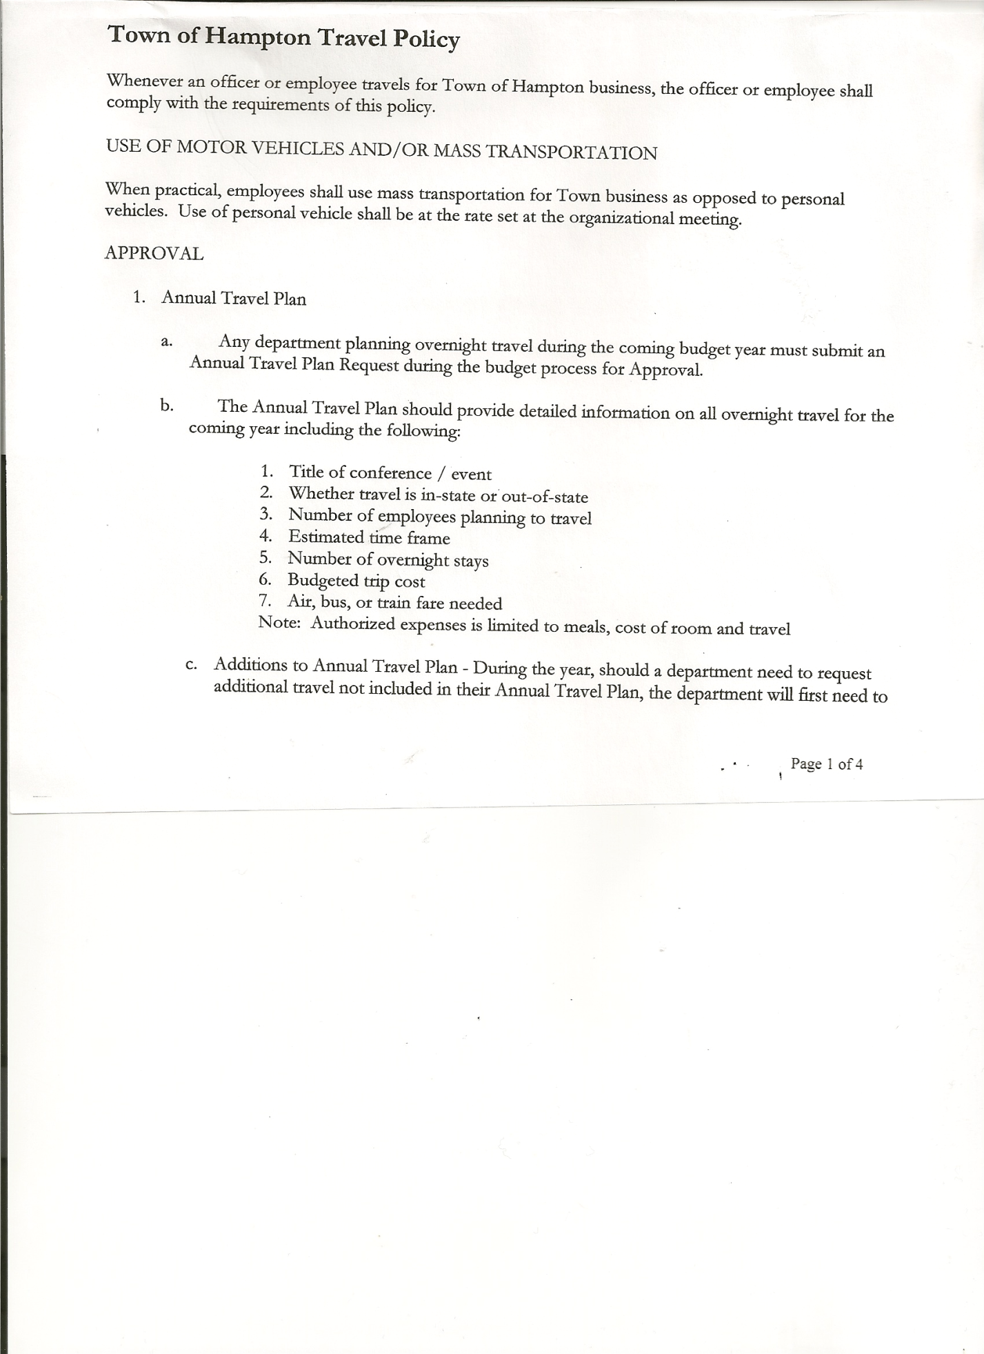
Michael Pietryka------------Councilman
Andrea Kugler---------------Councilwoman
Rebecca Jones---------------Town Clerk
Camilla Shaw----------------Deputy Town Clerk
Tyler McClure---------------Highway Superintendent

Planning Board Member (s):… Bonnie Hawley, Chair; Richard Cole, Ginny Kinsey and Rene Rountree
Others present at the Town Hall: see attached sheet

The Regular Meeting was called to order by Supervisor O’Brien at 7:30pm, followed by the Pledge of Allegiance. Location of Fire Exits were given. Quorum of board members present.

RESOLUTION NO. 55-2023
APPROVAL OF THE MINUTES
On a motion of Councilwoman Taran, seconded by Councilman Sady, the following resolution was ADOPTED: AYES 5 O’Brien, Sady, Taran, Pietryka, Kugler
NAYS 0
RESOLVED, that the Regular Town Board Meeting Minutes for May 18, 2023 are approved.

Dog Control Officer, not present no report given.

Tax Collector Report…..no activity. The Town Clerk/Collector had Board Members review and sign bank reconciliation statements for the Tax Collector Account May 31, 2023.

Bonnie Hawley, Chair Planning Board…copy of the minutes of their meeting held June 14, 2023 are attached. Next Planning Board meeting is planned for July 12, 2023.

Tyler McClure, Highway Superintendent submitted his report, copy of which, is attached.

TOWN BOARD MEETING
JUNE 15, 2023 PAGE 2

COUNTY UPDATES/COMMUNICATIONS

RESOLUTION NO. 56-2023
APPROVAL OF SUPERVISOR’S MONTHLY REPORT
On a motion of Councilman Sady, seconded by Councilwoman Taran, the following resolution was ADOPTED: AYES 5 O’Brien, Sady, Taran, Pietryka, Kugler
NAYS 0
RESOLVED that, the Supervisor’s Monthly report be accepted as submitted for MAY
04/30/23 05/31/23
ACCOUNT BALANCE RECEIPTS DISBURSEMENTS BALANCE
General Fund $ 77,859.33 $ 6,352.77 $ 7,193.10 $ 77,019.00
Highway Fund $269,867.57 $ 6.75 $ 25,702.60 $ 244,171.72
Equipment Reserve$149,969.00 $ 3.82 $ 0.00 $ 149,972.82
Fire #1 $ 46,371.00 $ 0.00 $ 0.00 $ 46,371.00
Fire #2 $ 15,361.00 $ 0.00 $ 0.00 $ 15,361.00
Cemetery $ 1,769.19 $ 1.62 $ 0.00 $ 1,770.81
Totals $561,197.09 $ 6,364.96 $ 32,895.70 $ 534,666.35
All Board Members present signed Supervisor’s Report.

June 25th there will be DAR Ceremony at the William Miller Chapel.

Health Insurance….going to be a 20% increase for 2024

For Informational purposes, the Town has no money in Low Hampton Fire Department building.

OLD BUSINESS
Supervisor O’Brien sent out the following via email….
“The Monthly Hampton Town Board Meeting will be held on Thursday, June 15th at 7:30 pm. On the Agenda will be two items of interest regarding town highways.
First, we will be discussing the closing of Staso Road from Ballard to County Route 18. There have been several incidents over the last few years which have increased concerns about the safety of turning onto County Route 18 from Staso. The steep hill creates a dangerous situation making it difficult to see properly when turning. Snowbanks piled along the sides of the road make it even more difficult to see in Winter. There have been an increasing number of heavy trucks and semis using the road more recently. Several incidents have occurred where trucks and a crane have been hung up on Staso Road creating a particularly dangerous situation for vehicular traffic on Route 18. In one situation a tandem truck slid off the road. If it wasn’t for the quick actions of the driver the truck would have gone down the hill into the field about 40 feet below. Fortunately, he was able to lock his brakes
TOWN BOARD MEETING
JUNE 15, 2023 PAGE 3

and hold the truck breaker until the town could bring its loader up to pull him out. School buses are also using the road, creating an additional safety issue with traffic on 18.
Second, we will be discussing highway maintenance. About half of our town roads are dirt and gravel. One comment many people make is, “just pave the roads”. The Town has worked with the county DPW and paving companies to estimate cost and effort. As a point of
reference, the town annually resurfaces about 8 tenths of a mile. The cost of simply resurfacing the road, which should be done once every 10 to 12 years, is currently
$135,000. In order to pave a dirt road, it is not simply a matter of putting blacktop on the road. The road has to be properly prepared. This has a cost. First the road needs to be prepared properly. Culverts replaced if needed and any proper ditching. Then to be done properly there needs to be a base coat put on the road and subsequently a binder or a top coat needs to be put on. Without proper construction the road will not last. With escalating costs of paving, the latest estimate of preparing and paving a road is between 185,000 to 250,000 dollars. To pave one mile of dirt road annually would increase both the town’s budget and resident taxes by an estimated 50 percent.
‘As everyone has seen the cost of materials and equipment have gone up substantially over the past four years. Road maintenance costs have also risen substantially over the past few years.

The Town Board and the Highway Supervisor will be discussing these items and will be able to address any questions you have regarding the roads at the June Town Board Meeting. We ask that residents attend and provide input on these two very important topics.”

There was a lengthy discussion regarding the above items.

RESOLUTION NO. 57-2023
AUDIT OF CLAIMS
On a motion of Councilman Sady, seconded by Councilwoman Kugler, the following resolution was ADOPTED: AYES 5 O’Brien, Sady, Taran, Pietryka, Kugler
NAYS 0
RESOLVED that the bills have been reviewed by the Town Board and are authorized for payment in the following amounts.
General Fund No.72 through No. 83 $ 2,437.86
Highway Fund No.61 through No. 73 $ 16,172.94
Total both funds $ 18,610.80

TOWN BOARD MEETING
JUNE 15, 2023 PAGE 4

The Town Clerk’s report for May 2023 was submitted to the Board. The Town Clerk had Board Members review and sign bank reconciliation statements for the Town Clerk Account and Special Clerk Account dated May 31st, 2023.

NYS Retirement…..Due to an error when sending in the Standard Workday/Reporting Resolution, the following Resolution had to be done again.

RESOLUTION NO. 58-2023
STANDARD WORKDAY and REPORTING RESOLUTION
On a motion of Councilwoman Taran, seconded by Councilman Sady the following resolution was ADOPTED:
By Roll Call Vote: Supervisor O’Brien AYE
Councilwoman Taran AYE
Councilman Pietryka AYE
Councilman Sady AYE
Councilwoman Kugler AYE
RESOLVED that, the Standard Workday and Reporting Resolution for Elected and Appointed Officials (RS 2417-A) be approved. (copy is attached)

RESOLUTION NO. 59-2023
MEETING ADJOURNED
On a motion of Councilwoman Taran, seconded by Councilman Sady, the following resolution was ADOPTED: AYES 5 O’Brien, Sady, Taran, Pietryka, Kugler
NAYS 0
RESOLVED that the meeting adjourned at 9:15pm.

Respectfully submitted,
Rebecca S. Jones, RMC
Town Clerk

