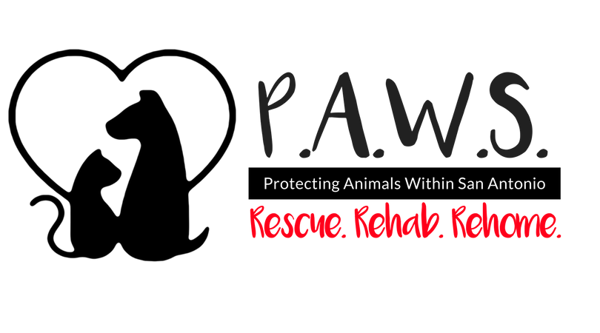 | Protecting Animals Within San Antonio (P.A.W.S.)  www.pawsa.org  Email completed app to: icatyger@aol.com or peaceloveadopt@gmail.com  Phone: 210-445-8585 or 972-741-3742

2023-2024 APPLICATION FOR ADOPTION

In addition to application, reference check, meet and greet and home check are required. Just because an application is completed, does not mean you are approved to adopt. Once you are approved, adoption fee is due. Meet and greets are scheduled through an animal’s foster once this application is submitted.

Dog or Cat’s name: _______________________________________________________________________________

Adopter’s name: ____________________________________________________________________________
Address: _______________________________ City/State: ____________________ ZIP Code: ___________
Cell number: ________________________ Work phone: ________________________
Home number: ________________________ Spouse’s number: ________________________
E-Mail: ________________________ Spouse name: ______________________________________________

HOME
❑ Own Home
❑ Rent—HOME or APARTMENT (circle one) Do you have to pay a pet deposit? YES NO
If you RENT: Landlord name and phone number: ___________________________________________

Does your home have a fenced yard? YES NO If Yes: FRONT BACK BOTH
If yes, what kind:  Chain Link (how tall) ____________
❑ Privacy Fence (how tall) ____________
❑ Other (Explain/describe) ___________________________________________

OTHER PEOPLE LIVING IN YOUR HOUSE
Please list all members of the family/those living in your household:
Name: ______________________________________ Relationship ________________ Age ______________
Name: ______________________________________ Relationship ________________ Age ______________
Name: ______________________________________ Relationship ________________ Age ______________

OTHER Animals LIVING WITH YOU
NAME | TYPE/BREED | AGE | NEUTERED/SPAYED
 |  |  | YES NO
 |  |  | YES NO
 |  |  | YES NO
VETERINARIAN YOU USE

Name: ________________________________________________ Phone #: ___________________________
Are all of your pets up-to-date on their vaccinations? YES NO SOME

ACCOMMODATIONS FOR DOGS
Where will the dog stay during the day?  Inside  Outside
Where will the dog stay at night?  Inside  Outside

If the dog stays outside at any time, is there a shelter/dog house of some kind? YES NO

If the dog stays inside, what will you have for its comfort?
❑ Crate  Stand-alone dog bed  Separate Room  Sleep on someone’s bed

On the average, how many hours per day is the dog going to be left alone? ____________________________

IF ADOPTING A CAT
Will the cat be allowed outside unattended? YES NO

Do you have feral cats on your property? YES NO

WHAT WOULD YOU DO?
In the event of an accident or illness where you could no longer care for you pet, what is the plan? Who will take on that responsibility?
Please describe: ___________________________________________________________________

______________________________________________________________________

REFERENCES (Please supply two references who are not relatives)
NAME: ____________________________ Phone: _____________________ RELATIONSHIP: ____________

NAME: ____________________________ Phone: _____________________ RELATIONSHIP: ____________

If you have no veterinarian reference, please give an additional personal reference:
NAME: ____________________________ Phone: _____________________ RELATIONSHIP: ____________

Your cat/dog microchip: Your dog will come with the microchip implanted already and the tag/microchip number attached to the vet paperwork. Please call the number/go to the website on the tag to put your information into their database. Until you do that, your dog is still registered to P.A.W.S. in Texas. You will need to contact company to switch information over.

Date: _____________________________

Once adoption fee is paid and dog has been transferred, this agreement will go into effect.

ADOPTION AGREEMENT

The following are the legal terms which you agreed for the adoption of the dog or cat called ________________________.

➔I agree to take adult dogs/cats to the vet within 30 days and puppies/kittens within 1-2 weeks of adoption to continue heartworm & flea prevention and /or well care. ___________

➔I agree to foster this dog/cat if there is any reason the dog/cat is not adjusting well. I agree to foster until the dog/cat can be returned to P.A.W.S. I will be held in violation if I surrender, dump or rehome it without permission.______

➔I agree to release rescue organization from liability for this animal's care and behavior once I adopt, pay the fee and receive the dog/cat. In the event that there is a dog aggression event where a dog or human is injured, I release any claims of liability or neglect against the rescue. ______

➔I agree that this is an animal rescue and most likely a stray. Therefore, I understand that the rescue has no knowledge of animal’s abilities beyond our experience with the animal in our foster homes. I also understand that the animal may come with limited medical history.______

➔If necessary, I agree to work with a certified dog trainer (no shock collars or prong collars) to help ensure the success of the dog adoption. _____

➔I agree to communicate and update P.A.W.S. with the animal’s progress and if there is a change of contact information or address. I will update the microchip information. _____

➔I agree that P.A.W.S. has the right to retrieve an animal in my care if it is determined that the animal has been neglected in any way. ______

➔I do not have any breed restrictions at my residence. ______

________________________________________ ________________________________________
Name Printed Signature

________________________________________ ________________________________________
Phone Number Date

________________________________________
Email

