Caraway Rug School
2019 Teachers

Jeannie Benjamin
All Types & Primitives
Judy Carter FULL
Animals
Bev Conway
Whimiscal, All Types
Donna Hrkman FULL
All Types
Lisanne Miller FULL
Vintage, Landscape, Prim
Maureen Rugar
All Types, Shading
Diane Stoffel FULL
All Types
-------------------------------------------------

How to Register For Caraway Rug School

- Fill out Registration Form
- Attach your check for $150
** Make payable to
Caraway Rug School

If you are mailing your Caraway Registration Form in:

Mail form with $150 check to
Jane Dunaway
43 Westridge Road
Brandon, MS 39047

At Caraway Rug School
Remember

No refunds for Caraway Rug School after January 1, 2019

Your balance is due by April 16, 2019 to avoid late fees

Yes, please feel free to make
Payments as fits your budget

Also, this is based on availability in the classes you selected!

Questions About Caraway Rug School???

Lisanne 207-360-0762 or lisannemiller1@aol.com

www.carawayrugschool.com

Caraway Rug School is located in Sophia, NC very close to Asheboro NC

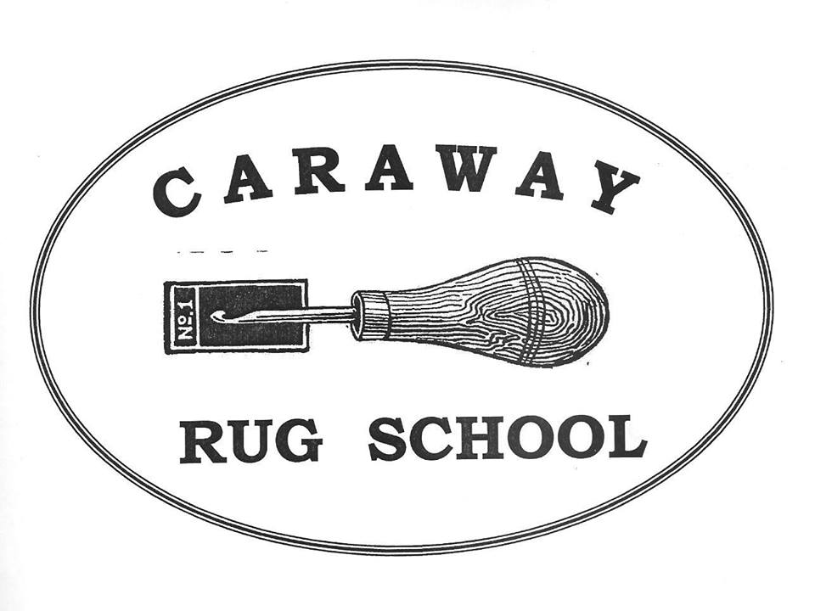

Caraway Rug School
June 16-21, 2019
Registration
(Please Print Clearly)

Name:___________________________________

Address:________________________________

City:____________________________________

State:________Zip:_______________

Phone:__________________________

Email:___________________________

Skill Level: (Circle One)
Beginner Intermediate Advanced

Teacher: (1)_____________________

(2)______________________________

Roommate:_____________________

Fees: (Circle All That Apply)

Double Occupancy $720 Each

Commuters $475 Each

Husbands $500 Each

**Those grandfathered into private rooms

Special Needs:

Caraway Rug School
Important Information

First Class Accommodations Include:
Towels
Bed Linens
Hair Dryer
Clock Radio
Private Bathrooms
AC in ALL Rooms
Smoke-free Environment
Internet Access Available
No Alcoholic Beverages
Elevators
Linen Service As Needed

Meals: Sunday Dinner to Friday Breakfast
(Meals are cafeteria style with a great salad bar at both lunch and dinner)

Fun Stuff That Makes Caraway, Caraway!

Movie Night with popcorn
Rug Show Walk and Talk
French Market Day
Auction Night
Scholarships
Rug Store & Supplies provided by
“W. Cushing & Co.”

At Caraway Rug School,
We continue the tradition of rug hooking while pushing our art forward!

Caraway Rug School
June 16-21, 2019

Open School * All Patterns Taught * All Levels from Beginner to Experienced

Join us for an exceptional Rug Hooking School and Exhibit of Traditional & Primitive Hand Hooked Rugs

WHEN: June 16-21, 2019
Registration Sunday 2 – 5 pm
Orientation 6:30 pm

WHERE: Caraway Conference Center
4756 Caraway Mountain Rd
Sophia, NC 27350
336-629-2374

CLASSES: Monday –Thursday 9 to 3:30 pm
Friday 8:30 to 10 am Hooking
Classrooms Open Nightly

RUG SHOW: Wednesday, June 19, 2019
11 am to 6 pm
OPEN TO THE PUBLIC

RATES/FEES:
Double Occupancy $720 Each
Commuters $475 Each
Husbands $500 Each
DUE DATES: $150 Deposit To Register
Balance Due April 16, 2019

REFUNDS: FULL Refund prior to Jan 1, 2019
No Partial Refunds Given

What You Need to Pack
For Caraway Rug School!

Your Rug Hooking Supplies
Rugs to Exhibit at the Rug Show
Personal Clothing Items, toiletries and Remember A Sweater!
Rug Hooking Related Item for the Scholarship Auction & A Smile

When Will You Hear From Your Teacher?

You will hear from your teacher
after March 1st!

So be sure to print your information clearly

What To Do Upon Your Arrival

Please register with Lisanne in the front foyer. Pick up your room key and
Registration packet
Nest in your classroom

Questions???

Lisanne 207-360-0762
lisannemiller1@aol.com

www.carawayrugschool.com

