Reach Beyond Basketball 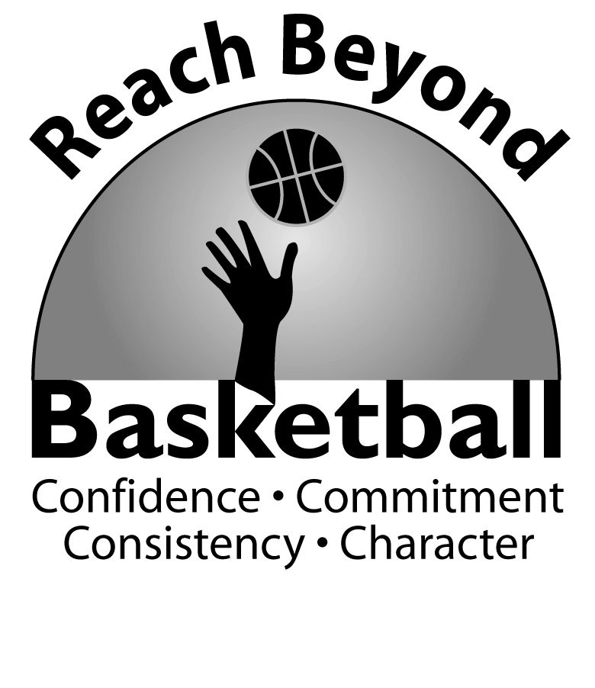
Skill Development Clinic
Provides a variety of basketball drills and games for participants of all skill levels and an experience to improve on fundamentals in a fun and safe learning environment. The importance of academics
and character is also emphasized by our staff.

Instructors: Diallo Nelson- (Head Varsity Boys Basketball Coach- Kennedy HS)
Lenny Myers- (Reach Beyond Basketball, Head Boys JV coach- Kennedy HS)

FOR: Boys and Girls of all ages

WHERE: John F. Kennedy HS

WHEN: Session 1- Saturday October 25th 12:00 am-2:00 pm
Session 2- Saturday November 1st 12:00 am-2:00 pm
Session 3- Saturday November 8th 12:00 am-2:00 pm

Cost: $25 per session or $20 if signed up for multiple sessions – SEE REVERSE SIDE FOR REGISTRATION DETAILS

*You can register online at www.reachbeyondbasketball.com or mail this form along with a check or money order made out to Reach Beyond Basketball to: 18222 Flower Hill way #213, Gaithersburg MD, 20879
_________________________________________________________________________________________

Participants Name__________________ Grade_____ School Attending___________________
Address_______________________________________ City______________ State_____ Zip Code_________
Name of Parent ______________________ Home/Cell Phone number___________________
Email Address ________________________ Emergency Contact Name/Phone _________________________

Disclaimer: The participant assumes all risks associated with participation in the Reach Beyond Basketball Clinic. Reach Beyond Basketball, Lenny Myers, nor any staff assumes liability for incidental injury or damages arising from participation in this program. Due to the strenuous nature of some activities, the Reach Beyond Basketball Camp and Lenny Myers encourages each participant to consult his or her physician concerning fitness to participate in the program. The participant consents to emergency treatment. You will be notified if any treatment becomes necessary. The participant also consent to the Reach Beyond Basketball’s use of any photographs taken or video tapes made of the Reach Beyond program. If the participant is a minor the parent or guardian approves of his or her participation in this program by signing below. Neither the instructors nor any staff are responsible for children prior to the start of or after the Reach Beyond Basketball Clinic ends.

Parent/Guardian signature: _____________________________
Name Printed: _______________________Date:____________

