DENTISTRY HEALTH CAMPAIGN, APRIL-MAY 2020:
REDUCING ALCOHOL HARM

THE CONTEXT: ALCOHOL-RELATED HARM IN GREATER MANCHESTER

The Greater Manchester Drug and Alcohol Strategy sets an ambition for our city-region to be a place where everyone can have the best start in life, live well and age well, safe from the harms caused by drugs and alcohol.

Reducing these harms is central to improving the safety, wellbeing and prosperity of Greater Manchester.

Alcohol seriously affects our people, our communities and our public services:

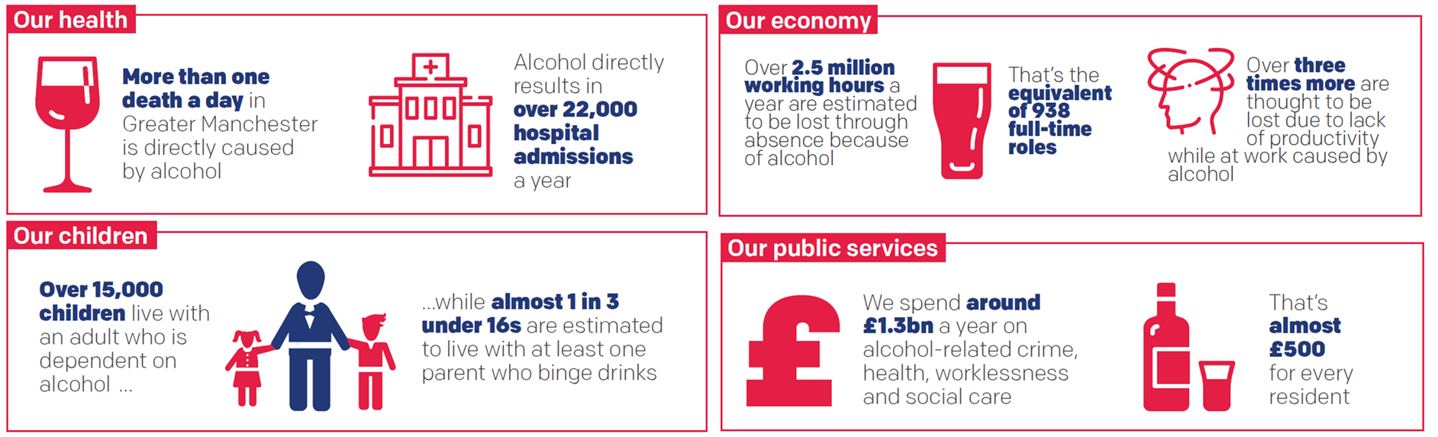

Many people here feel that alcohol is having serious impacts, on health and our local areas:

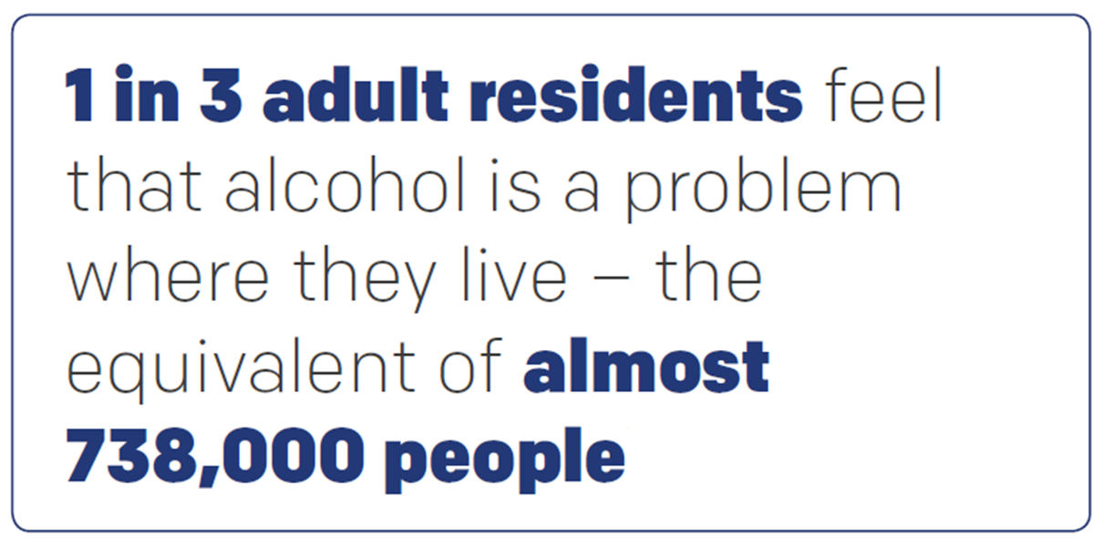
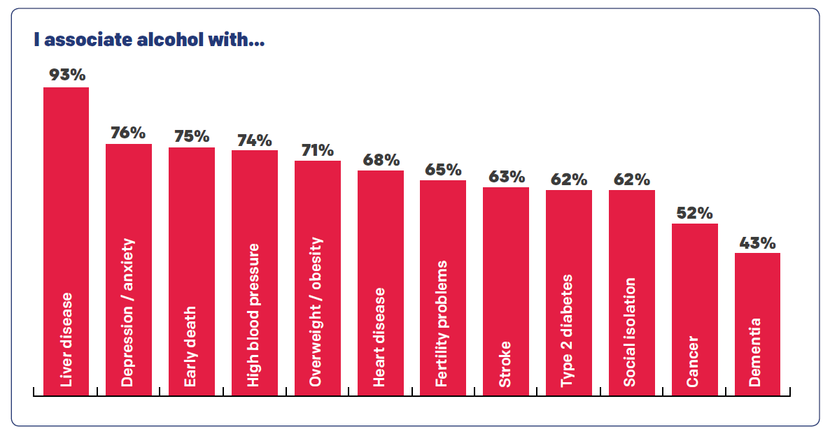

A relatively high proportion of our residents drink at levels which could cause harm – but far fewer show concern about the amount that they personally drink:

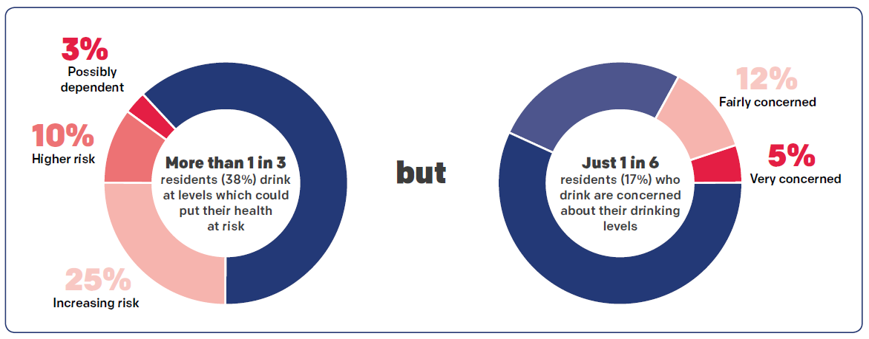

THE OPPORTUNITY: OUR NEW HLD HEALTH CAMPAIGN
To deliver an alternative campaign within the HLD programme. We are calling on dental practices across Greater Manchester to join us in helping our residents do things differently when it comes to alcohol.
We are focusing on two specific elements:

ONE: APRIL-MAY 2020 – DELIVER THE CAMPAIGN, REDUCING ALCOHOL IN PREGNANCY
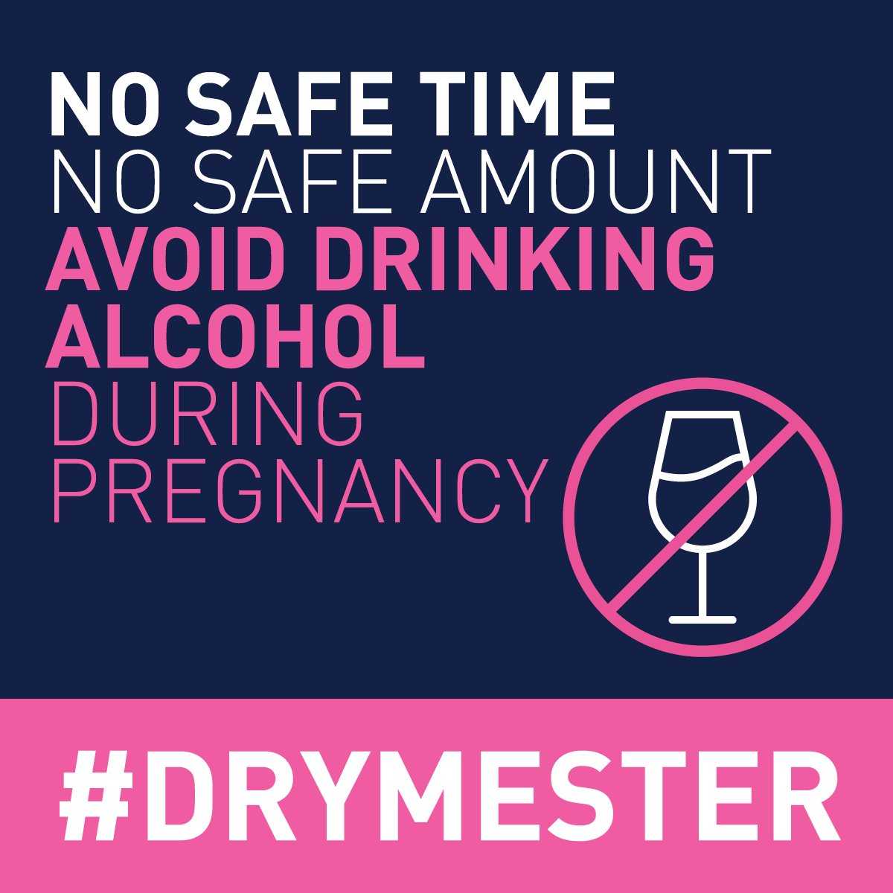
The UK’s Chief Medical Officers recommend that if you are pregnant or planning to become pregnant, the safest approach is not to drink alcohol at all, to keep risks to your baby to a minimum.
Despite this clear guidance, many would-be parents are still unsure about whether, and how much, they can safely drink. The Greater Manchester #DRYMESTER campaign has been created to increase awareness that there is no safe time or safe amount of alcohol to drink during pregnancy, and to help parents-to-be go alcohol free.
The campaign is part of a pioneering programme of action aiming to establish Greater Manchester as a world-leader in reducing and responding to the impacts of alcohol in pregnancy. Our ultimate goal is to end all new cases of Foetal Alcohol Spectrum Disorders – the range of lifelong disabilities that can occur as a result of drinking alcohol during pregnancy, and thought to affect a significant number of children born here each year.
What Dental teams can do:
- Discuss alcohol with visitors who are pregnant or planning a pregnancy. Ensure they are aware of the official guidelines – that the safest approach is not to drink alcohol at all.
- Encourage them to sign up at Drymester.org.uk to receive further information and access to free resources to support going alcohol free in pregnancy.
Further details are provided in a separate briefing issued alongside this note.

TWO: Dental Teams complete the Alcohol Identification and Brief Advice e-learning which will support teams when delivering simple brief advice.

The project helps professionals to identify those individuals whose drinking might impact their health, now or in the future and to deliver simple, structured advice aimed at reducing this risk.
Dental teams are part of the primary care umbrella. Therefore it is important that they have the most up-to-date information to be able to discuss with patients the impact lifestyle choices have on oral health.
IBA is the delivery of ‘simple brief advice’ which follows identification of how much your patient is drinking. IBA is usually delivered by non-alcohol specialists and has shown to be effective in helping people to reduce their alcohol health risk.
To access training aimed at dental teams that will help you undertake a screening test and then give routine, opportunistic ‘simple brief advice’. Please visit https://www.e-lfh.org.uk/programmes/alcohol/ or you can access this training via the HLD website
This programme is aligned to Section 8 ‘Alcohol Misuse and Oral Health’ within Delivering Better Oral Health.

What Dental teams can do:
- Ensure a question related to alcohol consumption is on your medical histories questionnaire to make starting the conversation easier.
- Discuss the role of alcohol in the lives and communities of your visitors whenever the opportunity arises.

