UWF Pool – The Ridge Cinema 8 –
Admission = $4 Movie = Free
Snack Box – Candy/Drink/Popcorn $5 - Optional

UWF Rockwall –
Admission = $5 Weber’s Skate World –

Rodger Scott Pool – Inline Skates = $5, Regular Skates = $4,
Admission = $3 Admission Only = $3, Stabilizer = $3
Arcade = Optional
Oops Alley –

Bowling $5, Arcade = Optional

LIME: Ages 5-7 NAVY: Ages 8-9 PURPLE: Ages 10+
JUNE 2019
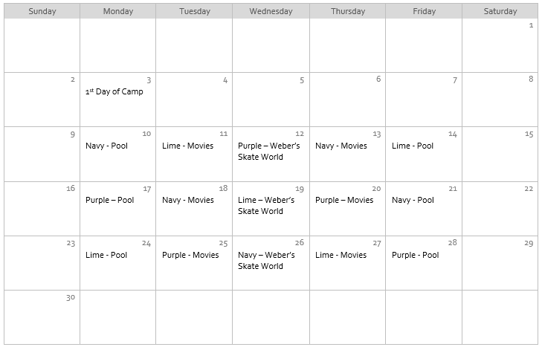
JULY 2019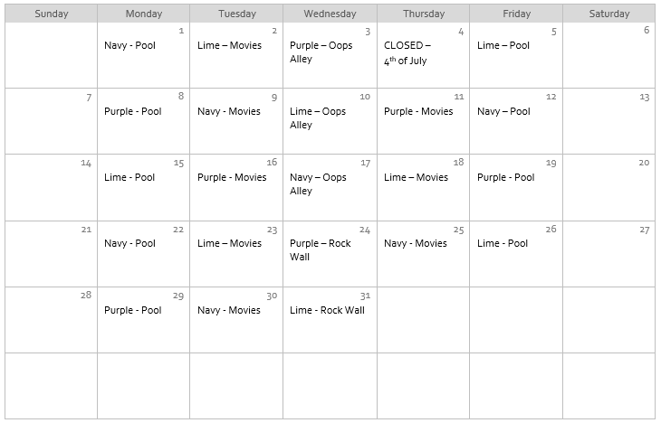
AUGUST 2019
