Kids’ Best Dressed Animal Contest

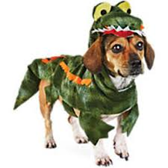
Dress your pet(s) up in a
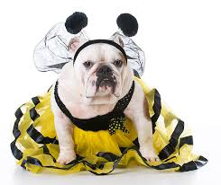
creative costume

Win prizes!

1:30 pm at the Kids’ Stage
Marina

