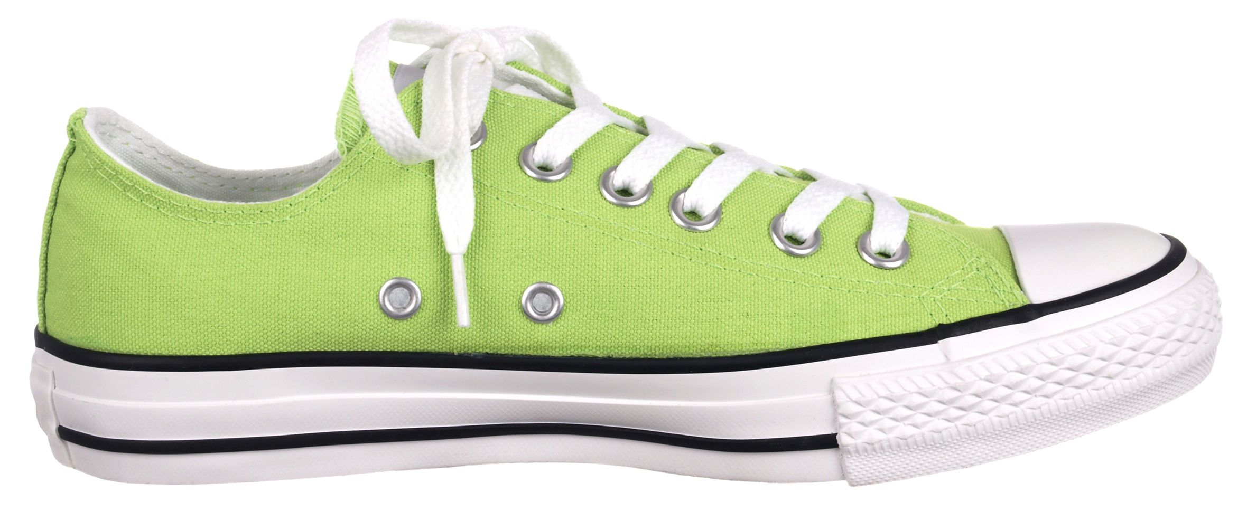

Just part of your comprehensive wellness program. Find out more at www.empowerlinc.com or call a health coach today at 888.882.LINC (5462).



UFIt

a fun and effective way to improve your fitness

TAKE THE

EXTRA STEP?

WILL U