Nassau-Suffolk EMA Ryan White Part A
HIV Health Services Planning Council
____________________________________
‘In Care’ MSM PLWH/A Needs Assessment
in the Nassau Suffolk EMA
____________________________________

2009 REPORT OF FINDINGS

Prepared by



COLLABORATIVE RESEARCH. LLC

May 2009

United Way of Long Island
TABLE OF CONTENTS

Executive Summary…………………………………………………………………………..3

Chapter 1: Introduction……………………………………………………………………11

Chapter 2: 'In Care' MSM PLWH/A Survey Findings…………………………………...16

Chapter 3: Recommendations for Comprehensive Strategic Plan………………...28

APPENDICES
In Care Client Survey Instrument

2009 “In Care” MSM PLWH/A
Needs Assessment -

Nassau-Suffolk EMA HIV Health Services Planning Council May 2009

Executive Summary

In the Long Island region, the Eligible Metropolitan Area (EMA) is made up of Nassau and Suffolk Counties. The Nassau-Suffolk region is an island, 100 miles long, an average of 12 miles wide, (287 square miles for Nassau and 911 square miles for Suffolk) with a population of over 2.8 million people. Long Island is the most populous island in the 48 contiguous U.S. states and the most populated of any U.S. state or territory with a population density of 5,470 people per square mile. The eastern end of the EMA splits into two peninsulas, known as the North Fork and the South Fork. The region’s link to the mainland is on its western border, through New York City.
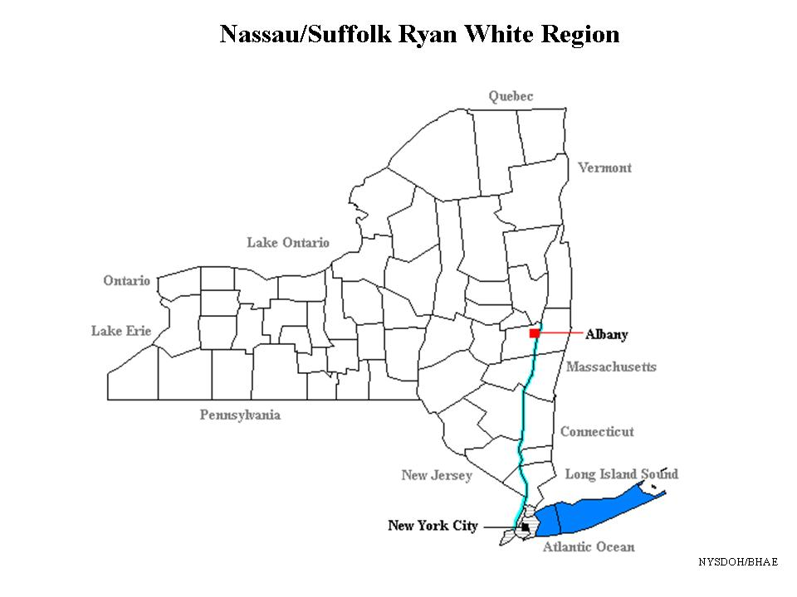
The geography of the EMA poses unique problems for delivery of, and access to, services. There is little mass transportation available in either county except the Long Island Railroad, which is primarily designed to serve commuters traveling from the suburbs into New York City. There is one interstate highway, I-495, that goes from New York City to the East End (Eastern Long Island) but does not reach to the end of the EMA. Additionally, there is no north/south mass transportation making it virtually impossible to get from the north side of the island to the south side. Thus, even for persons who do have an automobile, travel within the region is often quite difficult.

The general population for both counties is primarily White (Nassau County 79%; Suffolk County 85%); followed by the Hispanic populations (Nassau County 10%; Suffolk County 11%) and African American populations (Nassau County 10%; Suffolk County 7%). Despite areas of affluence throughout this two-county EMA, there remain pockets of poverty and problems traditionally viewed as urban. The EMA has an estimated 50,000 homeless persons, many substance users, a large immigrant population and, cumulatively, more persons living with AIDS than any other suburban region in the country.
The Nassau-Suffolk EMA contains approximately 2,815,129 residents or 38% of the total population residing on Long Island. As of December 31, 2007, the New York State Department of Health reported a total of 5,753 PLWH/A in the EMA. The region's three NYSDOH Designated AIDS Centers (DACs), located in East Meadow, Manhasset and Stony Brook, provide many valuable services, such as outpatient care, mental health services, and HIV/AIDS specialty services. Unfortunately, the challenges with transportation make it difficult for individuals to access and maintain these services.

Relevance of the 2009 “In Care” MSM PLWH/A Needs Assessment Study

In 2006, a total of 3,488 persons were reported as living with AIDS and 1,898 persons were reported as living with HIV for a total of 5,386 PLWH/A (NYSDOH, 2007). In 2007, the EMA reports a total of 3,714 PLWA and 2,039 PLWH, for a grand total of 5,753, yielding an increase of 7 % and 367 additional PLWH/A in the EMA. This number does not include incarcerated PLWH/A (n=165).

Data provided by the New York State Department of Health (NYSDOH) for the period ending December 31, 2007 illustrates the significant impact the epidemic has on the populations within the Nassau-Suffolk EMA. Clearly, the EMA’s minority populations are disproportionately impacted representing 74% of the emergent AIDS and 71% of new HIV cases for the period of 1/1/06 through 12/31/07. The Nassau-Suffolk TGA has a total PLWH/A population of 5,386 individuals, of which 66% are males and 34% are females. This number does not include incarcerated PLWH/A (n=165), who are disproportionately male. The following table represents the HIV/AIDS incidence and prevalence, by gender, in the TGA. Males comprise 69% of new AIDS cases, 69% of new HIV cases, 69% of PLWH and 60% of PLWA.

TABLE 1. GENDER COMPOSITION, 2006
Gender | New AIDS Cases |  | New HIV Cases |  | PLWH |  | PLWA
Gender | Total # | % of New AIDS | Total # | % of New HIV | Total # | % of PLWA | Total # | % of PLWH
Male | 282 | 69% | 334 | 69% | 1,143 | 60% | 2,399 | 69%
Female | 127 | 31% | 151 | 31% | 754 | 40% | 1,089 | 31%
Total | 409 | 100% | 485 | 100% | 1897* | 100% | 3,488 | 100%
Source: New York State Department of Health; *data missing one (1) case by gender category

The following table represents the breakdown by age of the total PLWH/A population for the Nassau-Suffolk TGA as of 12/31/06:

TABLE 2. AGE GROUP DISTRIBUTION (New AIDS and HIV, PLWH/A), 2006
Age Group (years) | New AIDS Cases |  | New HIV Cases |  | PLWA |  | PLWH
Age Group (years) | Total number | % of New AIDS | Total  number | % of New HIV | Total number | % of PLWA | Total number | % of PLWH
< 13 | 1 | <1% | 1 | <1% | 54 | 3% | 6 | <1%
13-19 | 16 | 4% | 11 | 2% | 59 | 3% | 50 | 1.5%
20-44 | 235 | 57.5% | 319 | 66% | 939 | 50% | 1,315 | 38%
Over 45 | 157 | 38% | 154 | 31.7% | 840 | 44% | 2,117 | 60%
Total | 409 | 100.0% | 485 | 100.0% | 1,892 | 100% | 3,488 | 100.0%
Source: New York State Department of Health; 2006
As demonstrated in the table below, Men Who Have Sex with Men (MSM) account for the largest number of cases when identifying HIV-risk behaviors that have contributed to the numbers of PLWH/A within the Nassau-Suffolk region. The second largest risk behavior that is demonstrated by the data is those PLWH/A who have a history of intravenous drug use (IDU).

The total proportion of PLWH/A cases attributable to MSM risk behavior is 33% or 1/3 of the entire living epidemic in the Nassau-Suffolk service delivery area (when the total number of MSM and MSM/IDU cases are combined).

TABLE 3. TRANSMISSION RISK BY PLWH/A IN NASSAU-SUFFOLK TGA, 2006
TRANSMISSION RISK | PLWH/A
TRANSMISSION RISK | Percentage of PLWH/A
MSM | 29%
IDU History | 20%
Heterosexual | 17%
MSM/IDU | 4%
Other/Unknown | 4%
Blood transfusion/components | 2%
Source: New York State Department of Health, 2006

The following graph provides a visual demonstration of the number of HIV/AIDS cases that are the result of MSM and MSM/IDU risk behavior patterns as evidenced from data supplied by NYSDOH.

FIGURE 1. PROPORTION OF PLWH/A BY RISK CATEGORY
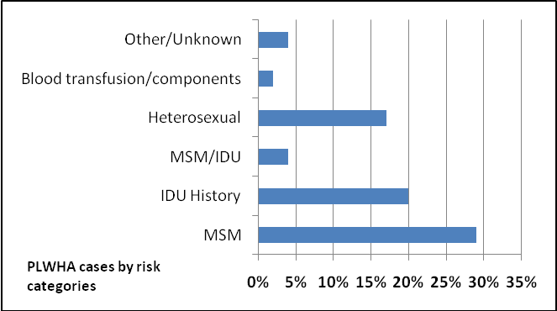

The 2008 Nassau-Suffolk EMA Planning Council has commissioned this 2009 Needs Assessment Study for the special population of MSM, to determine the service needs, uses, gaps and barriers to HIV primary medical care for this special population, the results of which will be used in the Planning Council’s 2010 Priority Setting and Resource Allocation (PSRA) process.

Overview of 2009 MSM PLWH/A ‘In Care’ Study Findings

The 2009 MSM survey participants’ profile reflects the larger MSM epidemic in the Nassau-Suffolk EMA. Almost half or 46% of the MSM respondents report their race/ethnicity as Caucasian; 28% Hispanic; 21% African American; 3% American Indian and 3% Asian/Pacific Islander. By age group, 3% report their age between 13-24 years; 15% report their age between 25-34 years; 21% report the 35-44 age band; 46% report age as 45-54 years; and 15% report their age between 55-64 years.

While 95% of the 2009 MSM survey respondents report MSM risk behavior as their risk exposure mode, an additional 13% report IDU; 21% report Heterosexual sex; and 2% report Sexual assault as one of their risk exposure modes. Approximately two-thirds of the MSM respondents report their sexual orientation as ‘gay’; 21% report bisexuality; and 8% report they consider themselves to be ‘straight’.

More of the MSM survey respondents report their location of residence in Suffolk County, and approximately 62% report accessing their HIV primary medical care services in Suffolk County, while 35% receive their HIV medical care services in Nassau. Over half of the MSM respondents reports Medicaid as their health insurance benefit; 31% cite Medicare; 8% report having private insurance; and 44% report ADAP for their health insurance coverage.

Almost 40% of the 2009 ‘In Care’ MSM respondent group reports current or previous homelessness. This finding indicates a high level of housing instability among the MSM PLWH/A population in the EMA, and supports the finding that housing assistance is viewed as a top priority service need.

A total of 31% of the ‘In Care’ MSM survey respondents report current employment, which generally reflects their indigent health care benefit and disability status, (with 54% reporting Medicaid benefits and 31% reporting Medicare benefits).The vast majority of the MSM survey respondents report their income at or below 200-250% of the federal poverty limit. Fully 44% report their eligibility for ADAP/Ryan White benefits.

Over 46% of the 2009 ‘In Care’ MSM survey respondents reports the previous diagnosis and/or treatment of a mental health disorder; over 51% report the previous diagnosis/treatment for a substance abuse disorder; almost 40% report a previous STD, other than HIV; and over 64% report treatment for another chronic illness, other than HIV disease.

The MSM respondent group reports a satisfactory ‘In Care’ connection and a strong PCP and laboratory monitoring presence, overall.

(See Table 4: 2009 ‘IN CARE’ MSM NEED, USE, GAP, & BARRIER MATRIX on the following page)
Overview of MSM PLWH/A ‘In Care’ Respondents’ Services Needs, Uses, Gaps and Barriers

TABLE 4: 2009 ‘IN CARE’ MSM NEED, USE, GAP, & BARRIER MATRIX
SERVICE CATEGORY | Need  Rank | Use  Rank | Gap  Rank | Barrier  Rank
Primary Medical Care | 1 | 1 | NR | 5 tie
Medications | 2 | 3 tie | NR | 5 tie (non-HIV meds)
Food Bank/Nutrition | 3 | 7 tie | 3 tie | 3 tie
Housing Assistance | 4 tie | NR | 1 | 2
Mental Health Counseling | 4 tie | 3 tie | 5 tie | 6
Medical Transportation | 5 tie | 4 | 2 | 1
Emergency Financial Assistance | 5 tie | 6 tie | 5 tie | 4 tie
Psychosocial Support | 6 | 5 tie | 4 tie | 5 tie
Health Insurance/Co-pay Assistance | 7 tie | 7 tie | 4 tie | 5 tie
Oral Health Care | 7 tie | 5 tie | NR | 3 tie
Substance Abuse Counseling | 7 tie | 8 | NR | NR
Employment Assistance | 8 | NR | 3 tie | 4 tie
Case Management | 9 tie | 2 | NR | NR
Legal Services | 9 tie | NR | 5 tie | NR
Vision Care | 9 tie | 9 | NR | NR
Health Information (Information about services) | 9 tie | NR | 5 tie | 5 tie
Social Services (public assistance/food stamps) | NR | 6 tie | NR | NR
Services availability in evenings | NR | NR | 4 tie | 5 tie
Interpreter Services | NR | NR | 5 tie | NR
Medical Specialty Services | NR | NR | NR | 5 tie

Top Ranking MSM PLWH/A Service Needs
1. Primary Medical Care
2. Medications
3. Food Bank/Nutrition Services
4. Housing Assistance tied with Mental Health Counseling
5. Medical Transportation tied with Emergency Financial Assistance
6. Psychosocial Support
7. Health Insurance/Co-pay Assistance tied with Oral Health Care and Substance Abuse Counseling
8. Employment Assistance
9. Case Management tied with Legal Services, Vision Care and Health Information (primarily referring to need for more orientation to/information about services available)

Top Ranking MSM PLWH/A Service Uses

1. Primary Medical Care
2. Case Management
3. Medications tied with Mental Health Counseling
4. Medical Transportation
5. Psychosocial Support tied with Oral Health Care
6. Emergency Financial Assistance tied with Social Services/Public Assistance benefits
7. Food Bank/Nutrition Services tied with Health Insurance/Co-pay Assistance

Top Ranking MSM PLWH/A Service Gaps

1. Housing Assistance
2. Medical Transportation
3. Food Bank/Nutrition Services tied with Employment Assistance
4. Psychosocial Support tied with Health Insurance/Co-pay Assistance tied with ‘lack of availability of extended/evening hours for services’
5. Mental Health Counseling tied with Emergency Financial Assistance, Legal Services, Health Information (primarily information about services available), and Interpreter Services

MSM PLWH/A Reasons for Service Gaps

Frustration creates anxiety which no one with HIV needs. I face obstacles all the time.
Rents are too high for me to get - don't have enough in my check
Too many cut backs – Need help with food, rent, but cannot get due to RW cut backs
I am out of town area - RW is too far. I have to travel to medical and RW.
No Spanish speaking persons - only speak English because the service helps me - need more interpreters
I do not qualify
No papers-cannot return to Country so stay here illegally and stay sick
Services not available in evenings
Just out of jail and trying to tap into services
Low orientation to services available
Medicaid is a terrible system

(See Table 5: 2009 MSM PLWH/A Service-Specific Gap Reasons, on the following page)

TABLE 5. 2009 MSM Service-Specific Gap Reasons
SERVICE CATEGORY | Need  Rank |  | Gap  Rank | Gap Reasons
Primary Medical Care | 1 | NR |  | It would be great to have a clinic with access to general health care—a clinic that can deal with everything. Clinic hours 9-5 and I work downtown Manhattan—it is difficult to get to clinic. No evening hours.
Medications | 2 | NR |  | NA
Food Bank/Nutrition | 3 | 3 tie |  | Can’t get food stamps. Hard to get food, especially healthy foods. Meals on Wheels can be difficult to get. Sometimes there aren’t certificates as in the past and there is a limited food pantry in this area. Living in a shelter everyone can take your food.
Housing Assistance | 4 tie | 1 |  | Everyday things like food and shelter hard to get. Hard to obtain rent assistance. It is harder to get housing assistance in N/S than it was in NYC. Tried HAASA but was denied because I was considered too healthy. Sometimes I need help paying my rent.
Mental Health Counseling | 4 tie | 5 tie |  | Hard to get connected with psychologist.
Medical Transportation | 5 tie | 2 |  | Buses do not run late or on Sunday. Only get one ride and if I go to Doctor and get prescription/have to go to pharmacy, I only get one ride. Have to schedule ride 3 days in advance, and do not always know. Anything I need I have to travel 45-60 minutes and longer. Gas is so expensive and I live hand to mouth, month to month.
Emergency Financial Assistance | 5 tie | 5 tie |  | It gets tough stretching till the end of the month.
Psychosocial Support | 6 | 4 tie |  | It is hard coping with all my illnesses—need companionship and support from family and friends. Need connection to support. It is hard to participate in group—no evening hours for working people. I live in the suburbs so support and services can be harder to get, especially with the difficult transportation issues. Lack of evening resources.
Health Insurance/Co-pay Assistance | 7 tie | 4 tie |  | Getting on to health insurance is my biggest issue. Need help transitioning from employment to disability. Am having a lot of problems with Medicaid.
Oral Health Care | 7 tie | NR |  | Really having a hard time getting adequate dental care. Only pay certain amount.
Substance Abuse Counseling | 7 tie | NR |  | NA
Employment Assistance | 8 | 3 tie |  | Need employment assistance—the business I work for is going out of business. There are limits on the work I can do. Need a steady job.
Case Management | 9 tie | NR |  | NA
Legal Services | 9 tie | 5 tie |  | Hard to get papers/illegal immigrant.
Vision Care | 9 tie | NR |  | Optical care is hard to get and pay for—I am legally blind due to CMV.
Health Information (Information about services) | 9 tie | 5 tie |  | Need more information about HIV and services available.
Medical and Psychosocial Services availability in evenings | NR | 4 tie |  | Lack of resources/services in the evening hours for working people
Interpreter Services | NR | 5 tie |  | Lack of interpreter services in primary care and other service settings.

Top Ranking MSM PLWH/Service Barriers

1. Medical Transportation
2. Housing Assistance
3. Food Bank Services tied with Oral Health Care
4. Emergency Financial Assistance and Employment Assistance
5. Primary Medical Care tied with Medications, Psychosocial Support, Health Insurance/Co-pay Assistance, Health Information (primarily information about services available), Lack of available Medical and Support Services in Evening/Extended Hours, and Medical Specialty Services

MSM PLWH/A Service Barrier Reasons
Too many restrictions
I guess the funds. Lots of cuts. RW cut back like emergency rent - sometimes I have to pay for meds out of pocket like over the counter and dental.
Too many documents and days trying to get help. Grants taken away like Thursdays Child - grant is gone.
More services in the city - to get services, travel worthwhile. With ACC was good resource early on.
Ineffective listening to client, I have been told due to cutbacks, and I also think a lack of communication, lack of efficiency, incompetence of workers. Workers inexperienced using service providers as stepping stones.
The grant amounts don't cover enough - you have to have extra money yourself
Basically hard to meet all the requirements - not enough extra monies - transportation is awkward and crazy with schedules
Cut backs
Because that is how Suffolk County is and it is getting worse.
With all the cutbacks, there is not much to offer me out there.
Sometimes I do not qualify
Because I'm illegal, don't have permission to work, difficult without work
Now, I don't have problems getting these services because I received help through the Hispanic C. Center in Bay shore.
Transportation can be a problem, but I have a car, I'm lucky.
The service I need, root canal, very expensive and not covered
Waiting for my (INS) papers
Program only allows certain areas

Chapter 1: Introduction

Annual Needs Assessments are “snapshot” studies in time conducted to determine the priority service needs, barriers, and gaps in the continuum of care for People Living with HIV/AIDS (PLWH/A). Results of this client-centered activity are used to establish service priorities, document the needs for and gaps in specific services, determine barriers to accessing care, provide baseline data for comprehensive planning including capacity building, and help providers improve the accessibility, acceptability and quality of services delivered, especially to the designated ‘Severe Need Groups/Special Populations’.

A comprehensive assessment of the HIV/AIDS-related service needs, uses, gaps and barriers of “In Care” MSM PLWH/A within the Nassau-Suffolk EMA was conducted in the spring of 2009. This assessment of need included an “In Care” survey questionnaire of MSM PLWH/A utilizing the In Care Needs Assessment Client Survey (NACS) tool.

Relevance of the Part A Comprehensive “In Care” MSM PLWH/A Needs Assessments

The targeted MSM PLWH/A and their sub-populations have emerged as a major focus of study for the planning area. The Planning Council is continuously challenged in identifying the changing needs of the PLWH/A community in order to best facilitate access, engagement and retention in care for all those living with HIV/AIDS in the service area. Based upon their highly disproportionate impact within the EMA, as evidenced in the table below, the ‘In Care’ needs assessment survey process and resulting report highlights the differing needs, uses, gaps and barriers to HIV primary medical care and support services experienced by the ‘In Care’ MSM PLWH/A within the Nassau-Suffolk EMA.

TABLE 6. POPULATIONS OF PLWH/A UNDERREPRESENTED IN RW FUNDED CARE SYSTEM
SEVERE NEED GROUP | Percent PLWH/A | Percent in Core Medical Care | Percent in Supportive Care | Percent in any Part A Care
African Americans | 38% | 30% | 63% | 40%
Hispanics | 20% | 15% | 17% | 15%
MSM | 29% | 21% | 16% | 19%
Women of Color | N/A per NYSDOH | 19% | 42% | 26%
IDU | 19% | 13% | 18% | 15%
45+/Aged | 58% | 46% | 68% | 53%

As evidenced in the table above, there are consistent disparities noted for each of the severe needs populations, when their relative proportion in the local epidemic is compared to their relative proportion in Part A funded core medical care services. While MSM comprise 29% of the living cases of HIV/AIDS, only 21% accessed core medical services and only 19% accessed any Part A funded service. MSM PLWH/A represented only 16% of all PLWH/A who accessed supportive services in 2007.
In the United States generally, and particularly in New York State, the HIV/AIDS epidemic has been reduced dramatically among children born to HIV positive women and among injection drug users. Emerging challenges include an aging population with newly acquired HIV infection and successfully maintaining individuals with HIV and AIDS in care and treatment over their lifetimes. However, an ongoing and increasing crisis continues among gay men and other men who have sex with men (MSM), particularly young men of color, who continue to become infected with HIV at alarming rates. (Report on Gay Men’s/MSM Forum: Prescription for Change, NYSDOH, AIDS Institute, December, 2006)

Project Design for the ‘In Care’ MSM PLWH/A Needs Assessment Study

The objective of the MSM PLWH/A Needs Assessment Study was to identify the extent and types of service Needs, Uses, Gaps and Barriers among “In Care” MSM PLWH/A in the Nassau-Suffolk EMA service area. The term men who have sex with men (MSM) refers to all men who have sex with other men, regardless of how they identify their sexual orientation (gay, bisexual, or heterosexual). The sample for surveying the ‘In Care’ population was first determined by establishing a 15% participation rate for a representative sampling of the estimated number of PLWH/A ‘In Care’ in the Nassau-Suffolk EMA (N=706). The survey process was designed to target as high level participation as possible among this disproportionately impacted population of PLWH/A (N=106). The actual ‘In Care’ MSM PLWH/A survey participation rate totaled 117 respondents to the 2009 Needs Assessment process. The table and figure below together capture the relative proportion of the priority Severe Need Groups in the Nassau-Suffolk EMA.

TABLE 7. RYAN WHITE IN CARE POPULATION BY SNG
Emerging Population | # RW clients served in ‘06
African Americans | 1,567
Hispanics | 681
MSM | 706
IDU | 581
Women of Color | 997
Aged | 1,624
TOTAL | 3,368

FIGURE 2. RYAN WHITE IN CARE POPULATION BY SNG, 2006
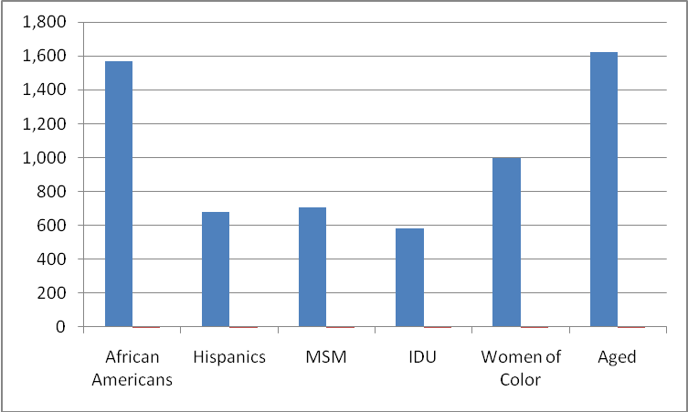

Nationally, MSM made up more than two thirds (68%) of all men living with HIV in the U.S.in 2005, even though only about 5% to 7% of men in the United States reported having sex with other men. The local epidemic among MSM in the Nassau-Suffolk EMA reflects the larger national epidemic, with 29% of the local PLWH/A comprised of MSM. Nationally, MSM still accounted for about 53% of all new HIV/AIDS cases and 71% of cases in male adults and adolescents in 2005. In the Nassau-Suffolk EMA, MSM made up 69% of the new cases of HIV/AIDS; 60% of the living cases of HIV and 69% of the living cases of AIDS.
FIGURE 3. HIV/AIDS CASES BY GENDER, 2007, U.S
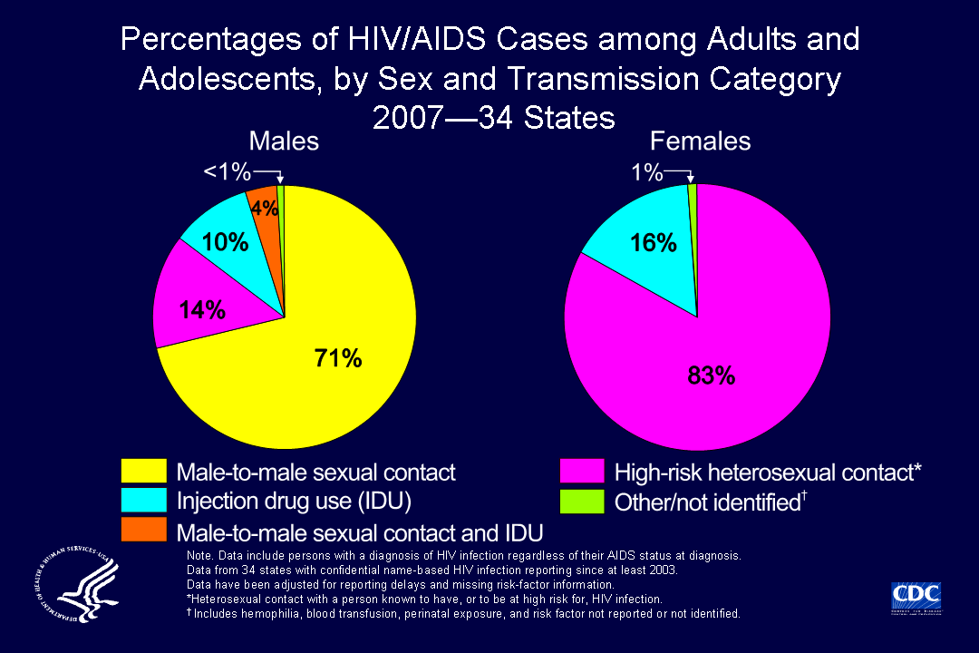
(Source: CDC, 2009)
The slide below shows the national distribution of HIV/AIDS cases among adults and adolescents diagnosed from 2004 through 2007, by transmission category, for 34 states with confidential name-based HIV infection surveillance. The percentage of HIV/AIDS cases attributed to male-to-male sexual contact increased from 48% in 2004 to 53% in 2007. HIV/AIDS cases attributed to IDU, high-risk heterosexual contact, and MSM/IDU remained stable from 2004 through 2007.
FIGURE 4. INCREASES IN HIV/AIDS CASES BY TRANSMISSION MODE, 2007, U.S
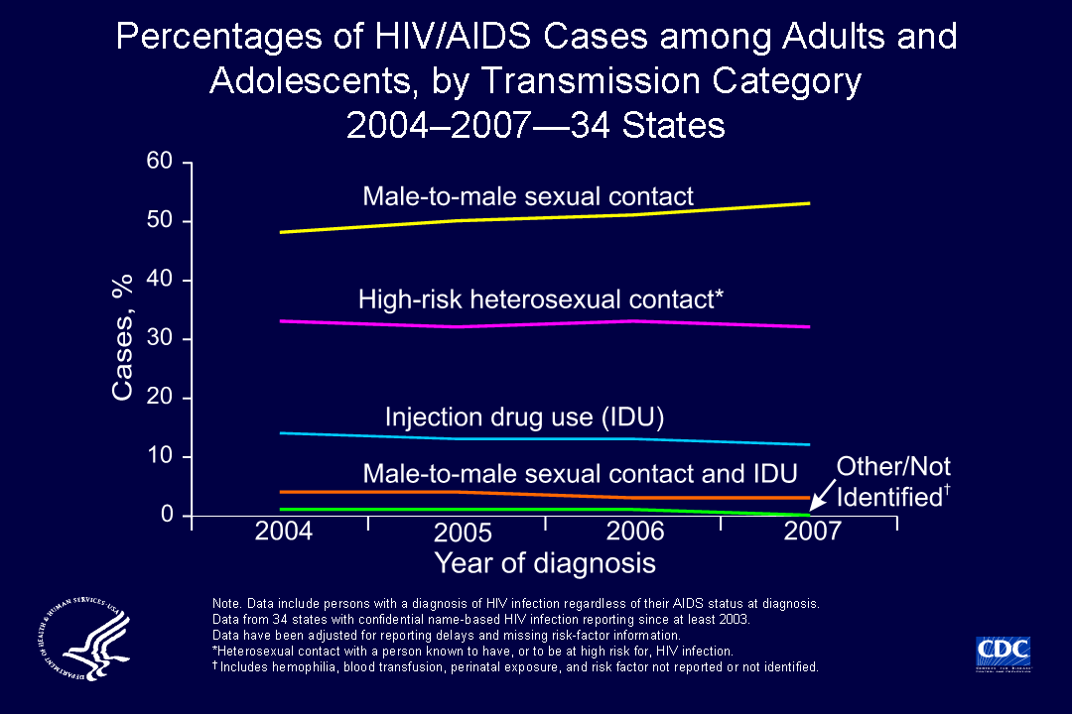
(Source: CDC, 2009)
On a national and local basis, MSM of Color are disproportionately impacted by HIV/AIDS. CDC estimates that 60% of the MSM cases in 2007 were among Men of Color. MSM of Color are heavily and disproportionately impacted by HIV/AIDS in the Nassau-Suffolk EMA, particularly African American and Hispanic males, among whom substantial proportions report MSM as a primary risk exposure mode.
TABLE 8. PORTRAIT OF GROUPS DISPROPORTIONATELY IMPACTED BY HIV/AIDS
Race/Ethnicity | Nassau County | Suffolk County | TGA HIV/AIDS (combined) population
White | 79.3% | 84.6% | 38%
African American | 10% | 7% | 39%
Hispanic | 10% | 11% | 19%
Native Indian/Alaskan | 1.6% | 2.7% | <1%
Asian/Pacific Islander | 4.8% | 6.1% | <1%
Other | 2.1% | 3.7% | 3%

FIGURE 5. MALE PLWH/A CASES BY RACE AND RISK, NASSAU-SUFFOLK, 2007
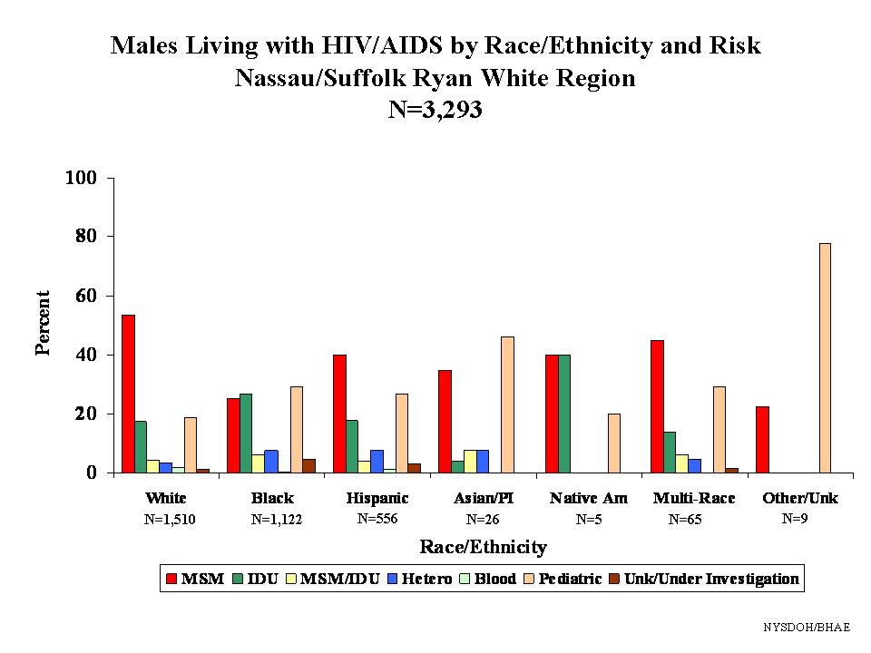
(Source: NYSDOH, Nassau-Suffolk Area Profile, 2007)

As depicted in the figure above, MSM is a leading risk for transmission among all races/ethnicities of male PLWH/A residing in the EMA. MSM risk behavior is proportionally greatest among White and Hispanic PLWH/A males, and is marginally second only to IDU among Black PLWH/A males.
Among NEW cases of HIV/AIDS in the Nassau-Suffolk EMA, the 25-49 age band is most heavily impacted and MSM is the leading known risk exposure mode, as evidenced below.

FIGURE 6. NEW HIV CASES BY AGE AND RISK, NASSAU-SUFFOLK, 2007
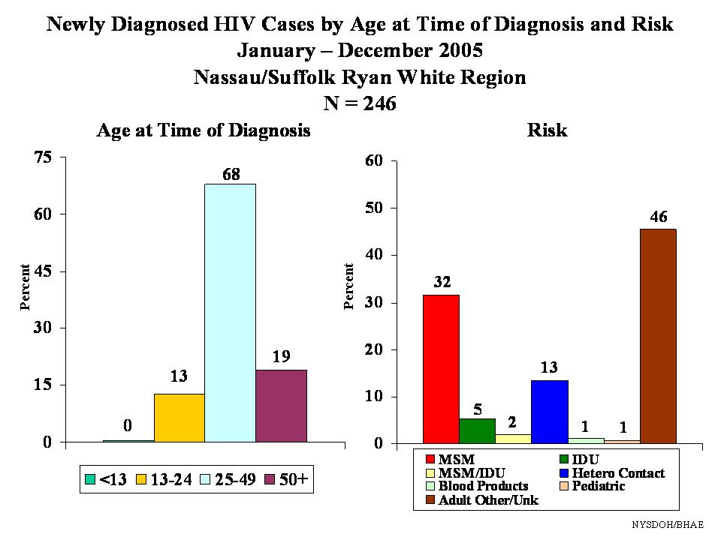

MSM generally present to care with higher rates of STDs and higher rates of co-morbidities with mental illness and substance abuse. Some studies have shown increased rates of mental health problems, such as mood disorders, among the MSM population. The use of alcohol and illicit drugs remains prevalent among this population, leading to an increase in risky sexual behaviors.
With the introduction of highly active antiretroviral therapies (HAART), the MSM population is living longer. Some MSM are under the misconception that HAART can prevent their partners from becoming infected with HIV. In light that many MSM remain sexually active after learning of their HIV diagnosis, prevention education and counseling are essential, especially when developing ‘prevention for positives’ campaigns.
Like many racial and ethnic minorities, minority MSM often face poor access to health care because of lack of health insurance and poverty. In addition, MSM must cope with many types of stigma—related to racial/ethnic minority, sexual orientation, and HIV positivity. MSM of color may fear condemnation from their families, communities, and service providers. (NASTAD, Black MSM Issue Brief #3, 2008) Young MSM of Color are particularly impacted and substantially marginalized. Gay/MSM youth may engage in potentially destructive behavior. Men in rural areas are especially prone to experiencing isolation, which may have harmful effects on mental health. Older men may face specific kinds of isolation and challenges to their mental health, as the gay/MSM culture emphasizes youth. Among HIV positive men of any age or geographic area, the stigma of infection compounds co-existing isolation, depression, anxiety, and fears of disclosure and rejection. (Report on Gay Men’s/MSM Forum: Prescription for Change, NYSDOH, AIDS Institute, December, 2006)

Chapter 2: 2009 MSM Needs Assessment Survey Findings

The main objective of the 2009 MSM ‘In Care’ Needs Assessment process was to provide the data necessary to inform decisions relating to the Nassau-Suffolk EMA’s prioritization of care services for the Ryan White Part A funding allocation process. Additional goals of the project were to:
- Assess the current continuum of care and to determine, what, if any health care disparities exist with the area’s continuum of care for MSM;
- Assess what service gaps and barriers exist for those MSM PLWH/A who know their status and are accessing primary medical care (In Care Need);
- Provide legislatively mandated information to the federal Health Resources Services Administration (HRSA) on service needs and system response; and
- Provide planning information for agencies, organizations, and health care providers.

The 2009 MSM HIV/AIDS Needs Assessment provides a current “appraisal” of the MSM PLWH/A community service needs, usage, barriers, and gaps as expressed by consumers currently accessing HIV related services in the Nassau-Suffolk EMA. The target sample goal of the ‘In Care’ MSM survey process was to achieve a 15% participation rate by the ‘In Primary Care/In System’ clients (N=706), hereafter referred to as ‘‘In Care’’ MSM population (N=106). The actual ‘In Care’ participation rate was slightly higher (N=117).

This level of participation represents an adequate sample size from which to generalize the survey findings to the larger population of MSM receiving care and services in the EMA. The Nassau-Suffolk EMA survey process was implemented by Collaborative Research. The survey sites consisted of the Ryan White funded service provider agencies in order to access those persons currently receiving RW funded services and to ensure a minimum of duplication among survey participants. MSM survey respondents (both in-person and telephone participants) received a $10 gift card for participating in the ‘In Care’ survey process.

‘‘In Care’’ MSM Survey Results

The ‘‘In Care’’ client surveys were scheduled during the spring of 2009, with 117 total surveys completed. The demographic and health profiles for the ‘In Care’ MSM Survey Sample follow.

Demographic and Health Profile of ‘‘In Care’’ MSM Survey Respondents:

TABLE 9. RACE/ETHNICITY OF MSM RESPONDENTS
Do you consider yourself?
Answer Options | Frequency | Count
African American | 20.5% | 24
American Indian | 2.6% | 3
Asian/Pacific Islander | 2.6% | 3
Caucasian | 46.2% | 54
Hispanic/Latino | 28.2% | 33
answered question |  | 117
TABLE 10. AGE RANGE OF MSM RESPONDENTS
What year were you born?
Answer Options | Frequency | Count
13-24 years | 3% | 3
25-34 years | 15% | 18
35-44 years | 21% | 24
45-54 years | 46% | 54
55-64 years | 15% | 18
65+ | 0% | 0
answered question |  | 117

Almost half of the MSM respondent group (46%) reports their age between 45 and 54 years. Over 60% report their age in the 45+ age range, reflective of the high proportion of the aged PLWH/A population in the EMA. Thirty-six percent (36%) reports their age in the range of 25-44 years. Only 3% and 15% of this respondent group reports their ages in the 13-24 and 55-64 age range, respectively. None of the respondents reported their age as 65+.

TABLE 11. SEXUAL ORIENTATION OF MSM RESPONDENTS
What is your sexual orientation?
Answer Options | Frequency | Count
Gay | 66.7% | 78
Bisexual | 20.5% | 24
Straight | 7.7% | 9
Prefer not to Answer | 2.6% | 3
Other (please specify): 1 answered ‘Transgender’ | 2.6% | 3
answered question |  | 117

As evidenced in the table above, two thirds of this MSM respondent group of PLWH/A reports their sexual orientation as ‘gay’; almost 21% reports bisexuality; and almost 8% reports a heterosexual orientation. One MSM reported Transgender for sexual orientation.

As depicted in the table below, some members of the MSM respondent group report more than one mode of transmission. The vast majority of the MSM respondent group reported their risk exposure mode as MSM (95%); another 13% attributed their transmission mode to injection drug use (IDU); and almost 21% cited heterosexual sex as one of their risk exposure modes.

TABLE 12. RISK EXPOSURE MODE
Do you know how you may have acquired HIV/AIDS? (All that apply)?
Answer Options | Frequency | Count
Male sex w/male | 94.9% | 111
Injection Drug Use | 12.8% | 15
Heterosexual Sex | 20.5% | 24
Sexual Assault | 2.6% | 3
answered question |  | 117

Residence and Living Arrangements
A total of 57 (or almost half) of the 117 ‘‘In Care’’ MSM survey participants reported their residence in one of 8 zip codes in the Nassau-Suffolk EMA. As evidenced below, the majority of the MSM respondents report their residence in the Suffolk area. A total of 28 different zip codes were reported by the 2009 MSM PLWH/A respondents. (See Table 13 below)

TABLE 13: TOP 8 ZIP CODES OF RESIDENCE
ZIP CODE | COUNTY | Number MSM Respondents
11550 | Hempstead, Nassau | 6
11706 | Bay Shore, Suffolk | 9
11717 | Brentwood, Suffolk | 7
11722 | Central Islip, Suffolk | 5
11763 | Medford, Suffolk | 9
11772 | Patchogue, Suffolk | 6
11779 | Ronkonkoma, Suffolk | 7
11946 | Hampton Bays, Suffolk | 8
TOTAL |  | 57

HIV/AIDS Status and Year of Diagnosis

Over half (51%) of the MSM respondents reports living with HIV and 46% reports living with AIDS. The range of years from initial HIV diagnosis spans from 1984 to 2008, with the majority of HIV/AIDS diagnoses having occurred since 1995. The vast majority of MSM reports receiving their HIV/IDS diagnoses in New York. Only 15 MSM PLWH/A (approximately 13% of the respondent group) report receiving their initial HIV diagnosis in a state other than New York, including California, Florida, Georgia and El Salvador.

Health Insurance Coverage

Only a fraction of the 2009 PLWH/A respondent group (approximately 8%) reports full dependence on Ryan White funded primary medical care services, reporting no other third party health care coverage. Over half (54%) of the respondents reported Medicaid benefits; another 31% reports Medicare and almost 8% reports private insurance. None of the 2009 respondents reported VA benefits. The ‘other’ benefits were reported as ADAP, HIAP or Suffolk Health Plan.

TABLE 14. CURRENT HEALTH INSURANCE COVERAGE
Do you currently have health insurance?
Answer Options | Frequency | Count
Private Health Insurance (Humana, Aetna, etc) | 7.7% | 9
Medicare | 30.8% | 36
Medicaid | 53.8% | 63
VA | 0.0% | 0
ADAP | 43.6% | 51
None | 5.1% | 6
Other (please specify) | 10.3% | 12
answered question |  | 117

Last Physician Visit and CD4 and Viral Load Monitoring Visits
As noted below, only one of the 2009 MSM PLWH/A were ‘erratically’ In Care and one PLWH/A had just returned to care from a lengthy ‘Out of Care’ status according to MSM respondent reports of their most recent HIV Primary Care Physician (PCP) visit. Overall, this ‘‘In Care’’ respondent group evidences a strong primary medical care presence, with only a technically recent ‘Out of Care’ fraction at less than 1% of the total ‘In Care’ MSM survey respondent group.

TABLE 15: PATTERN OF MOST RECENT PCP, CD4 AND VIRAL LOAD MONITORING VISITS
Visit Time  Frame | Doctor |  | CD4 |  | Viral Load
Past 3-4 Months  1/09-3/09  (Ideal ‘‘In Care’’ Status) |  | 43 |  | 43 |  | 126
Past 4-6 Months  10/08-12/08  (Satisfactory ‘‘In Care’’ Status) |  | 69 |  | 69 |  | 24
Past 7-9 Months  7/08-9/08  (Erratically ‘‘In Care’’ Status) |  | 0 |  | 0 |  | 0
Past 10-12 Months  4/08-6/08  (Erratically ‘‘In Care’’ Status-  At risk of Unmet Need) |  | 0 |  | 1 |  | 1
TOTAL ‘‘In Care’’ |  | 112 |  | 113 |  | 113
‘Out of Care’ > One Year  (OOC Since 2007 or before) |  | 1-just re-entered |  | 1- just re-entered |  | 1- just re-entered
Did not answer |  | 4 |  | 3 |  | 3
TOTAL ‘Out of Care’ |  | 0 |  | 0 |  | 0
GRAND TOTAL |  | 117 |  | 117 |  | 117

The HIV clinics and primary care physicians most frequently reported by the 2009 ‘In Care’ MSM respondent group are indicated below. Almost equal proportions of the MSM respondent group report the receipt of their HIV primary medical care at Stony Brook and North Shore Clinics (31% and 28%, respectively). Approximately 10% reports accessing HIV primary medical care services through Nassau University Medical Center. ‘Other’ HIV primary care clinics reported by this MSM respondent group included Brentwood Health Center, David E. Rogers Center, Patchogue Clinic, South Brookhaven, and a private doctor.

TABLE 16. CLINIC/DOCTOR LOCATION
What clinic/doctor’s office do you go to for your HIV?
Answer Options | Frequency | Count
SUNY-Stony Brook | 30.8% | 36
North Shore | 28.2% | 33
Nassau University Medical Center (NUMC) | 10.3% | 12
Other (please specify) | 30.8% | 36
answered question |  | 117
The majority of the 2009 MSM respondents’ report the location of their HIV primary care physician in Suffolk County (62%), then Nassau County (36%), with only three respondents reporting New York City as the location of their primary care physician.

TABLE 17. COUNTY LOCATION OF PCP
In what County is this doctor located?
Answer Options | Frequency | Count
Nassau | 35.9% | 42
Suffolk | 61.5% | 72
New York City | 2.6% | 3
Other (please specify) | 0.0% | 0
answered question |  | 117

Current Antiretroviral Therapy

TABLE 18. CURRENT ART
Are you currently taking ART (HIV) medications?
Answer Options | Frequency | Count
Yes | 94.9% | 111
No | 5.1% | 6
Don’t know | 0.0% | 0
answered question |  | 117

Almost 95% of the 2009 ‘‘In Care’’ MSM sample of survey respondents reports current antiretroviral therapy.

History of Mental Illness

TABLE 19. HISTORY OF DIAGNOSIS/TREATMENT FOR MENTAL ILLNESS
Have you ever been diagnosed with or treated for a mental illness?
Answer Options | Frequency | Count
Yes | 46.2% | 54
No | 53.8% | 63
answered question |  | 117

Forty six percent (46%) of the entire MSM respondent group reports having previously been diagnosed or treated for mental illness. As evidenced below, over half (51%) of the MSM respondents reports previous treatment for a substance abuse disorder. These high levels of mental health and substance abuse co-morbidities complicate entry and retention in care.

History of Substance Abuse

TABLE 20. DIAGNOSIS OF OR TREATMENT FOR SUBSTANCE ABUSE DISORDER
Have you ever been diagnosed with or treated for substance abuse?
Answer Options | Frequency | Count
Yes | 51.3% | 60
No | 48.7% | 57
answered question |  | 117

History of Diagnosis and/or Treatment for STDs and Diseases Other than HIV

As evidenced in the tables below, almost 40% of the MSM PLWH/A reports the previous diagnosis and/or treatment for STDs other than HIV, and 64% reports diagnosis and/or treatment for other chronic illness, indicating a higher cost of care ratio among many ‘In Care’ MSM in the EMA.

TABLE 21. DIAGNOSIS AND TREATMENT OF STDS
Have you ever been diagnosed with or treated for sexually transmitted diseases (STD)?
Answer Options | Frequency | Count
Yes | 39.5% | 45
No | 60.5% | 69
answered question |  | 114

TABLE 22. DIAGNOSIS AND TREATMENT OF DISEASES OTHER THAN HIV
Have you ever been diagnosed with or treated for diseases other than HIV?
Answer Options | Frequency | Count
Yes | 64.1% | 75
No | 35.9% | 42
answered question |  | 117

History of Homelessness

TABLE 23. CURRENT OR PREVIOUS HOMELESSNESS
Are you now or have you ever been homeless?
Answer Options | Frequency | Count
Never | 60.5% | 69
Currently homeless | 5.3% | 6
Been homeless in past 2 years, but not now | 5.3% | 6
Been homeless longer than past 2 years, not now | 28.9% | 33
answered question |  | 114

As evidenced by the table above, a total of almost 40% of the 2009 ‘In Care’ MSM respondent group reports being currently or previously homeless. This finding indicates a high level of housing instability among the MSM PLWH/A population in the EMA, and supports the finding that housing assistance is viewed as a top priority service need.

Current Living Arrangements

As evidenced in Table 24 below, 20% of the entire 2009 ‘In Care’ MSM survey participants are currently homeless and/or report they are temporarily housed (living with a friend or relative) and therefore may be at current risk for homelessness. When this indirect indicator of housing instability is combined with the reports of actual reported current and previous homelessness (40%) by the 2009 ‘In Care’ MSM respondents, the proportion of the PLWH/A residing in the Nassau-Suffolk service delivery area who are at risk for impending homelessness increases to an astounding 55% of the entire respondent group, indicative of substantial challenge in facilitating entry, engagement and retention in primary medical care for this marginalized group of PLWH/A. Approximately 28% of this MSM survey respondent group reports the current receipt of some form of rental assistance.

TABLE 24. CURRENT LIVING ARRANGEMENTS/PLACE OF RESIDENCE
Do you currently?
Answer Options | Frequency | Count
Own your home | 10.3% | 12
Rent | 69.2% | 81
Live with a Friend/Relative | 15.4% | 18
Stay in a Homeless Shelter | 2.6% | 3
Other (please specify); Transitional housing; Sober Living residence | 2.6% | 3
answered question |  | 117

Recent Jail or Prison Stay

Only 5% of the MSM PLWH/A survey participants reported a recent jail or prison stay in the past six months.

TABLE 25. INCARCERATION OVER PAST 6 MONTHS
Have you been in jail or prison in the past 6 months?
Answer Options | Frequency | Count
Yes | 5.3% | 6
No | 94.7% | 108
answered question |  | 111

Employment, Education and Income Levels

TABLE 26. CURRENT EMPLOYMENT STATUS
Are you currently employed?
Answer Options | Frequency | Count
Yes | 30.8% | 36
No | 69.2% | 81
answered question |  | 117

Almost 1/3 of the 2009 MSM PLWH/A survey participants (31%) reports active current employment.

As evidenced by the table on the following page, the educational levels of the 2009 MSM PLWH/A vary widely, and skew to the lower levels, with approximately 44% reporting a high school diploma or only some high school or grade school education or less. Almost 18% report some college level education. Almost 31% report a college degree and almost 8% report some graduate level education or a graduate level degree.

TABLE 27. HIGHEST LEVEL OF EDUCATION
What is your highest level of education?
Answer Options | Frequency | Count
Grade school | 2.6% | 3
Some high school | 20.5% | 24
High School degree/GED | 20.5% | 24
Some college | 17.9% | 21
College degree | 30.8% | 36
Some graduate school | 5.1% | 6
Graduate school degree | 2.6% | 3
answered question |  | 117

As indicated in the table below, the MSM survey respondents report low levels of income, overall, with the vast majority reporting incomes at or below 250% of the federal poverty level. This finding correlates with the high numbers of persons reporting the receipt of indigent health care benefits, including Medicaid and other state assistance. Reported levels of current income reflect an impoverished group of PLWH/A, overall.

TABLE 28. ANNUAL INCOME LEVEL
What is your approximate yearly income?
Answer Options | Frequency | Count
$0-$9,999 | 55.3% | 63
$10,000 - $19,999 | 26.3% | 30
$20,000-$29,999 | 5.3% | 6
$30,000 - $30,999 | 2.6% | 3
$40,000-$49,999 | 5.3% | 6
Over $50,000 | 5.3% | 6
answered question |  | 114

‘2009 ‘In Care’ MSM Needs Assessment Survey Results

The ‘‘In Care’’ MSM Needs Assessment Survey results are discussed in order by the frequency and rankings of expressed service needs, service usage, service gaps and service barriers based upon the following definitions:

NEED | Number of ‘‘In Care’’ client survey respondents who stated “I currently need this service.”
USE | Number of ‘‘In Care’’ client survey respondents who indicated service use in the past year
BARRIER | Number of ‘‘In Care’’ client survey respondents who indicated that a needed service is ‘Hard to Get’.
GAP | Sum of ‘‘In Care’’ client survey respondents who indicated a needed service is unavailable (“Cannot get”)

2009 MSM PLWH/A Service Need, Use, Gap, and Barrier Matrix

TABLE 29: 2009 ‘In Care’ MSM NEED, USE, GAP, & BARRIER MATRIX
SERVICE CATEGORY | Need  Rank | Use  Rank | Gap  Rank | Barrier  Rank
Primary Medical Care | 1 | 1 | NR | 5 tie
Medications | 2 | 3 tie | NR | 5 tie (non-HIV meds)
Food Bank/Nutrition | 3 | 7 tie | 3 tie | 3 tie
Housing Assistance | 4 tie | NR | 1 | 2
Mental Health Counseling | 4 tie | 3 tie | 5 tie | 6
Medical Transportation | 5 tie | 4 | 2 | 1
Emergency Financial Assistance | 5 tie | 6 tie | 5 tie | 4 tie
Psychosocial Support | 6 | 5 tie | 4 tie | 5 tie
Health Insurance/Co-pay Assistance | 7 tie | 7 tie | 4 tie | 5 tie
Oral Health Care | 7 tie | 5 tie | NR | 3 tie
Substance Abuse Counseling | 7 tie | 8 | NR | NR
Employment Assistance | 8 | NR | 3 tie | 4 tie
Case Management | 9 tie | 2 | NR | NR
Legal Services | 9 tie | NR | 5 tie | NR
Vision Care | 9 tie | 9 | NR | NR
Health Information (Information about services) | 9 tie | NR | 5 tie | 5 tie
Social Services (public assistance/food stamps) | NR | 6 tie | NR | NR
Medical and Psychosocial Services availability in evenings | NR | NR | 4 tie | 5 tie
Interpreter Services | NR | NR | 5 tie | NR
Medical Specialty Services | NR | NR | NR | 5 tie

Top Ranking MSM PLWH/A Service Needs

1. Primary Medical Care
2. Medications
3. Food bank/Nutrition Services
4. Housing Assistance tied with Mental Health Counseling
5. Medical Transportation tied with Emergency Financial Assistance
6. Psychosocial Support
7. Health Insurance/Co-pay Assistance tied with Oral Health Care and Substance Abuse Counseling
8. Employment Assistance
9. Case Management tied with Legal Services, Vision Care and Health Information (primarily the need for more orientation to/information about services available)
Top Ranking MSM PLWH/A Service Uses

1. Primary Medical Care
2. Case Management
3. Medications tied with Mental Health Counseling
4. Medical Transportation
5. Psychosocial Support tied with Oral Health Care
6. Emergency Financial Assistance tied with Social Services benefits (Public assistance/Food stamps)
7. Food Bank Services tied with Health Insurance/Co-pay Assistance

Top Ranking MSM PLWH/A Service Gaps

1. Housing Assistance
2. Medical Transportation
3. Food Bank/Nutrition Services tied with Employment Assistance
4. Psychosocial Support tied with Health Insurance/Co-pay Assistance tied with ‘lack of availability of extended/evening hours for services’
5. Mental Health Counseling tied with Emergency Financial Assistance, Legal Services, Health Information (primarily information about services available), and Interpreter Services

2009 MSM PLWH/A Reasons for Service Gaps

MSM PLWH/A Reasons for Service Gaps
Frustration creates anxiety which no one with HIV needs. I face obstacles all the time. I am frustrated by the lack of quality of services at LIACC especially.
Rents are too high for me to get - don't have enough in my check
Too many cut backs – Need help with food, rent, but cannot get due to RW cut backs
I am out of town area - RW is too far. I have to travel to medical and RW.
No Spanish person - only speak English because the service helps me - need more
I do not qualify
No papers-cannot return to Country so stay here illegally and stay sick
Services not available in evenings
Just out of jail and trying to tap into services
Low orientation to services available
In school and need extra help
Medicaid is a terrible system

TABLE 30. 2009 MSM PLWH/A SERVICE-SPECIFIC GAP REASONS
SERVICE CATEGORY | Need  Rank |  | Gap  Rank | Gap Reasons
Primary Medical Care | 1 | NR |  | It would be great to have a clinic with access to general health care—a clinic that can deal with everything. Clinic hours 9-5 and I work downtown Manhattan—it is difficult to get to clinic. No evening hours.
Medications | 2 | NR |  | NA
Food Bank/Nutrition | 3 | 3 tie |  | Can’t get food stamps. Hard to get food, especially healthy foods. Meals on Wheels can be difficult to get. Sometimes there aren’t certificates as in the past and there is a limited food pantry in this area. Living in a shelter everyone can take your food.
Housing Assistance | 4 tie | 1 |  | Everyday things like food and shelter hard to get. Hard to obtain rent assistance. It is harder to get housing assistance in N/S than it was in NYC. Tried HAASA but was denied because I was considered too healthy. Sometimes I need help paying my rent.
Mental Health Counseling | 4 tie | 5 tie |  | Hard to get connected with psychologist.
Medical Transportation | 5 tie | 2 |  | Buses do not run late or on Sunday. Only get one ride and if I go to Doctor and get prescription/have to go to pharmacy, I only get one ride. Have to schedule ride 3 days in advance, and do not always know. Anything I need I have to travel 45-60 minutes and longer. Gas is so expensive and I live hand to mouth, month to month.
Emergency Financial Assistance | 5 tie | 5 tie |  | It gets tough stretching till the end of the month.
Psychosocial Support | 6 | 4 tie |  | It is hard coping with all my illnesses—need companionship and support from family and friends. Need connection to support. It is hard to participate in group—no evening hours for working people. I live in the suburbs so support and services can be harder to get, especially with the difficult transportation issues. Lack of evening resources.
Health Insurance/Co-pay Assistance | 7 tie | 4 tie |  | Getting on to health insurance is my biggest issue. Need help transitioning from employment to disability. Am having a lot of problems with Medicaid.
Oral Health Care | 7 tie | NR |  | Really having a hard time getting adequate dental care. Only pay certain amount.
Substance Abuse Counseling | 7 tie | NR |  | NA
Employment Assistance | 8 | 3 tie |  | Need employment assistance—the business I work for is going out of business. There are limits on the work I can do. Need a steady job.
Case Management | 9 tie | NR |  | NA
Legal Services | 9 tie | 5 tie |  | Hard to get papers/illegal immigrant.
Vision Care | 9 tie | NR |  | Optical care is hard to get and pay for—I am legally blind due to CMV.
Health Information (Information about services) | 9 tie | 5 tie |  | Need more information about HIV and services available.
Medical and Psychosocial Services availability in evenings | NR | 4 tie |  | Lack of resources/services in the evening hours for working people
Interpreter Services | NR | 5 tie |  | Lack of interpreter services in primary care and other service settings.

Top Ranking MSM PLWH/A Service Barriers

1. Medical Transportation
2. Housing Assistance
3. Food Bank Services tied with Oral Health Care
4. Emergency Financial Assistance and Employment Assistance
5. Primary Medical Care tied with Medications, Psychosocial Support, Health Insurance/Co-pay Assistance, Health Information (primarily information about services available), Lack of available Medical and Support Services in Evening/Extended Hours, and Medical Specialty Services

2009 MSM PLWH/A Service Barrier Reasons

MSM PLWH/A Reasons for Service Barriers
Too many restrictions
I guess the funds. Lots of cuts. RW cut back like emergency rent - sometimes I have to pay for meds out of pocket like over the counter and dental.
Too many documents and days trying to get help. Grants taken away like Thursdays Child - grant is gone.
More services in the city - to get services, travel worthwhile. With ACC was good resource early on.
Ineffective listening to client, I have been told due to cutbacks, and I also think a lack of communication, lack of efficiency, incompetence of workers. Workers inexperienced using service providers as stepping stones.
The grant amounts don't cover enough - you have to have extra money yourself
Basically hard to meet all the requirements - not enough extra monies - transportation is awkward and crazy with schedules
Cut backs
Because that is how Suffolk County is and it is getting worse.
With all the cutbacks, there is not much to offer me out there.
Sometimes I do not qualify
Because I'm illegal, don't have permission to work, difficult without work
Now, I don't have problems getting these services because I received help through the Hispanic C. Center in Bay shore.
Transportation can be a problem, but I have a car, I'm lucky.
The service I need, root canal, very expensive and not covered
Waiting for my (INS) papers
Program only allows certain areas

CHAPTER 3: Recommendations for Comprehensive Strategic Plan

Special Strategies Directed toward Optimizing Access and Retention in Care

In response to the MSM ‘In Care’ needs assessment study findings, the following general recommended strategies may be employed by the Nassau-Suffolk HIV Health Services Planning Council to further strengthen the service delivery system for the multiple subpopulations of MSM in the Nassau-Suffolk EMA:

1) Ensure that an up-to-date and comprehensive Ryan White Service Guide is provided to newly entering PLWH/A, to facilitate knowledge of how to access and maximally use all available services in the EMA.
2) Ensure ‘point of entry’ agency and staff awareness of all available Ryan White and other resources to ensure timely referrals and linkages with care and services for newly diagnosed and out of care PLWH/A.
3) Ensure Medical and Social Case Management provider awareness and use of all Ryan White and other local funding sources available for meeting the comprehensive service needs expressed by MSM PLWH/A.
4) Ensure consistent mental health and substance abuse screenings of MSM PLWH/A on Intake and aggressively refer those who evidence anxiety, depression and/or other mental health/substance abuse co-morbidities, (which contribute to care deterrence and erratic or fragile care status), and ensure strong linking mechanisms and co-locate to the extent possible increased levels of on-site Mental Health and Substance Abuse treatment services to address the high degree of these co-morbid conditions within the MSM PLWH/A population.
5) Strengthen the “youth friendly” and “minority friendly” provider settings to encourage engagement and retention in care for the MSM subpopulations of men of color and young PLWH/A.
6) Strengthen ‘prevention with positives’ with individualized and targeted programs and activities to reduce the high STD co-morbidities and reduce further HIV transmission among all ages and races/ethnicities of MSM PLWH/A in the EMA.
7) Increase client linkages to care by assessing and addressing needs upon entry to care; targeting those deemed at high risk for erratic care use and/or disengagement from care; and strongly engaging them in care during the first year of primary medical care participation.
8) Consider the expanded use of Peer Advocates matched to and which target the MSM subpopulations of PLWH/A, in order to provide guidance in navigating the systems of care in the EMA, to provide ongoing social support, and continuous support for treatment adherence.
9) Expand/seek additional funding to support the unmet transportation, housing, medical transportation, food, employment assistance, health insurance, mental health counseling and social support, EFA, legal and interpreter assistance, and other service needs reported as Gaps by the surveyed MSM PLWH/A.
10) Ensure optimal collaboration among core medical and supportive services providers, co-locating to the extent possible all priority services to meet the expressed needs of MSM PLWH/A.
11) Market the benefits of treatment and availability of simpler and improved treatment regimens.
12) Increase to the extent possible more after-hours/evening availability of primary medical care and support services.
13) Strive to reduce the stigma surrounding HIV disease in the service area. HIV-related stigma acts as a barrier to testing and care among MSM and prevents disclosure of HIV status, which acts as a serious impediment to preventing/reducing further transmission of HIV disease among MSM of all ages and races/ethnicities in the service area.

II. Address the Service Gaps Expressed by MSM PLWH/A

The Top Ranking Service Gaps for MSM PLWH/A include:

1. Housing Assistance
2. Medical Transportation
3. Food Bank/Nutrition Services tied with Employment Assistance
4. Psychosocial Support tied with Health Insurance/Co-pay Assistance tied with ‘lack of availability of extended/evening hours for services’
5. Mental Health Counseling tied with Emergency Financial Assistance, Legal Services, Health Information (primarily information about services available), and Interpreter Services

III. Address the Service Barriers Expressed by MSM PLWH/A

The Top Ranking Service Barriers for MSM PLWH/A include:

1. Medical Transportation
2. Housing Assistance
3. Food Bank Services tied with Oral Health Care
4. Emergency Financial Assistance and Employment Assistance
5. Primary Medical Care tied with Medications, Psychosocial Support, Health Insurance/Co-pay Assistance, Health Information (primarily information about services available), ‘lack of available Medical and Support Services in evenings/extended hours’, and Medical Specialty Services

APPENDIX
‘In Care’ Survey Instrument

This survey is confidential, not anonymous. Individual responses will not be shared. The information you provide will be used to provide overall trend information. If you have any questions, please ask the survey facilitator.

1. What is your date of birth?

2. What is your Zip Code? __________________
3. Are you HIV positive or has your HIV progressed to AIDS? □ HIV □ AIDS □ Don’t Know

4. What Year were you diagnosed with HIV:____ ____ ____ ____ □ unknown

5. What Year were you diagnosed with AIDS:____ ____ ____ □ unknown

6. Do you know how you may have acquired HIV/AIDS? (please check all that apply)

□ Male sex w/male □ Injection Drug Use □ Health Care Worker
□ Female sex w/female □ Sex with Drug User □ Mother w/HIV/AIDS
□ Heterosexual Sex □ Sexual Assault □ Unknown
□ Prison □ Transfusion □ Other

7. Do you currently have health insurance?
□ Private Health Insurance (Humana, Aetna, etc) □ Medicare □ Medicaid □ VA □ None
□ Other

8. When was the last time you saw a doctor to treat your HIV?_____________________
Month, Year

9. When was the last time you had a CD4 (T-cell) Count? __________________________
Month, Year

10. When was the last time you had a Viral Load test?_____________________________
Month, Year

11. Are you currently taking ART (HIV) medications? □ Yes □ No □ Don’t know
12. Have you ever been diagnosed with or treated for a mental illness? □ Yes □ No

13. Have you ever been diagnosed with or treated for substance abuse?□ Yes □ No

14. Have you ever been diagnosed with or treated for sexually transmitted diseases (STD)?
□ Yes □ No □ Don’t know □ RTA

15. Have you ever been diagnosed with or treated for diseases other than HIV?
□ Yes □ No □ Don’t know □ RTA

16. Are you now or have you ever been homeless? □ Never □ Currently homeless
□ Been homeless in past 2 years, but not now
□ Been homeless longer than past 2 years, but not now

17. Do you currently? □ Own your home □ Rent □ Live with a Friend/Relative □ Stay in a Shelter
□ Other _______________________________________________

18. Do you get help with your rent? □ Yes □ No

19. Are you currently employed? □ Yes □ No

20. What is your approximate yearly income? □ $0-$9,999 □ $10,000 - $19,999 □ $20,000-$29,999
□ $30,000 - $30,999 □ $40,000-$49,999 □ Over $50,000
21. What is your highest level of education? □ Grade school □ Some high school □ High School degree/GED
□ Some college □ College degree □ Some graduate school □ Graduate school degree

22. What is your sexual orientation? □ Gay □ Bisexual □ Straight □ Prefer not to Answer □ Other
23. Have you been in jail or prison in the past 6 months? □ Yes □ No

24. In what city and state were you FIRST diagnosed with HIV or AIDS?
city and state

25. Are you? □ Male □ Female □ Transgender □ Other _________________

29. Do you consider yourself? □ African American □ American Indian □ Asian/Pacific Islander
□ Caucasian □ Hispanic/Latino □ Multi-Racial
□ Other_______________________________

30. Who is your HIV Doctor?

31. What clinic/doctor’s office do you go to for your HIV?
□ SUNY-Stonybrook □ Northshore
□ Nassau University Medical Center (NUMC) □ VA
□ Health Unit (Prison) □ Other_______________________________

32) Need: As a person living with HIV/AIDS, what are the 5 most important needs?
1.
2.
3.
4.
5.

- Use: List the top 5 services that you use to stay in care for HIV
1.
2.
3.
4.
5.

- Barrier: List the top 5 services that you need for HIV that are hard to get
1.
2.
3.
4.
5.

- Why are these services hard to get?

- List the top 5 services that you need for HIV that you can’t get
1.
2.
3.
4.
5.

- Why can’t you get these services?

Thank you for your time in completing this survey. Your confidential responses will be valuable information for the Nassau/Suffolk HIV Planning Council. If you would like information on how to participate with the Nassau/Suffolk HIV Planning Council, please ask the survey facilitator.

? 1) CD4 – CD4 (T4) or CD4 + CELL COUNT and PERCENT. 2) VIRAL LOAD TEST - Test that measures the quantity of HIV RNA in the blood. 3) ANTIRETROVIRAL DRUGS - Substances used to interfere with replication or inhibit the multiplication of retroviruses such as HIV. .

