Media Kit
Un-X Media Announces the Release of Family Secrets

Kansas City, Missouri, June 30, 2017

Un-X Media is proud to offer the debut work from Jean Walker, Family Secrets, hitting online bookstores everywhere today.
Family Secrets is an intriguing and true account of the strange paranormal events that Jean M. Walker and her family have experienced throughout their lives. Jean, a retired science teacher and UFO investigator living in a suburb of Kansas City, Missouri, has now bravely come forward to share her strange, often frightening, sometimes delightful, yet unexplainable encounters.
Jean’s encounters include everything from aliens and UFOs to portals, fairies, bigfoot, and unexplained creatures. Paranormal investigators have found much evidence when they are in proximity to Jean no matter where she goes.
The strange phenomena followed Jean and her brother and husbands from house to house, and from her hometown of Independence, Missouri, to vacation spots in other states. No matter where Jean is, the unexplained world seems to follow her.
Jean decided to put her experiences in writing to share the events with the public and others who may have had similar experiences. Jean said she did this so that other people would realize that they have not lost their mind and that these experiences are real.
Family Secrets is available at Amazon at www.amazon.com and major booksellers for $13.99. A Kindle version will be available soon.
Sample books are available upon request for bookstores and radio talk show hosts.
Media Contact: Jean M. Walker jmwblondie@hotmail.com 816-289-4884
Bookstores may purchase directly from the publisher: editor@unxmedia.com 816-833-1602 www.unxmedia.com
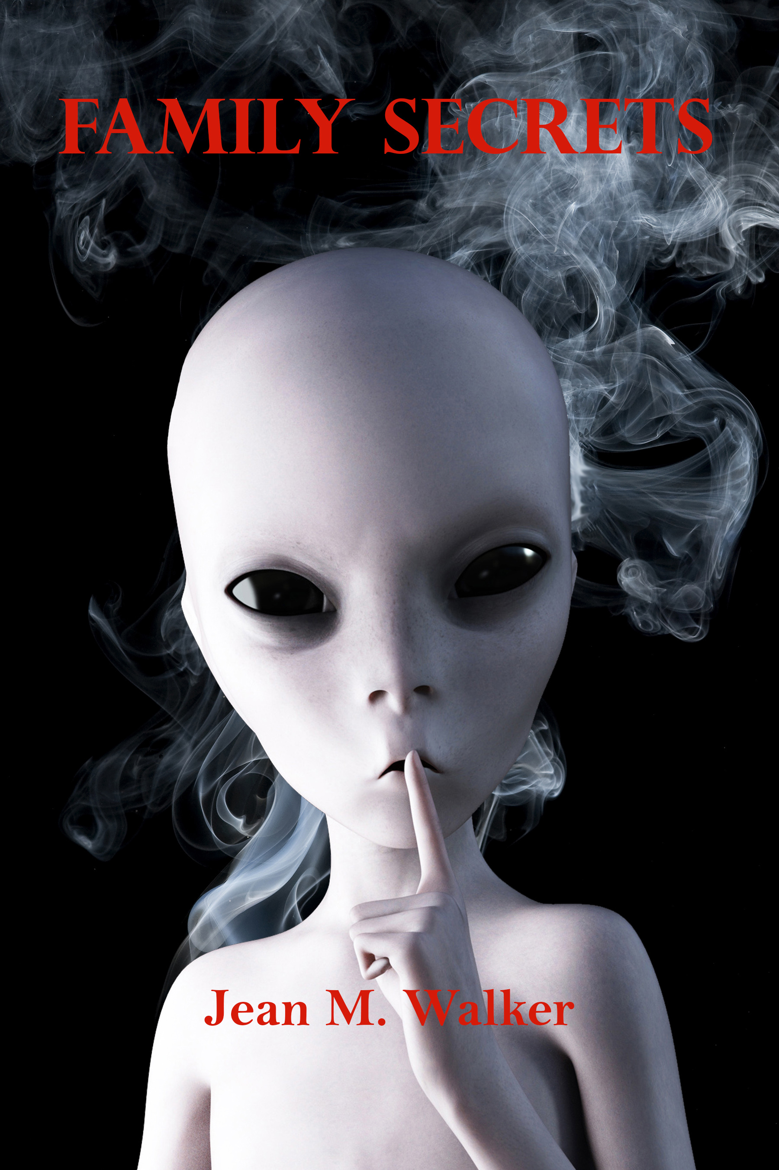
Paperback: 212 pages
Publisher: Un-X Media; 1 edition (March 26, 2017)
Language: English
ISBN-10: 0998855804
ISBN-13: 978-0998855806
Product Dimensions: 6 x 0.5 x 9 inches

About the Author
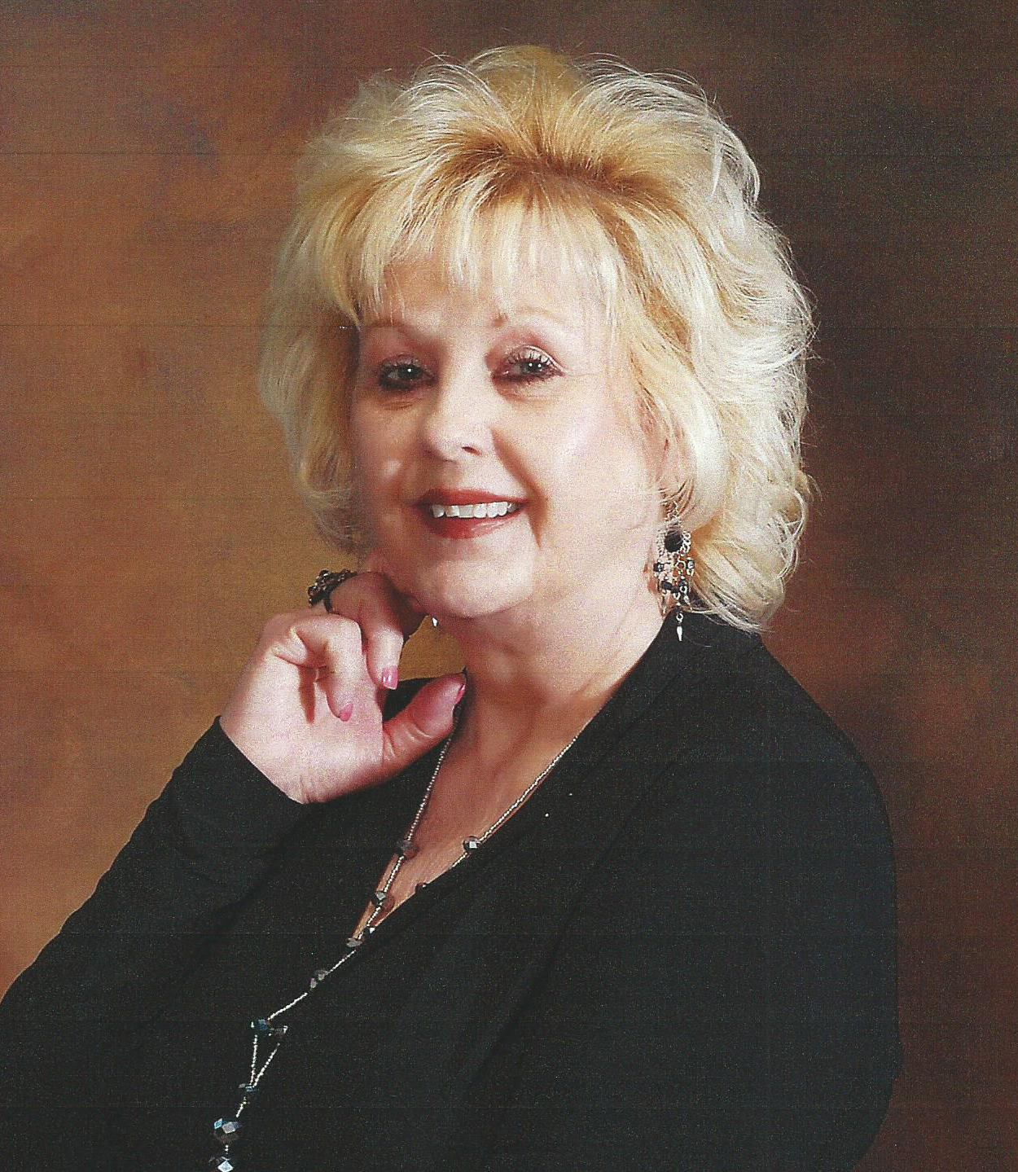
Jean Marie (Myers) Walker was born in Kansas City, Missouri where she still resides. Jean is a MUFON Star-Team Field Investigator, speaker, author, and educator. She is also Section Director and Secretary for the MUFON Kansas City Chapter and has investigated many cases in Missouri. Jean’s great grandmother was a well-known psychic in the Kansas City area, and Jean has followed through with many of her grandmother’s traits.
Jean is an educator who taught middle school Science for the Kansas City, Missouri School District. She has a BA from Central Missouri State University in Elementary Education, Middle School Certification, Science, and Language Arts. She has a Master’s in Education and Computers from Webster University in Kansas City, Missouri.
After teaching Science for almost 20 years Jean is now retired. In retirement, she finally has the time to follow up on a lifetime of strange experiences. Jean became a MUFON Field Investigator in 2011. She is working diligently trying to help find out what is going on in our universe and here on Earth. In this book, Jean has been able to put into writing many of her lifetime experiences with UFOs and alien abductions since childhood along with her brother’s experiences. She is also speaking out about many of the psychic and paranormal events taking place in her family.

Jean has been doing speaking engagements concerning her UFO investigations. She feels the need now to help to educate the public concerning what is really happening with the UFO phenomena. She is hoping to educate and help counsel others about the phenomena and the fact we are not alone!
Jean started writing a cookbook titled “Out of This World Recipes.” She also has plans to write more books and continues to educate herself in the study of UFOs. She hopes by working with MUFON and other field investigators, and by doing research in this field, she will increase her knowledge base in these areas of study.

