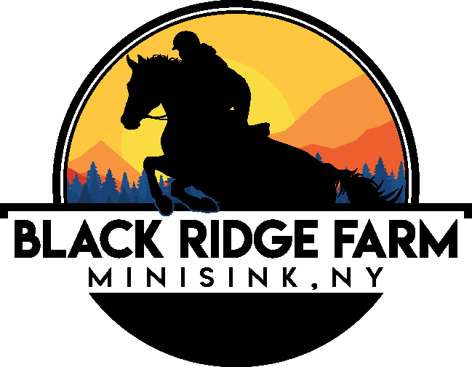
Brittany Cooper 324 Toad Pasture Road
845-741-3248 Middletown, NY 10940

2025 Horsemanship Day Camp Application

NAME ____________________________________ BIRTHDATE ___________ BOY/GIRL (Circle)

ADDRESS _______________________________________________________ ZIP ______________

PARENTS’ NAMES __________________________________________________________________

PARENTS’ PHONE __________________ (H) ___________________ (W) _________________ (C)

EMAIL ____________________________________________________________________________

IN CASE OF EMERGENCY ________________________________ PHONE __________________

DOCTOR _______________________________________________ PHONE ___________________

ALLERGIES OR MEDICAL CONDITIONS? ______________________________________________

__________________________________________ HOSPITAL ______________________________

RETURNING CAMPER _____ NEW CAMPER _____ NAME OF SIBLING ___________________

RIDING EXPERIENCE Number of Years Riding ___________ Name of previous trainer _________________________

LEVEL OF RIDING EXPERIENCE (Please check at least one) Beginner _____ Intermediate _____ Advanced _____ Showing _____

CAMP DATES AND PRICES
Camp is from 9:00 am – 3:00 pm daily for the listed weeks below. Please choose the week(s) you would like to attend below. Camp is $450 per week. Register and pay in full before May 1st and pay only $425 per week. Families registering more than one child will receive 10% off the second camper. There is a $75/week non-refundable deposit to hold your spot at the time of sign up!

__ Spring Break Camp April 15, 16, 17 ($275- special rate for all 3 days)

__ July 7 -11

__ July 14-18

__ Aug 4-8

__ Aug 11-15

Total number of weeks _____________ Price __________ Amount Enclosed _________

Early drop off is available starting at 7:30 am and Late Pick Up is available up to 5:30 pm. Please check below if you would like me to contact you in regard to different drop off and pick up times and prices. ___ I would like to set up early drop off ___ I would like to set up late pick up

SAFETY EQUIPMENT & BARN RULES
Our strong emphasis on safety requires all riders to wear boots and an ASTM-approved riding helmet. (A copy of New York State Equestrian Helmet Law is available upon request as well as posted in this facility.) You are welcome to bring your own helmet.

All clients are to abide by the rules set by Black Ridge Farm. The rules are posted around the barn and can be given out in copies as per request.

RELEASE & HOLD HARMLESS
I (We) acknowledge the risks involved in riding and working around horses, which include bodily injury from using, riding, training, or being in close proximity to horses. In addition, it is my clear understanding that both horse and rider can be injured in normal daily activities as well as during showing and competition.

I (We), do hereby agree to hold harmless and indemnify BLACK RIDGE FARM Inc., Owner Brittany Cooper and any subcontractors, trainers, or employees working for Black Ridge Farm Inc. and further release them from any liability or responsibility for accident, damage, injury, death or illness to the Undersigned or any horse owned by the Undersigned or to any family member or spectator accompanying the Undersigned on the premises of Black Ridge Farm.

Date: ______________ Parent or Guardian Signature: __________________________________

