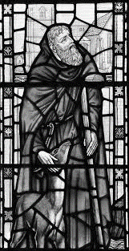

2021

St Giles with St Peter, Aintree

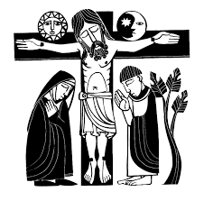
~ An Order of Service ~
Stations of the Cross

Gathering & Greeting
We gather, either beside the first station in church, or wherever the service is due to start.
We start our worship in the traditional way:
In the name of the Father, and of the Son, and of the Holy Spirit.
All Amen.
A minister, or one of the congregation, reads:
Jesus told his disciples, ‘If any want to become my followers, let them deny themselves and take up their cross and follow me. For those who want to save their life will lose it, and those who lose their life for my sake will find it.’
Matthew 16.24,25
The following prayer may be prayed:
Almighty and everlasting God,
who in your tender love towards the human race
sent your Son our Saviour Jesus Christ to take upon him our flesh and to suffer death upon the cross: grant that we may follow the example of his patience and humility, and also be made partakers of his resurrection;
through Jesus Christ your Son our Lord,
who is alive and reigns with you,
in the unity of the Holy Spirit,
one God, now and for ever. Amen.
Station 1: Jesus in agony in the Garden of Gethsemane
We adore you, O Christ, and we bless you,
All because by your holy cross you have redeemed the world.
Reading
A reading from the Gospel according to Mark.
Mark 14.32-36 is read.
A Reflection, period of meditation or quiet may follow.
Prayer
Lord Jesus, you entered the garden of fear
and faced the agony of your impending death:
be with those who share that agony
and face death unwillingly this day.
You shared our fear and knew the weakness of our humanity:
give strength and hope to the dispirited and despairing.
To you, Jesus, who sweated blood,
be honour and glory with the Father and the Holy Spirit,
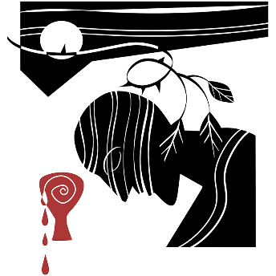
now and for ever.
All Amen.
All Holy God,
holy and strong,
holy and immortal,
have mercy upon us.
Station 2: Jesus betrayed by Judas and arrested
We adore you, O Christ, and we bless you,
All because by your holy cross you have redeemed the world.
Reading
A reading from the Gospel according to Mark.
Mark 14.43-46 is read.

A Reflection, period of meditation, or time of quiet may follow.

Prayer
Lord Jesus, you were betrayed by the kiss of a friend:
be with those who are betrayed and slandered and falsely accused.
You knew the experience of having your love
thrown back in your face for mere silver:
be with families which are torn apart by mistrust or temptation.
To you, Jesus, who offered your face to your betrayer,
be honour and glory with the Father and the Holy Spirit,
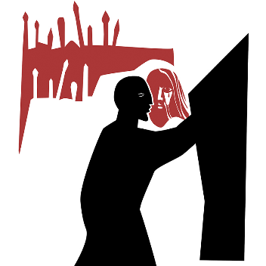
now and for ever.
All Amen.

All Holy God,
holy and strong,
holy and immortal,
have mercy upon us.
Station3: Jesus condemned by the Sanhedrin We adore you, O Christ, and we bless you,
All because by your holy cross you have redeemed the world.
Reading
A reading from the Gospel according to Mark.
Mark 14.55-64

A reflection, period of meditation, or time of quiet may follow.

Prayer
Lord Jesus, you were the victim of religious bigotry:
be with those who are persecuted by small-minded authority.
You faced the condemnation of fearful hearts:
deepen the understanding of those who shut themselves off from the
experience and wisdom of others.
To you, Jesus, unjustly judged victim,
be honour and glory with the Father and the Holy Spirit,
now and for ever.
All Amen.
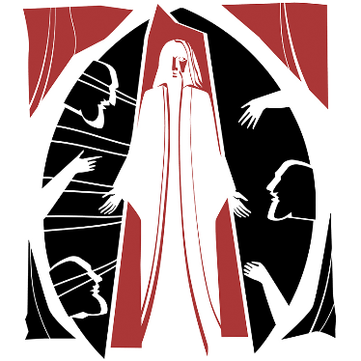
All Holy God,
holy and strong,
holy and immortal,
have mercy upon us.

Station 4: Peter denies Jesus
We adore you, O Christ, and we bless you,
All because by your holy cross you have redeemed the world.
Reading
A reading from the Gospel according to Mark.
Mark 14.72

A reflection, period of meditation, or time of quiet may follow.

Prayer
Lord Jesus, as Peter betrayed you,
you experienced the double agony of love rejected and friendship denied: be with those who know no friends and are rejected by society.
You understood the fear within Peter:
help us to understand the anxieties of those who fear for their future.
To you, Jesus, who gazed with sadness at your lost friend,
be honour and glory with the Father and the Holy Spirit,
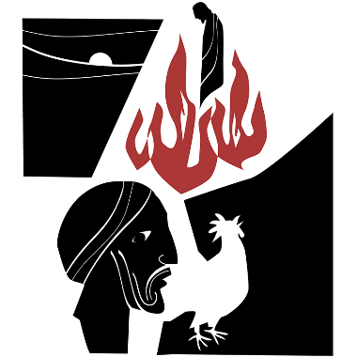
now and for ever.
All Amen.

All Holy God,
holy and strong,
holy and immortal,
have mercy upon us.

Station 5: Jesus judged by Pilate
We adore you, O Christ, and we bless you,
All because by your holy cross you have redeemed the world.

Reading
A reading from the Gospel according to Mark.
Mark 15.14,15

A reflection, period of meditation, or time of quiet may follow.

Prayer
Lord Jesus, you were condemned to death for political expediency:
be with those who are imprisoned for the convenience of the powerful.
You were the victim of unbridled injustice:
change the minds and motivations of oppressors and exploiters to your way of peace.
To you, Jesus, innocent though condemned,
be honour and glory with the Father and the Holy Spirit,
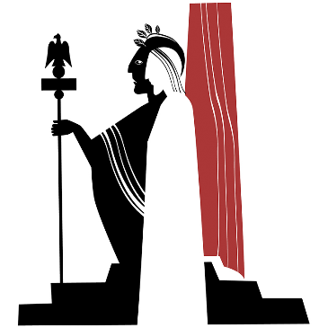
now and for ever.
All Amen.
All Holy God,
holy and strong,
holy and immortal,
have mercy upon us.
Station 6: Jesus scourged and crowned with thorns
We adore you, O Christ, and we bless you,
All because by your holy cross you have redeemed the world.

Reading
A reading from the Gospel according to Mark.
Mark 15.17-19

A reflection, period of meditation, or time of quiet may follow.

Prayer
Lord Jesus, you faced the torment of barbaric punishment and mocking tongue:
be with those who cry out in physical agony and emotional distress.
You endured unbearable abuse:
be with those who face torture and mockery in our world today.
To you, Jesus, the King crowned with thorns,
be honour and glory with the Father and the Holy Spirit,
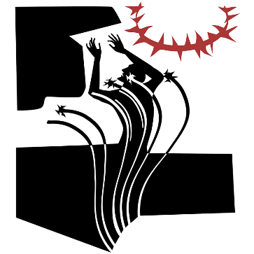
now and for ever.
All Amen.

All Holy God,
holy and strong,
holy and immortal,
have mercy upon us.
Station 7: Jesus carries the cross
We adore you, O Christ, and we bless you,
All because by your holy cross you have redeemed the world.

Reading
A reading from the Gospel according to Mark.
Mark 15.20

A reflection, period of meditation, or time of quiet may follow.

Prayer
Lord Jesus, you carried the cross through the rough streets of Jerusalem:
be with those who are loaded with burdens beyond their strength.
You bore the weight of our sins when you carried the cross:
help us to realize the extent and the cost of your love for us.
To you, Jesus, bearing a cross not your own,
be honour and glory with the Father and the Holy Spirit,
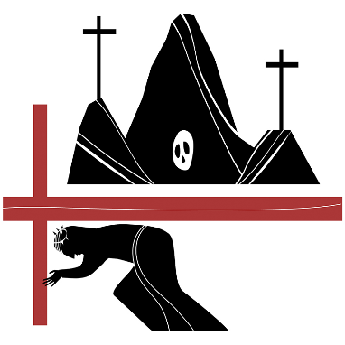
now and for ever.
All Amen.

All Holy God,
holy and strong,
holy and immortal,
have mercy upon us.
Station 8: Simon of Cyrene helps Jesus to carry the cross
We adore you, O Christ, and we bless you,
All because by your holy cross you have redeemed the world.

Reading
A reading from the Gospel according to Mark.
Mark 15.21

A reflection, period of meditation, or time of quiet may follow.

Prayer
Lord Jesus, you were worn down by fatigue:
be with those from whom life drains all energy.
You needed the help of a passing stranger:
give us the humility to receive aid from others.
To you, Jesus, weighed down with exhaustion and in need of help,
be honour and glory with the Father and the Holy Spirit,
now and for ever.

All Amen.

All Holy God,
holy and strong,
holy and immortal,
have mercy upon us.

Station 9: Jesus meets the women of Jerusalem
We adore you, O Christ, and we bless you,
All because by your holy cross you have redeemed the world.

Reading
A reading from the Gospel according to Luke.
Luke 23.27-31

A reflection, period of meditation, or time of quiet may follow.

Prayer
Lord Jesus, the women of Jerusalem wept for you:
move us to tears at the plight of the broken in our world.
You embraced the pain of Jerusalem, the ‘city of peace’:
bless Jerusalem this day and lead it to the path of profound peace.
To you, Jesus, the King of peace who wept for the city of peace,
be honour and glory with the Father and the Holy Spirit,
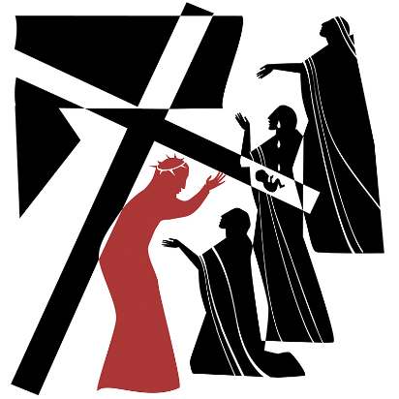
now and for ever.

All Amen.

All Holy God,
holy and strong,
holy and immortal,
have mercy upon us.
Station 10: Jesus is crucified
We adore you, O Christ, and we bless you,
All because by your holy cross you have redeemed the world.

Reading
A reading from the Gospel according to Mark.
Mark 15.24

A reflection, period of meditation, or time of quiet may follow.

Prayer
Lord Jesus, you bled in pain as the nails were driven into your flesh:
transform through the mystery of your love the pain of those who suffer.
To you, Jesus, our crucified Lord,
be honour and glory with the Father and the Holy Spirit,
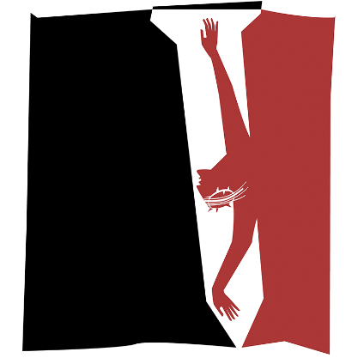
now and for ever.

All Amen.

All Holy God,
holy and strong,
holy and immortal,
have mercy upon us.

Station 11: Jesus promises the kingdom to the penitent thief

We adore you, O Christ, and we bless you,
All because by your holy cross you have redeemed the world.

Reading
Luke 23.39-43

A reflection, period of meditation, or time of quiet may follow.

Prayer
Lord Jesus, even in your deepest agony you listened to the crucified thief:
hear us as we unburden to you our deepest fears.
You spoke words of love in your hour of death:
help us to speak words of life to a dying world.
To you, Jesus, who offer hope to the hopeless,
be honour and glory with the Father and the Holy Spirit, now and for ever.
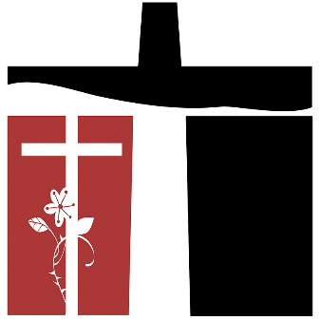
All Amen.

All Holy God,
holy and strong,
holy and immortal,
have mercy upon us.

Station 12: Jesus on the cross; his mother and his friend

We adore you, O Christ, and we bless you,
All because by your holy cross you have redeemed the world.

Reading
John 19.26,27

A reflection, period of meditation, or time of quiet may follow.

Prayer
Lord Jesus, your mother and your dearest friend stayed with you to the bitter end, yet even while racked with pain you ministered to them: be with all broken families today
and care for those who long for companionship.
You cared for your loved ones even in your death-throes:
give us a love for one another that is stronger even than the fear of death. To you, Jesus, loving in the face of death,
be honour and glory with the Father and the Holy Spirit,
now and for ever.

All Amen.

All Holy God,
holy and strong,
holy and immortal,
have mercy upon us.
Station 13: Jesus dies on the cross

We adore you, O Christ, and we bless you,
All because by your holy cross you have redeemed the world.

Reading
A reading from the Gospel according to Mark.
Mark 15.34-37

A reflection, period of meditation, or time of quiet may follow.

Prayer
Lord Jesus, you died on the cross
and entered the bleakest of all circumstances:
give courage to those who die at the hands of others.
In death you entered into the darkest place of all:
illumine our darkness with your glorious presence.
To you, Jesus, your lifeless body hanging on the tree of shame,
be honour and glory with the Father and the Holy Spirit,
now and for ever.
All Amen.

All Holy God,
holy and strong,
holy and immortal,
have mercy upon us.
Station 14: Jesus laid in the tomb

We adore you, O Christ, and we bless you,
All because by your holy cross you have redeemed the world.

Reading
A reading from the Gospel according to Mark.
Mark 15.46

A reflection, period of meditation, or time of quiet may follow.

Prayer
Lord Jesus, Lord of life, you became as nothing for us:
be with those who feel worthless and as nothing in the world’s eyes.
You were laid in a cold, dark tomb and hidden from sight:
be with all who suffer and die in secret,
hidden from the eyes of the world.
To you, Jesus, your rigid body imprisoned in a tomb,
be honour and glory with the Father and the Holy Spirit,
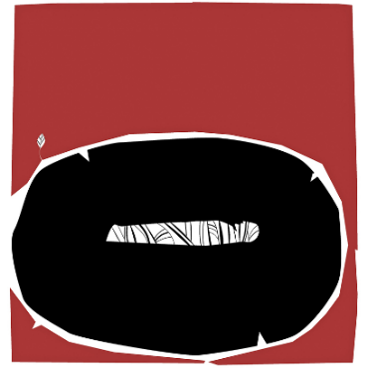
now and for ever.
All Amen.

All Holy God,
holy and strong,
holy and immortal,
have mercy upon us.

The conclusions
Let us pray for the coming of God’s kingdom in the words our Saviour taught us.
The Lord’s Prayer is said.

Most merciful God,
who by the death and resurrection of your Son Jesus Christ
delivered and saved the world:
grant that by faith in him who suffered on the cross
we may triumph in the power of his victory;
through Jesus Christ your Son our Lord,
who is alive and reigns with you,
in the unity of the Holy Spirit,
one God, now and for ever.
All Amen.

May God bless us,
that in us may be found love and humility,
obedience and thanksgiving,
discipline, gentleness and peace.
All Amen

