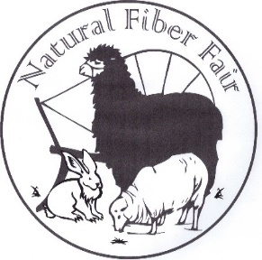
Natural Fiber Fair
PO Box 212
Arcata, CA 95518
Website: naturalfiberfair.com
Email: naturalfiberfair@yahoo.com

Natural Fiber Fair September 9th and 10th, 2017 Arcata Community Center
2017 Workshop Proposal Deadline for submission-March 15th, 2017
Please write clearly. Make copies for additional proposals. Submit as many proposals as you like. We will make the selection based on classroom size and topic.
Your Name___________________________________________________________________

Address_______________________________________________________________________

Phone number_______________________ Email address_________________________________

Topic________________________________________________

Brief Class Description:

This information will be posted on our web site along with your bio and an image of your work.
Length of class 3 hour_____ 6 hour______
Instructor Bio-Please include a bio of no more than 50 words.

List of materials and/ or advanced preparation required of students.
Space requirements and special equipment needed for your classroom. Please include number of tables, etc.
Do you need plastic covered tables?

Material fee________________ What materials are provided in the material fee?

Maximum number of students_____________Minimum number of students______________
Payment;
We will pay the instructor $25.00 per student for the 3 hour class, $50.00 for the 6 hour class.

Please pass this proposal form to anyone you think might be a great addition to our teachers at the Natural Fiber Fair.
Just a note to let you know that students like to be able to go home with a finished product, or almost finished.
Questions? Please don’t hesitate to send a message to carin.engen@gmail.com

Thank you,
Carin
Send your proposals by March 15th, 2017 to:
Carin Engen
43 Alice Ave.
Garberville, Ca. 95542
Or via email to: carin.engen@gmail.com

