SPONSORS’ HOUR MANUAL
Revised 2-2018
1. The Program for Sponsors’ Hour is the responsibility of the Chairperson. In most cases, you will need 80 programs printed. You should have 36 programs to give Agape for the pilgrim’s packets and balance is to be used during actual Sponsor’s Hour. The actual number of programs needed will be based on number of pilgrims on the Walk. Means of printing the program is optional. Professional printing in black ink is available as an act of agape. Should the Chairperson wish to utilize this free service, contact: Frank McKenzie fmcknz@gmail.com or 334-749-3100 (shop) or 334-524-5255. (cell) PLEASE let Frank know if you plan to use his services as early as possible in order for him to include in his daily work load. The Chairperson is responsible for contacting the Lay Director of the Walk to obtain the graphic that will be used on the front of the printed program. If the Chairperson chooses to print the program, the template can be downloaded at www.caew.org under the tab “CAEW info.” Click on “Work Area Books”, then “Sponsor’s Hour.” If using the free printing service, you will use this same template and send this completed template to the printer. Send the template as close to the Walk as possible to avoid too many changes. The cost of printing, including paper and ink cartridges, is considered agape and is not reimbursable by C.A.E.C. The Chairperson may be able to seek reimbursement from their Cluster, if needed.
The printer will be responsible for delivering the printed programs to the camp on the afternoon the Walk is to begin, if their service is utilized. They are usually left either in Agape room or in the Conference room foyer.
2. The Pilgrim’s names will be emailed to the Chairperson by the Registrar for the Walk. It is the responsibility of the Chairperson to forward any changes of the pilgrim list to the printer or make changes as they are received prior to the beginning of the Walk. It is strongly suggested that the printing of the Sponsors’ Hour program be delayed until the day before the Walk begins, if possible, to ensure all names are included (or deleted) and accurate.
Contact information for the registrars of both Men’s and Women’s walks can be found on the CAEW web site under the Board Reps” tab.
3. The Conference room team names are to be listed on the back page of the program. You should receive this information at the first Team Meeting prior to the Walk.
4. Labels – The Chairperson is responsible for printing labels for the pilgrim’s candles. The professional printer will ONLY print the programs. The pilgrim’s name, Walk #, and the Lay Director’s graphic, are to be printed on each label. The Avery label 8163 which is 2’x4’ will provide the space needed for this information. You may also want to include the Lay Director’s chosen scripture.
5. The candles and crosses for the pilgrims are in the possession of Sponsors Hour’s Board Rep. Please contact the Board Rep for obtaining the needed candles and crosses for the walk. In most cases you will receive the crosses at the first Team Meeting and the candles will be at Camp Alamisco Indoor Chapel by 4:00 P.M., Wednesday afternoon of the Walk. You may want to plan on getting to the camp early to ensure you have time to get labels attached to the candles.
6. The Room (Indoor Chapel) should already be arranged by Logistics workers, but it is the responsibility of the Chairperson to ensure the setup has been completed upon arrival at the camp before the Walk begins. There should be lighters, 3x5 index cards and white table cloths in the Sponsor’s Hour storage tub. If for some reason the cloth is missing, please ask Worship to borrow one of theirs. Arrange the candles on the front table (with name label facing the helper standing behind the table) so that candles can be lit by the helper during the Program. Crosses should be laid out neatly to the side of the candles for Sponsor to pick up during the program. See picture of suggested layout. Place a program and a 3x5 card in each chair.

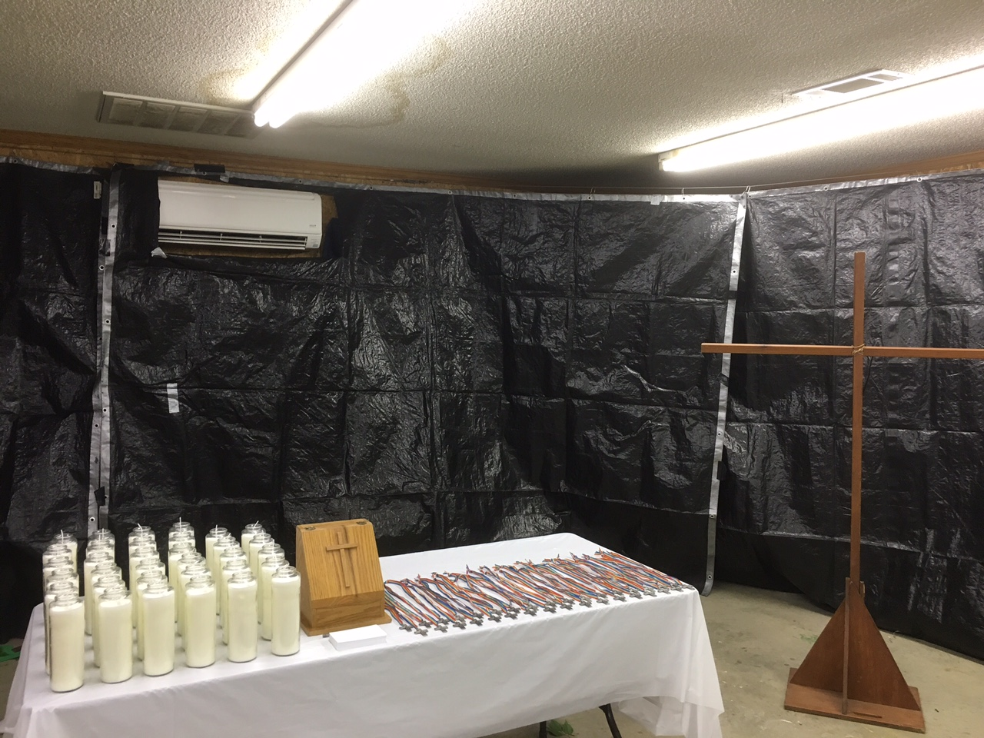
Ensure prayer box is up front. Sponsors put any personal specific confidential prayer requests for their pilgrim in the prayer box; they do not announce them to the group. The prayer request should be given to the Spiritual Director. Note that this is part of the script as well.
7. The Chairperson in charge will lead Sponsors’ Hour by following the agenda in the program.
8. The Helper lights candles at front of room as each name is called. The sponsor comes forward and picks up the cross and, after praying silently or aloud for the pilgrim, places it on the large Cross.
9. Have one helper prepared to pray for any pilgrim whose sponsor fails to stay for Sponsors Hour.
10. At the end of Sponsors’ Hour the Chairperson will be responsible for ensuring that the big cross with the pilgrim’s crosses on it is delivered to the Speakers’ Prayer Chapel where it will remain until the pilgrims receive their Cross on Saturday. Logistics personnel may help you with this.
11. Leave the Sponsor’s Hour storage tub in the Agape room with a note attached for this tub NOT to be packed away until Saturday when the Agape team will place the cloth in the storage tub. (Unless cloth is borrowed for Worship)
12. The candles are to remain in the indoor chapel until Saturday when the Agape team places them in the pilgrim’s bags.
13. If you find supplies missing, please advise the Board Rep for Sponsor’s Hour so they can be replenished prior to the next Walk.

THANK YOU FOR YOUR SERVICRE AND YOUR PRAYERS!

De Colores!
Board Rep for Sponsors’ Hour

