ADB’s Social and Environmental Safeguards, with Improvements, can be a Benchmark
IED News Release | 11 November 2014
http://www.adb.org/news/adb-s-social-and-environmental-safeguards-improvements-can-be-benchmark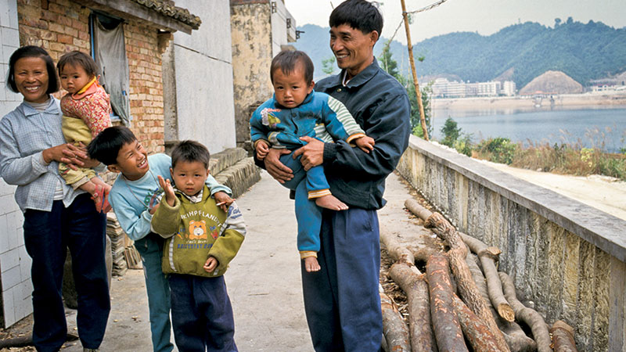
1
MANILA, PHILIPPINES — Effective safeguards to minimize damage that development projects can cause to communities and the environment are needed more than ever as new sources of international financing for infrastructure become available to emerging economies, says Independent Evaluation at the Asian Development Bank (ADB).
Independent Evaluation’s just-released review of ADB’s safeguards policy underscores the importance of social and environmental care in operations, and increasing the commitment and capability of client countries to apply these shields in development projects.
The findings feed into an ongoing debate in the international financing community on the adequacy of safeguards. This comes amid the entry of two new lenders for development; the People’s Republic of China-led Asian Infrastructure Investment Bank, launched on 24 October, and the New Development Bank set up by the BRICS countries of Brazil, Russia, India, People’s Republic of China, and South Africa. Meanwhile, a potentially path-changing review of safeguard policies is underway at the Washington-based World Bank Group, which is considering a more flexible approach to its safeguards policy. Both developments could dilute the strength of social and environmental protections.
“Safeguards are vital for redressing the collateral damage that can be caused by development projects, especially large-scale ones such as dams and roads,” says Vinod Thomas, Director General of Independent Evaluation at ADB. “Yet safeguards are often inadequately implemented by governments and businesses, even as it makes economic sense to mitigate against spill-over damages. At its core, this is an issue of better governance, which development banks can help address.”
Infrastructure is a highly visible area because it can affect air and water quality, forests and biodiversity, resettlement and the rights of indigenous people. Special measures agreed with governments in loan-funded projects—for instance, resettlement plans— can redress such fallout, as in the People’s Republic of China’s Xiaolangdi Dam on the Yellow River, which involved resettling some 180,000 people. Safeguards are also essential in development areas which often do not register on the radar screen, such as occupational safety in interventions to strengthen the small business sector and businesses funded by microfinance.
ADB’s 2010 safeguards policy introduced new requirements in its operations for biodiversity conservation, greenhouse gas emissions, and livelihood improvements when projects cause people to be resettled. The evaluation endorses this reformed framework for safeguards.
At the same time, as found in evaluations elsewhere, implementation and supervision of projects have serious gaps and need to improve. Independent Evaluation’s review calls for improvements in three specific areas. First, there needs to be greater attention to the implementation and supervision of not only high risk projects, but also those posing lesser albeit still substantial risks to communities and the environment.
Second, safeguard systems used by countries need to be strengthened to avert or minimize spillover damage from public and private investments. Here ADB, through policy dialogue with client countries, can plan play an important role. Third, improved monitoring is needed in the safeguards that apply to financial intermediaries, such as government investment funds and microfinance institutions, in ADB’s operations in the private sector.
A key message of the review is that the increased costs for staffing and other resources needed for effective safeguards in projects are worthwhile given the rising social and environmental risks facing emerging economies, including widening wealth gaps and runaway climate change.
“Governments are under pressure to ramp up growth amid fears of a slowdown in middle-income countries while low-income nations are seeking faster catch-up growth,” says Walter Kolkma, the report’s principal author. “So the case for stronger enforcement and supervision of safeguards is compelling, especially in Asia where the push for high economic growth has taken a huge toll on the environment.”
The shake-up in development banking with the entry of new lenders for development is putting safeguards under increased scrutiny. Says Thomas: “The additional sources of finance for infrastructure will be good for Asia’s legendary economic growth. But this raises the stakes—and presents a unique opportunity—for guaranteeing social and environmental defenses.”
Independent Evaluation considers ADB’s policy as a good prototype of safeguards blending compliance and flexibility, once important measures to improve its application are incorporated. It could provide a reasonable framework for harmonizing the safeguards of other development partners and ADB member countries’ own systems.
Three principles should underpin such a framework. First, there needs to be progress on the adequacy of country safeguard systems and their subsequent use. Second, their use must be complemented by legally binding indicators for social and environmental impacts, such as air and water pollution levels. Third, the performance of these indicators need to be monitored and verified by a reliable and independent third party and disclosed publicly.
In essence, given the rising social risks and environmental threats, Independent Evaluation advocates the continued use of a requirements-based safeguards system as used by ADB, rather than a switch to an aspirational one of safeguards standards as is being proposed at the World Bank Group.
# # #
To read the evaluation report, visit http://www.adb.org/documents/safeguards-operational-review-adb-processes... and download the main report.
About Independent Evaluation at the Asian Development Bank
Asian Development Bank's Independent Evaluation, reporting to the Board of Directors through the Development Effectiveness Committee, contributes to development effectiveness by providing feedback on ADB's policies, strategies, operations, and special concerns in Asia and the Pacific.

Media Contact
van Rijn, Hans Principal Evaluation Specialist +63 2 632 5642 E-mail contact form

Related
- Independent Evaluation
- Safeguards Operational Review: ADB Processes, Portfolio, Country Systems, and Financial Intermediaries

