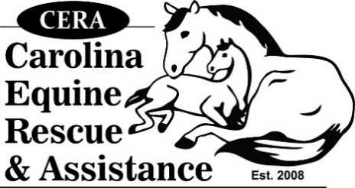
"CERA HORSE SHOW SERIES"
704-219-3559
EMAIL ENTRY FORM TO: darlenekindle@windstream.net

Rider First Name |  | Address
Rider Last Name
Horse's Name |  | Best Phone #
Show Date |  | Email Address

Class Fee $10.00 each SHOW #: ____________________________ (ASSIGNED BY SHOW OFFICE)
CLASS # | CLASS # | CLASS #
ADDITIONAL FEES WILL BE APPLIED FOR:
$10.00 - Office Fee for Each Entry
$5.00 - Not pre-registering, Late Entry Fee

HOW TO PRE-REGISTER: Save this form to your computer. Complete
above information, enter class #'s you will ride in. Save the file. Email
this form to darlenekindle@windstream.net. Day of the show, come to the
show office, I will have this form, sign below & I will give you your show #.
After riding in all your classes, come to the show office to check out & pay
your show bill. Deadline to pre-register is Thursday before each show by 4:00pm
IN CONSIDERATION, THEREFORE, FOR THE PRIVILEGE OF RIDING AND/OR OBSERVING AND/OR ENGAGING IN AN EQUINE ACTIVITY AT UCSC/HONEYSUCKLE RIDING ADADEMY, LOCATED IN MONROE NC, THE UNDERSIGNED DOES HEREBY AGREE TO HOLD HARMLESS AND INDEMNIFY UCSC/HONEYSUCKLE RIDING ACADEMY, INCLUDING, BUT NOT LIMITED TO DARLENE S KINDLE, VOLUNTEERS AND UCSC/HONEYSUCKLE RIDING ACADEMY, ALSO KNOWN AS THE EQUINE ACTIVITY SPONSOR, THEIR AGENTS AND ASSIGNEES AND FURTHER RELEASE THEM FROM ANY LIABILITY OR RESPONSIBILITY FOR ACCIDENT, DAMAGE, INJURY, OR ILLNESS TO THE UNDERSIGNED OR TO ANY HORSE OWNED BY THE UNDERSIGNED OR TO ANY FAMILY MEMBER OR SPECTATOR ACCOMPANYING THE UNDERSIGNED ON THE PREMISES. UNDER NORTH CAROLINA LAW, AN EQUINE ACTIVITY SPONSOR OR EQUINE PROFESSIONAL IS NOT LIABLE FOR AN INJURY OR THE DEATH OF A PARTICIPANY IN EQUINE ACTIVITIES. CHAPTER 99E OF THE NORTH CAROLINA GENERAL STATUTES. IN THE EVENT THAT THE UNDERSIGNED IS UNDER THE AGE OF 18 THE SIGNATURE OF A PARENT/GUARDIAN IS REQUIRED.
Rider Signature (Parent/Guardian if rider under 18): _____________________________________________DATE: ___________________
- Each Rider must provide a copy of the current Coggins

