Public Aquarium California Specimen List
Marine Aquaria Receiver’s Lis. 84973
SCP# 328

CNIDARIAN SPECIMEN LIST
Robert Burhans: (858) 774-2806 or email:Bob@matsucollections.com
*SCP required specimens require that the purchasing facility also have a current California SCP.
**Special order specimens are those which are infrequently encountered or pose specific collecting challenges.
EXAMPLE | COMMON NAME  LATIN NAME | COMMENTS* | SIZE & DISTRIBUTION | US$
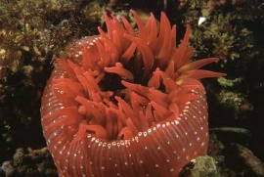 | White-spotted Rose Anemone  Urticnia lofotensis  SCP required | Attaches to pilings and rocks. | To: 4” diameter (10cm)  Range: Sitka Alaska to Baja California | 125.00
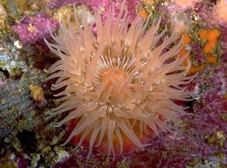 | Fish Eating Urticina  Urticina piscivora  SCP required | Feeds on fish and invertebrates | To: 8” diameter (20cm)  Range: Range: Alaska to La Jolla | 125.00
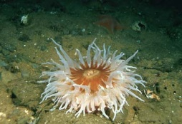 | Sand Rose Anemone  Urticina columbiana  SCP required | Like to bury in sand or mud bottoms. | To: 14” diameter (35cm)  Range: British Columbia to Baja California | 100.00
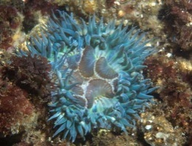 | Giant Green Anemone  Anthopleura xanthogrammica  SCP required | Does have zooxanthellae. Has sticky tentacles to capture food. | To: 12” diameter (30cm)  Range: Alaska to Baja California | 70.00
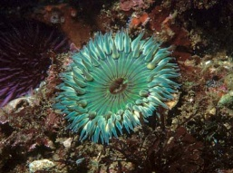 | Aggregating Anemone  Anthopleura elegantissima  SCP required | Occurs in aggregations or solitary | To: 2.5” diameter (8cm)  Range: Alaska to Baja California | 35.00
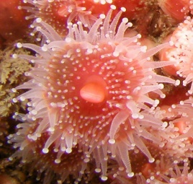 | Club-Tipped Anemone  Corynactis californica  SCP required | Prefers currents. Feeds on plankton. Will reproduce asexually | To: 1” in diameter 2.5cm)  Range: Point Arena California to Baja California | Sm 25.00  Med 35.00  Lg 50.00
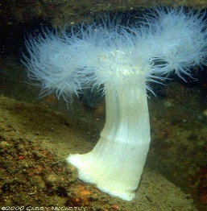 | White Plumed Anemone  Metridium giganteum  SCP required | Feeds on plankton. Prefers strong currents. | To: 4’ diameter (10cm)  Range: Alaska to southern California | 100.00
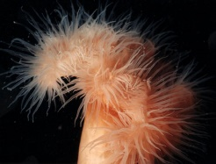 | White-Plumed Anemone  Metridium senile  SCP required |  | To 4” height & 2” diameter | $50.00 cluster
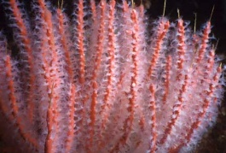 | Red Gorgonian  Lophogorgia chilensis | Plankton feeder that likes direct current. | To: 36” height (90cm)  Range: Monterey Bay California to Baja California | >5” $20  6-10” $25  11-15” $35  15”< $45
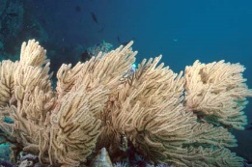 | California Golden Gorgonian  Muricea californica  SCP required | Has yellow polyps. Plankton feeder that likes current. | To: 36” height (90cm)  Range: Point Conception California to Baja California | <5” $20  6-10” $25  11-15” $35  15”< $45
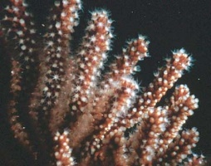 | Brown Gorgonian  Muricea fruticosa  SCP required | Has white polyps. Plankton feeder that likes current. Does well in less than ideal conditions | To: 36” height (90cm)  Range: Point Conception California to Baja California | <5” $20  6-10” $25  11-15” $35  15”< $45
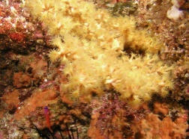 | Zoanthid Anemone  Zoanthus sp.  SCP required | Found on rocks and dead gorgonians. May reproduce by budding. | Size: .25-.75” diameter  Range: Alaska to San Diego | Sm. 40.00  Med. 45.00  Lg. 55.00
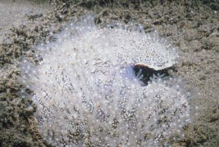 | Sea Pansy  Renilla koellikeri | Heart shaped, anchors to the sand. Plankton feeder that comes out more in current. | To: 5” diameter (12.5cm)  Range: S. California to Baja California | 10.00
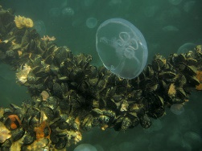 | Moon Jelly  Aurelia aurita |  | To: 16” (40cm)  Range: Worldwide | Seasonal  Sm. 18.00  Med. 25.00  Lg. 30.00
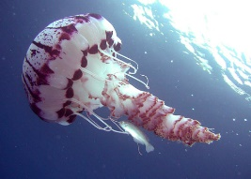 | Purple Jelly  Pelagia noctiluca  SCP required |  | To: 30” (80cm)  Range Central California south | Seasonal
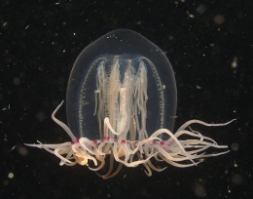 | Bell Jelly  Polyorchis penicillatus | Feed on small plankton and crustaceans | To: 4” (10cm)  Range: British Columbia to San Diego California | Seasonal  15.00
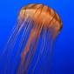 | Brown Jelly  Chrysaora melanaster  SCP required | Planktonic. Very powerful sting. | To: 12” (30cm)  Range: Alaska to S. California | Seasonal
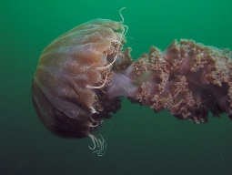 | Black Jelly  Chrysaora achlyos  SCP required | Planktonic. Very powerful sting. | To: 12” (30cm)  Range: California Coast | Seasonal
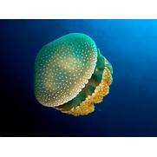 | Australian White Spotted Jelly  Phyllorhiza punctata | Has zooxanthellae. Requires light. | To: 16” (40cm)  Range: Occurring in Australia, Hawaii, San Diego, Gulf Coast | Seasonal

