Saint Paul’s Episcopal Church

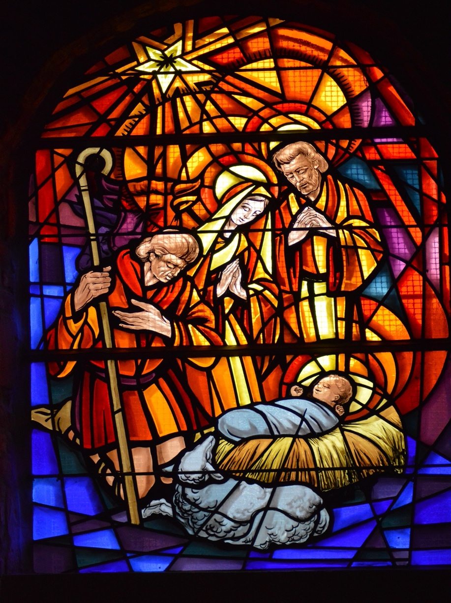

The Second Sunday after Christmas
January 2, 2022

Pastor Dan Wilfrid

79 Cross Street, Gardner, Massachusetts ~ 01440

Welcome to St. Paul’s. We’re glad that you have joined us for worship, either in person or livestreamed on our YouTube channel. For as long as COVID infection rates remain elevated in our area, we ask everyone attending in person to wear a mask in worship and to sit safely distanced from people not from your household. At the distribution of Holy Communion (bread only), please come forward one at a time, and return to your seat through the door to your right and from the rear of the nave down the center aisle. Worship leaders are all vaccinated and will only unmask while speaking. Words in boldface type are the congregation’s responses.

Prelude: What Star is This ~ Setting by Thomas Keesecker

The Word of God

Blessed be God: Father, Son, and Holy Spirit.
And blessed be his kingdom, now and forever. Amen.

Collect for Purity
Almighty God, to you all hearts are open, all desires known, and from you no secrets are hid: Cleanse the thoughts of our hearts by the inspiration of your Holy Spirit, that we may perfectly love you, and worthily magnify your holy Name; through Christ our Lord. Amen

Gloria in Excelsis: S 204 (Old Scottish Chant)

Glory be to God on high, and on earth peace, good will toward men.
We praise Thee, we bless Thee, we worship Thee, we glorify Thee,
we give thanks to Thee for Thy great glory:
O Lord God, heavenly King; God the Father Almighty.
O Lord, the only begotten Son, Jesus Christ;
O Lord God, Lamb of God, Son of the Father:
That takest away the sins of the world, have mercy upon us.
Thou that takest away the sins of the world, receive our prayer.
Thou that sittest at the right hand of God the Father, have mercy upon us.
For Thou only art holy; Thou only art the Lord;
Thou only, O Christ, with the Holy Ghost,
art the most high in the glory of God the Father. Amen.

The Collect

The Lord be with you.

And also with you.

Let us pray.
O God, who wonderfully created, and yet more wonderfully restored, the dignity of human nature: Grant that we may share the divine life of him who humbled himself to share our humanity, your Son Jesus Christ; who lives and reigns with you, in the unity of the Holy Spirit, one God, for ever and ever. Amen

First Reading: Jeremiah 31:7-14
Thus says the Lord:
Sing aloud with gladness for Jacob,
and raise shouts for the chief of the nations;
proclaim, give praise, and say,
"Save, O Lord, your people,
the remnant of Israel."
See, I am going to bring them from the land of the north,
and gather them from the farthest parts of the earth,
among them the blind and the lame, those with child and
those in labor, together;
a great company, they shall return here.
With weeping they shall come,
and with consolations I will lead them back,
I will let them walk by brooks of water,
in a straight path in which they shall not stumble;
for I have become a father to Israel,
and Ephraim is my firstborn.
Hear the word of the Lord, O nations,
and declare it in the coastlands far away;
say, "He who scattered Israel will gather him,
and will keep him as a shepherd a flock."
For the Lord has ransomed Jacob,
and has redeemed him from hands too strong for him.
They shall come and sing aloud on the height of Zion,
and they shall be radiant over the goodness of the Lord,
over the grain, the wine, and the oil,
and over the young of the flock and the herd;
their life shall become like a watered garden,
and they shall never languish again.
Then shall the young women rejoice in the dance,
and the young men and the old shall be merry.
I will turn their mourning into joy,
I will comfort them, and give them gladness for sorrow.
I will give the priests their fill of fatness,
and my people shall be satisfied with my bounty,
says the Lord.

The word of the Lord.
Thanks be to God.

Psalm 84 Quam dilecta!

¹ How dear to me is your dwelling, O Lord of hosts! *
My soul has a desire and longing for the courts of the Lord;
my heart and my flesh rejoice in the living God.
² The sparrow has found her a house
and the swallow a nest where she may lay her young; *
by the side of your altars, O Lord of hosts, my King and my God.
³ Happy are they who dwell in your house! *
they will always be praising you.
⁴ Happy are the people whose strength is in you!
whose hearts are set on the pilgrims' way.
⁵ Those who go through the desolate valley will find it a place of springs, *
for the early rains have covered it with pools of water.
⁶ They will climb from height to height, *
and the God of gods will reveal himself in Zion.
⁷ Lord God of hosts, hear my prayer; *
hearken, O God of Jacob.
⁸ Behold our defender, O God; *
and look upon the face of your Anointed.
⁹ For one day in your courts is better than a thousand in my own room,*
and to stand at the threshold of the house of my God
than to dwell in the tents of the wicked.
¹⁰ For the Lord God is both sun and shield; *
he will give grace and glory;
¹¹ No good thing will the Lord withhold *
from those who walk with integrity.
¹² O Lord of hosts, *
happy are they who put their trust in you!

Second Reading: Ephesians 1:3-6,15-19a

Blessed be the God and Father of our Lord Jesus Christ, who has blessed us in Christ with every spiritual blessing in the heavenly places, just as he chose us in Christ before the foundation of the world to be holy and blameless before him in love. He destined us for adoption as his children through Jesus Christ, according to the good pleasure of his will, to the praise of his glorious grace that he freely bestowed on us in the Beloved.

I have heard of your faith in the Lord Jesus and your love toward all the saints, and for this reason I do not cease to give thanks for you as I remember you in my prayers. I pray that the God of our Lord Jesus Christ, the Father of glory, may give you a spirit of wisdom and revelation as you come to know him, so that, with the eyes of your heart enlightened, you may know what is the hope to which he has called you, what are the riches of his glorious inheritance among the saints, and what is the immeasurable greatness of his power for us who believe.

The word of the Lord.
Thanks be to God.

Alleluia Verse: Christmastime Alleluia

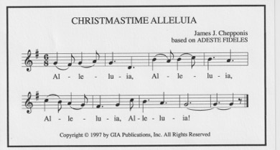

Gospel Reading: Matthew 2: 1 - 12

The Holy Gospel of our Lord Jesus Christ according to Matthew.
Glory to you, Lord Christ.
2 In the time of King Herod, after Jesus was born in Bethlehem of Judea, wise men from the East came to Jerusalem, ² asking, “Where is the child who has been born king of the Jews? For we observed his star at its rising, and have come to pay him homage.” ³ When King Herod heard this, he was frightened, and all Jerusalem with him; ⁴ and calling together all the chief priests and scribes of the people, he inquired of them where the Messiah was to be born. ⁵ They told him, “In Bethlehem of Judea; for so it has been written by the prophet:
⁶ ‘And you, Bethlehem, in the land of Judah,
are by no means least among the rulers of Judah;
for from you shall come a ruler
who is to shepherd my people Israel.’”
⁷ Then Herod secretly called for the wise men and learned from them the exact time when the star had appeared. ⁸ Then he sent them to Bethlehem, saying, “Go and search diligently for the child; and when you have found him, bring me word so that I may also go and pay him homage.” ⁹ When they had heard the king, they set out; and there, ahead of them, went the star that they had seen at its rising, until it stopped over the place where the child was. ¹⁰ When they saw that the star had stopped, they were overwhelmed with joy. ¹¹ On entering the house, they saw the child with Mary his mother; and they knelt down and paid him homage. Then, opening their treasure chests, they offered him gifts of gold, frankincense, and myrrh. ¹² And having been warned in a dream not to return to Herod, they left for their own country by another road.
The Gospel of the Lord.

Praise to you, Lord Christ.

The Sermon ~ Pastor Dan Wilfrid

The Hymn: We Three Kings of Orient Are, #128

1. We three kings of Orient are, bearing gifts we traverse afar,
field and fountain, moor and mountain, following yonder star.
Refrain:
O star of wonder, star of night,
star with royal beauty bright;
westward leading, still proceeding,
guide us to thy perfect light!
2. Born a King on Bethlehem's plain, gold I bring to crown him again,
King for ever, ceasing never over us all to reign. (Refrain)
3. Frankincense to offer have I: incense owns a Deity nigh;
prayer and praising, gladly raising, worship him, God Most High. (Refrain)
4. Myrrh is mine; its bitter perfume breathes a life of gathering gloom;
sorrowing, sighing, bleeding, dying, sealed in the stone-cold tomb. (Refrain)
5. Glorious now behold him arise, King and God and Sacrifice;
Heaven sings alleluia; Alleluia the earth replies. (Refrain)

The Nicene Creed
We believe in one God, the Father, the Almighty,
maker of heaven and earth, of all that is, seen and unseen.
We believe in one Lord, Jesus Christ, the only Son of God,
eternally begotten of the Father, God from God, Light from Light,
true God from true God, begotten, not made, of one Being with the Father. Through him all things were made.
For us and for our salvation he came down from heaven:
by the power of the Holy Spirit he became incarnate from the Virgin Mary, and w as made man.
For our sake he was crucified under Pontius Pilate;
he suffered death and was buried.
On the third day he rose again in accordance with the Scriptures;
he ascended into heaven and is seated at the right hand of the Father.
He will come again in glory to judge the living and the dead,
and his kingdom will have no end.
We believe in the Holy Spirit, the Lord, the giver of life,
who proceeds from the Father and the Son.
With the Father and the Son, he is worshiped and glorified.
He has spoken through the Prophets.
We believe in one holy catholic and apostolic Church.
We acknowledge one baptism for the forgiveness of sins.
We look for the resurrection of the dead,
and the life of the world to come. Amen.

Prayers of the People ~ Form III ~ The Book of Common Prayer, p. 387

Father, we pray for your holy Catholic Church;
That we all may be one.

Grant that every member of the Church may truly and humbly serve you;
That your Name may be glorified by all people.

We pray for all bishops, priests, and deacons;
That they may be faithful ministers of your Word and Sacraments.

We pray for all who govern and hold authority in the nations of the world;
That there may be justice and peace on the earth.
Give us grace to do your will in all that we undertake;
That our works may find favor in your sight.

Have compassion on those who suffer from any grief or trouble;
That they may be delivered from their distress.

Give to the departed eternal rest;
Let light perpetual shine upon them.

We praise you for your saints who have entered into joy; especially giving thanks this day for the life and witness of Archbishop Desmond Tutu;
May we also come to share in your heavenly kingdom.

Let us pray for the needs and concerns of this congregation and its people; especially for:

Jared Snyder Dwight Davis
Lisa Boulanger Michael Crowley
Cindy Richard Maureen Owens
Brandon Grenier Eveline Beauregard
Millie Williams Jay Hipkins
Jacob Decarolis Dawn Deluca
Cyndi Flanagan Andy LePage
Christopher Sharon Hamel
Suzanna Cleveland Bob and Lorene McLaughlin
Kathy Lewis Fred and Ginny Monette
Evelyn Wolenty Tom and Felicity Littlepage
Robin Hatch and family
For those in military service.
For all people who suffer hunger, poverty or oppression.
For safety and welcome for refugees seeking asylum far from home.
For people who have suffered injury and loss from storms, fires and floods.
For our parishioners unable to be with us.
In thanksgiving for the Sanctuary Candle given by Terry Jaillet.

The Collect
Almighty and Eternal God, ruler of all things in heaven and earth: Mercifully accept the prayers of your people, and strengthen us to do your will; through Jesus Christ, our Lord. Amen.

The Confession of Sin
Let us confess our sins against God and our neighbor.
Have mercy upon us, most merciful Father; in your compassion forgive us our sins, known and unknown, things done and left undone; and so uphold us by your Spirit that we may live and serve you in newness of life, to the honor and glory of your Name; through Jesus Christ our Lord. Amen.

The Absolution
Almighty God have mercy on you, forgive you all your sins through our Lord Jesus Christ, strengthen you in all goodness, and by the power of the Holy Spirit keep you in eternal life. Amen.

The Peace
The peace of the Lord be always with you. And also with you.

Announcements

The Holy Communion
Offertory Invitation
So bring him incense, gold and myrrh; come peasant, king, to own him. The King of kings salvation brings; let loving hearts enthrone him. Haste, haste to bring him laud, the babe, the son of Mary.

Offertory Hymn: Brightest and best of the stars of the morning, #117

- Brightest and best of the sons of the morning,
dawn on our darkness and lend us thine aid.
Star of the east, the horizon adorning,
guide where our infant Redeemer is laid.

- Cold on his cradle the dewdrops are shining;
low lies his head with the beasts of the stall.
Angels adore him in slumber reclining,
Maker and Monarch and Savior of all.

- Shall we then yield him, in costly devotion
odors of Edom, and offerings divine,
gems of the mountain and pearls of the ocean,
myrrh from the forest and gold from the mine?

- Vainly we offer each ample oblation,
vainly with gifts would his favor secure.
Richer by far is the heart's adoration,
dearer to God are the prayers of the poor.

- Brightest and best of the sons of the morning,
dawn on our darkness and lend us your aid.
Star of the east, the horizon adorning,
guide where our infant Redeemer is laid.

Offertory Prayer
Gracious God, we offer with joy and thanksgiving what you have first given us, - ourselves, our time, and our possessions, signs of your generosity and love.

Receive them for the sake of the one who offered himself for us, Jesus Christ our Lord. Amen.

Eucharistic Prayer B ~ from the Book of Common Prayer p. 367
The Lord be with you.
And also with you.
Lift up your hearts.
We lift them to the Lord.
Let us give thanks to the Lord our God.

It is right to give God thanks and praise.
It is right, and a good and joyful thing, always and everywhere to give thanks to you, Father Almighty, Creator of heaven and earth. Because you gave Jesus Christ, your only Son, to be born for us; who, by the mighty power of the Holy Spirit, was born of the flesh of the Virgin Mary his mother; so that we might be delivered from the bondage of sin, and receive power to become your children.
Therefore we praise you, joining our voices with Angels and Archangels and with all the company of heaven, who for ever sing this hymn to proclaim the glory of your Name:
The Sanctus S 130
Holy, holy, holy Lord, God of power and might,
Holy, holy, holy Lord, God of power and might,
heaven and earth are full, full of your glory.
Hosanna in the highest. Hosanna in the highest.
Blessed is he who comes in the name of the Lord.
Hosanna in the highest. Hosanna in the highest.

We give thanks to you, O God, for the goodness and love which you have made known to us in creation; in the calling of Israel to be your people; in your Word spoken through the prophets; and above all in the Word made flesh, Jesus, your Son. For in these last days you sent him to be incarnate from the Virgin Mary, to be the Savior and Redeemer of the world. In him, you have delivered us from evil, and made us worthy to stand before you. In him, you have brought us out of error into truth, out of sin into righteousness, out of death into life.
On the night before he died for us, our Lord Jesus Christ took bread; and when he had given thanks to you, he broke it, and gave it to his disciples, and said, “Take, eat: This is my Body, which is given for you. Do this for the remembrance of me.”
After supper he took the cup of wine; and when he had given thanks, he gave it to them, and said, “Drink this, all of you: This is my Blood of the new Covenant, which is shed for you and for many for the forgiveness of sins. Whenever you drink it, do this for the remembrance of me.”
Therefore, according to his command, O Father,
We remember his death.
We proclaim his resurrection.
We await his coming in glory.

And we offer our sacrifice of praise and thanksgiving to you, O Lord of all; presenting to you, from your creation, this bread and this wine.
We pray you, gracious God, to send your Holy Spirit upon these gifts that they may be the Sacrament of the Body of Christ and his Blood of the new Covenant. Unite us to your Son in his sacrifice, that we may be acceptable through him, being sanctified by the Holy Spirit. In the fullness of time, put all things in subjection under your Christ, and bring us to that heavenly country where, with all your saints, we may enter the everlasting heritage of your sons and daughters; through Jesus Christ our Lord, the firstborn of all creation, the head of the Church, and the author of our salvation.
By him, and with him, and in him, in the unity of the Holy Spirit all honor and glory is yours, Almighty Father, now and for ever. Amen
And now, as our Savior Christ has taught us, we are bold to say:
Our Father, who art in heaven, hallowed be thy Name,
thy kingdom come, thy will be done, on earth as it is in heaven.
Give us this day our daily bread. And forgive us our trespasses,
as we forgive those who trespass against us.
And lead us not into temptation, but deliver us from evil.
For thine is the kingdom, and the power, and the glory, forever and ever. Amen.

The Breaking of the Bread

Alleluia. Christ our Passover is sacrificed for us;
Therefore let us keep the feast. Alleluia.

Lamb of God (S 164)
Jesus, Lamb of God: have mercy on us.
Jesus, bearer of our sins: have mercy on us.
Jesus, redeemer, redeemer of the world:
Give us your peace, give us your peace.

The Distribution

Come. Receive what you are: the body of Christ.
May we become what we receive.

Communion Music: In the Bleak Midwinter ~ Setting by Thomas Keesecker

Post-Communion Prayer

Let us pray.
Eternal God, heavenly Father, you have graciously accepted us as living members of your Son our Savior Jesus Christ, and you have fed us with spiritual food in the Sacrament of his Body and Blood. Send us now into the world in peace, and grant us strength and courage to love and serve you with gladness and singleness of heart; through Christ our Lord. Amen.

The Blessing
Almighty God, Father, + Son, and Holy Spirit, bless you now and forever. Amen

Sending Hymn: What star is this, with beams so bright, #124

- What star is this, with beams so bright,
more beauteous than the noonday light?
It shines to herald forth the King,
and Gentiles to his crib to bring.

- True spake the prophet from afar
who told the rise of Jacob's star;
and eastern sages with amaze
upon the wondrous token gaze.

- The guiding star above is bright;
within them shines a clearer light,
and leads them on with power benign
to seek the Giver of the sign.

- O Jesus, while the star of grace
impels us on to seek thy face,
let not our slothful hearts refuse
the guidance of thy light to use.

- To God the Father, heavenly Light,
to Christ, revealed in earthly night,
to God the Holy Ghost we raise
our equal and unceasing praise.

Dismissal

Go in peace to love and serve the Lord.

Thanks be to God.

Postlude: Let Our Gladness Know No End ~ Setting by Benjamin M. Culli

Worship Leaders and Helpers Today

Presider/Preacher … Pastor Dan Wilfrid
Reader … Denise Whitney LEM … Denis Meunier
Organist … Judy Greenlees
Altar Guild … Eva Eaton-Price Camera … Susan Hubbard

JANUARY BIRTHDAYS |  | JANUARY ANNIVERSARIES
Bruce Harris | Jan. 2 | -
Amanda Mitchell | Jan. 2
Pat Lewis | Jan. 11
Fred Monette | Jan. 12
Mary Chipman | Jan. 12
Evelyn Wolenty | Jan. 25
Ann St. Sauveur | Jan. 29
Albert Gauthier | Jan. 30

