EASTER SUNDAY OF THE RESURRECTION OF THE LORD
APRIL 21, 2019
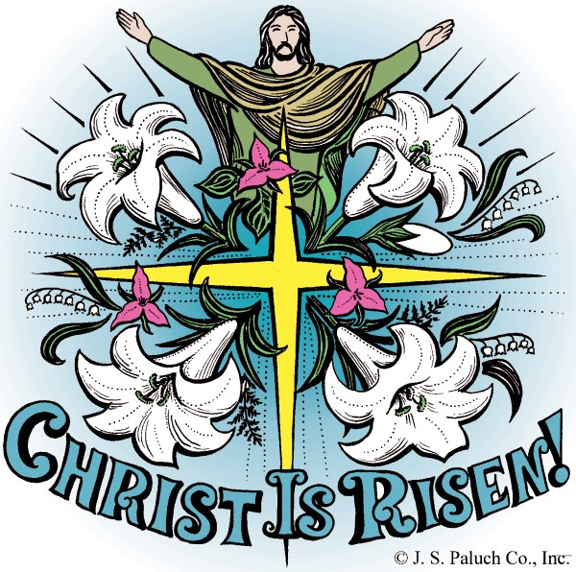
HAPPY EASTER!

Happy Easter! Or as most other languages prefer: Blessed Pasch—Passover! Pasqua, Padcua, Páscoa, Páques! Israel’s Passover through the Red Sea to the Promised Land! Jesus’ Passover through the Cross to Resurrection! Our Catechumens’ Passover last night, and ours once upon a time, through Baptism’s waters to our family’s Eucharistic! Welcome, everybody! As someone once said of the Catholic Church, “Here comes everybody!” So in the Jubilee of Mercy, we make our own Saint John Chrysostom’s Easter welcome from fourteen hundred years ago: “Let everyone enjoy this radiant feast! You who fasted from Lent’s beginning, and you who didn’t fast at all, rejoice! The table’s richly set! Come take from it, everybody, no worries, no embarrassment! All of you, taste the banquet of faith! Enjoy the feast of forgiveness! Let no one grieve for having sinned again and again: pardon has risen from the tomb!” Happy Easter! Blessed Pasch! Welcome everybody!

SPIRITUAL PROOF
By Dennis Tavares

Scientists studying the brain believe that memory images are stored as electrical states in the brain cells; our intellect is rooted in our material brain. But what about imagination in which our mind can form a scene which we have never experienced in real life. Where does the scene originate since no electric states were ever created for that scene we never experienced. This proves to me that the mind is a separate entity from the material brain; it must be connected to the spiritual world. The mind, which is not material, uses the brain to connect to the body. So we have here proof of the spiritual realm in our own bodily processes. It makes sense that God would not have hidden from us the source of our intellect and will. We need to think about such things like Socrates , Aquinas, and Jesus did.

PASTORAL RUMINATIONS
By Father Andre

A PARISHIONER REQUESTED ME TO EXPLAIN WHEN THE SEASON OF LENT ENDS. IT WAS A HONEST QUESTION THAT MOST MAY HAVE BEEN ENTERTAINING IN THE BACK OF THEIR MINDS, BUT NEVER HAD THE COURAGE TO ASK; HENCE, ALLOW ME TO ELUCIDATE ON THE ISSUE.
LENT ENDS AS WE BEGIN “THE EASTER TRIDUUM” ON MAUNDY THURSDAY UNTIL THE EASTER VIGIL ON SATURDAY EVENING. PEOPLE WILL NOTICE THAT THE TRIDUUM LITURGY IS, IN FACT, A CONTINUOUS THREE-DAY SEAMLESS CELEBRATION OF CHRIST’S INSTITUTION OF THE HOLY EUCHARIST AT HOLY THURSDAY’S LAST SUPPER, OUR LORD’S PASSION AND DEATH ON GOOD FRIDAY, AND FINALLY HIS RESURRECTION WHICH CULMINATES ON SATURDAY AFTER SUNSET.
MAY YOU AND YOUR FAMILIES EXPERIENCE THE JOY OF THE RESURRECTION IN A MEANINGFUL AND LIBERATING WAY THIS SEASON OF EASTER. CHRIST IS TRULY RISEN. ALLELUIA!!! ALLELUIA!!!
SHOULD YOU HAVE ANY QUESTIONS, PLEASE DON’T HESITATE TO PERSONALLY ASK ME AND I WOULD GLADLY ANSWER THEM HERE IN MY COLUMN.

~0~

ERRATUM: “STRAIGHTEN” SHOULD HAVE READ “STRENGTHEN.”

ALLELUIA!

Almighty Father, let the Church’s Alleluia! Be in my heart because your Son has won the victory for me--even when I do not yet understand.

Now the Church cries out a seemingly ceaseless Alleluia! Praise the Lord!
It’s like we are in a huge football stadium. The star quarterback, injured by a terrible blow earlier in the game, comes back to the field with his home team losing. Confusion occurs after the snap, and we can’t see what happened. Who even has the ball? Suddenly the quarterback emerges with the ball wrapped in his arms. He races down the field for a touchdown, and wins the game just as time runs out. The filled stadium, at first confused, then erupts with continuous cheering in near disbelief.
Mary Magdalene, as well as Simon Peter and the Beloved Disciple, do not at first understand what happened early that Sunday morning. The tomb is empty, assuredly. Did some people take the Lord’s dead body away? The disciples do not shout cries of praise. Mary Magdalene cries tears of sadness. Only later will the disciples realize that their Lord is Risen from the dead.
In the darkness of our hearts, we may feel like those first disciples at the empty tomb: confused and not yet understanding. But the Church, like the stadium of fans, helps us see what is really going on. Christ has won the victory for us. The everlasting Alleluia! Begins, whether we understand or not. Praise the Lord!

AND THE RAFFLE WINNERS ARE:
1st price: Tablet : Cynthia O'Brien
2nd price: Bench Willie Pell
3rd price: Oak firewood Dolly Guisti
4th price: Madrone firewood Rick Friar
5th price: Overtime Brewery Gift Card Cesar Yanez

THANK YOU FOR YOUR SUPPORT!

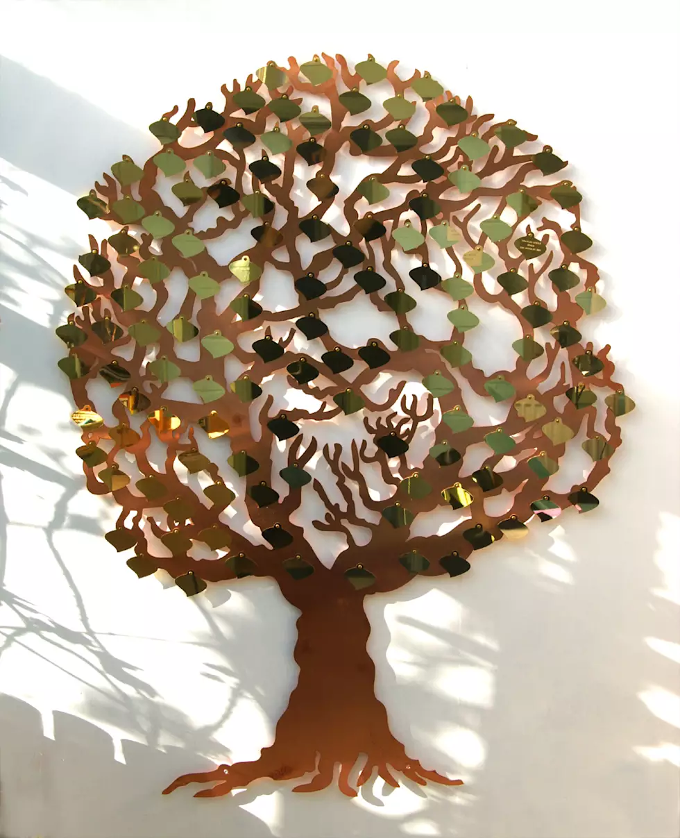
OLGC’S MEMORIAL TREE
In the vestibule of the Church, on the southern wall, is a beautiful Memorial Tree.
Its bright leaves represent permanent memorials to the departed of our Parish.
For the sum of $200.00, you can give to the Parish Secretary, the correct spelling and dates of the departed and in due time the leaf is printed and attached to the tree: a permanent reminder of a loved one who is gone.
For more information, call the Parish Office at
964-0229.

Attention all young people of
Our Lady of Good Counsel:
You are invited to come join
Don Bosco Youth Group.
We meet every Monday from 6:00pm - 8:00 pm in Classroom #1.
Come have some fun while growing in Faith! All are welcome! For more information, please contact Yesenia Huerta at 357-6512 or the Parish Office at 964-0229.

PLEASE PRAY FOR OUR SICK PARISHIONERS
Richard Braga, Lisa Wright, Ricardo Contreras, Florencia Chávez, Refugio Yáñez, Tarcicio García, Sofía García, María de Jesús Mendoza, Antonio Cazares, Ana García, Ryan Moore, Jane Vartanian, Marianne Brannan, Lilia Parrish, Nancy Smith, Julián Palomar, Luisa Martínez, Jennifer Vera, John Braet, Kim Koskinen, Margaret Valencia, Matthew Marcoulier, Dennis Tavares, Jose Freitas, Alfredo Sousa, Juana Arreguín, Aron Yasskin, Victoria Walzer, Fidela Yáñez Jara, Erika Ramos, Bill Gibson, Carla Tomas, Erasmo Yáñez, Memo Soria, Patricia Vargas, Fidela Yáñez, Elvia Flores, Yonel Ruíz, Angie Freitas, Russel Bryant, Derrick Heater, Luis Angel, Juan Barrera-Terán, Gabriel Hurtado, Gerald Butler, Helen Reynolds, Toni Clark, Ann Gallagher, Brianna Lopez, Margaret Milliken, Gina Pivirotto, Nick Quin, Mary Servis, Denis Sousa, Victor Venegas, Matty Walker, Charles Lorenz, Rebecca Lorenz, Ofelia Ibarra, Leonardo Naal, Gina Leal.

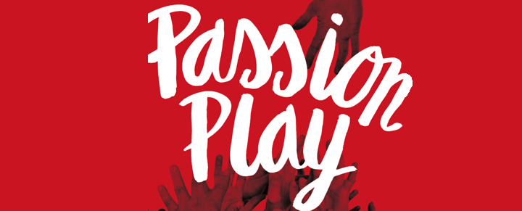
Lake County 39th Annual Outdoor Passion Play 3rd weekend in May!!
Saturday and Sunday May 18th and 19th, 2019
4- 6pm in Beautiful Lake County!!!
Visit us at: www.lakecountypassionplay.org
Call: 707-263-0349 or 833-263-5277 or Like our Facebook Page
www.facebook.com/PassionPlayLakeCo/
Admission is Free!
New cast members are always welcome!
If you want to feel the Power of our Lord! Come and Experience the Passion Play!

MASS INTENTIONS
APRIL 24 - 28, 2019
Wednesday (24)  Thursday (25)  Friday (26)  Saturday (27)  Sunday (28) | 12:05pm  12:05pm  12:05pm  5:00pm  6:30pm  8:00am  10:00am | Nery Sel †  Joe Redmond Jr. †  Homebound & Elderly  Fred & Clara White †  Gabriel Rodríguez †  Moy Villalpando †  Dionicio Barrera †  María Yáñez †  Carlos & Virginia Barrera †  Weera & Supa Kithchathorn (health)  Weera Kithchathorn (health)

PRAY FOR OUR FAMILY AND FRIENDS THAT ARE IN THE MILITARY SERVICE
Rebeca Sánchez, José Araiza Jr., Edgar Toscano, Marina González, Alondra Jara, Sonia Jara, Jason Lorenz, Matt Mill
& Jared Schroeder

WEEKLY COLLECTION
APRIL 13 & 14, 2019…..$2,579.00
MIANTENANCE FUND…..$967.00

THIS WEEKEND’S SECOND COLLECTION:
HOLY LAND
NEXT WEEKEND’S SECOND COLLECTION:
AMA (ANNUAL MINISTRY APPEAL)

THANK YOU
FOR YOUR SUPPORT & CHRISTIAN GENEROSITY

HOLY WEEK SCHEDULE
_{HOLY THURSDAY/JUEVES SANTO}
_{APRIL 18/18 DE ABRIL}
_{5:00PM} SPANISH MASS: WASHING OF THE FEET/ MISA EN ESPAÑOL: LAVATORIO DE PIES
_{7:00PM} ENGLISH MASS: WASHING OF THE FEET/ MISA EN INGLES: LAVATORIO DE PIES
8:00PM - 12:00AM VENERATION OF THE BLESSED SACRAMENT (MICHAELRAJ HALL)
VENERACIÓN DEL SANTÍSIMO SACRAMENTO (SALÓN MICHAELRAJ)

_{GOOD FRIDAY/VIERNES SANTO}
_{APRIL 19/19 DE ABRIL}
9:00AM – 12:00PM VENERATION OF THE BLESSED SACRAMENT (MICHAELRAJ HALL)
VENERACIÓN DEL SANTÍSIMO SACRAMENTO (SALÓN MICHAELRAJ)
_{NOON} STATIONS OF THE CROSS, READING OF THE PASSION, COMMUNION SERVICE
VÍA CRUCIS, LECTURAS DE LA PASIÓN Y SERVICIO DE COMUNIÓN
_{3:00PM -12:00AM} VENERATION OF THE BLESSED SACRAMENT (MICHAELRAJ HALL)
VENERACIÓN DEL SANTÍSIMO SACRAMENTO (SALÓN MICHAELRAJ)
_{5:30PM} PASSION PLAY – SPANISH/ OBRA DE LA PASIÓN DE CRISTO - ESPAÑOL

HOLY SATURDAY - EASTER VIGIL / SABADO SANTO – VIGILIA PASCUAL
_{APRIL 20/20 DE ABRIL}
_{9:00AM} LITURGY OF THE HOURS/LITURGIA DE LAS HORAS
_{6:00PM} _{BILINGUAL MASS/MISA BILINGÜE}

EASTER SUNDAY/DOMINGO DE PASCUA
_{APRIL 21/21 DE ABRIL}
_{8:00AM} _{ENGLISH MASS/MISA EN INGLÉS}
_{10:00AM} _{BILINGUAL MASS/MISA BILINGÜE}

PARISH EASTER EGG HUNT TO FOLLOW AFTER 10:00AM MASS
BUSQUEDA DE HUEVOS AL FINALIZAR LA MISA DE 10:00AM

