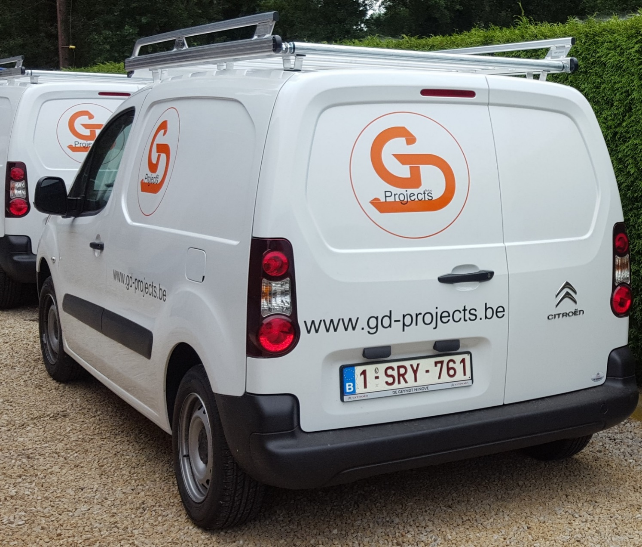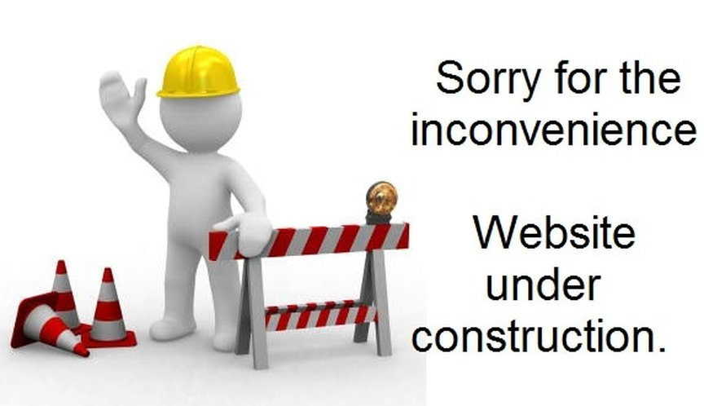

[**info@gd-projects.be**](mailto:info@gd-projects.be) **0478/04 06 97**