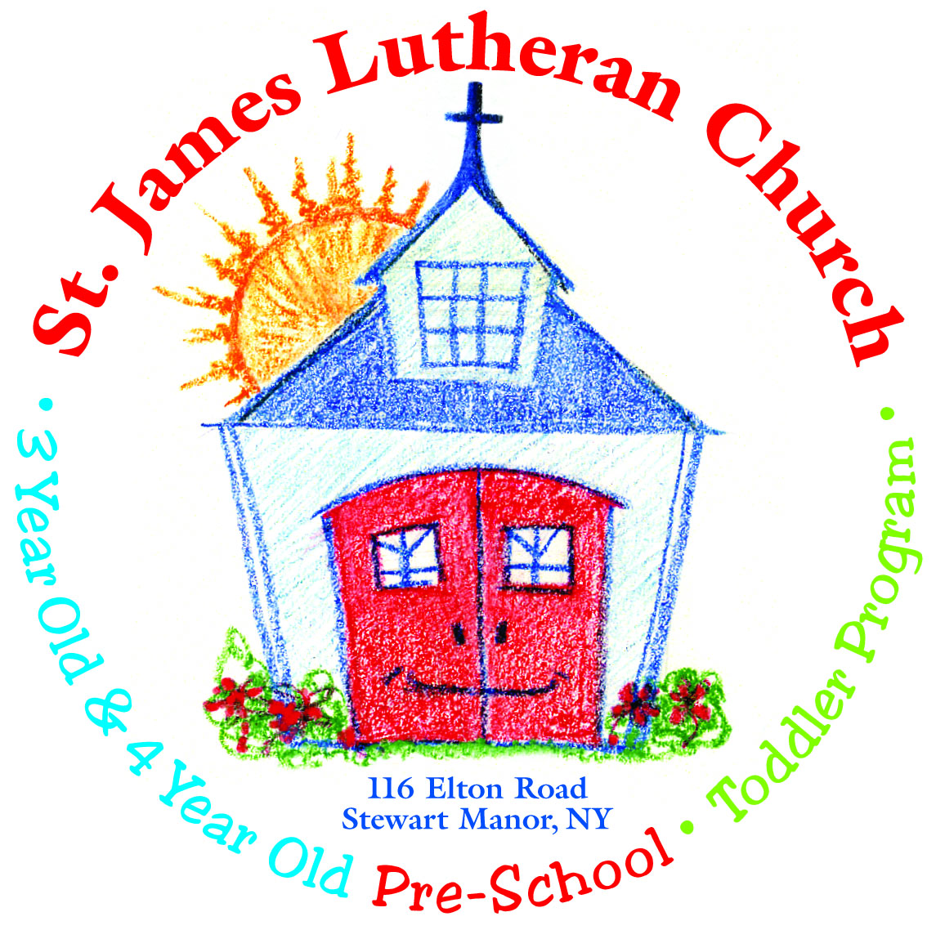

Summer Camp
2017

St. James Church is happy to announce the offering of our Summer Camp Program!

Our Summer Camp Program is available for children entering
Nursery School thru entering Kindergarten.
(3 years old by 12/1/17 and no older than 5 by 12/1/17)

Summer Camp Dates are as follows:

Tues – Wed – Thurs from 9:00 am – 12:00 noon

2 Sessions Available
Session I: July 11, 12, 13 & 18, 19, 20
Session II: Aug 1, 2, 3 & 8, 9 & 10

Cost: $140. per session

40. per session

Registration begins Monday, May 1, 2017.

A non-refundable full payment is due at the time of registration.

Registration forms may be picked up or dropped off between the hours of 8:30 and 11:00 am and may be placed at any time in the mail slot of the side (brown) door of the church on Elton Road.

Don’t delay…this is a popular program and space is limited!!

Please call us at (516) 352-4099 if you have any questions.

***Children must be potty-trained to attend***

