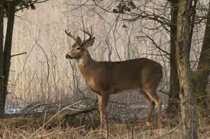
Member Waiver and Indemnification
CAMP CREEK HUNT CLUB
158 Pine Valley Drive, Stanley N.C. 28164
Greg Carroll, Treasurer (704)-681-0086
www.campcreekhuntclub.org

I, ________________________________________ (print name) obtain permission to use “CAMP CREEK HUNT CLUB” land as a member, my heirs and personal representative, waive and release “CAMP CREEK HUNT CLUB”, it’s employees, agents, licensees, and representatives (collectively “CAMP CREEK HUNT CLUB”) from any Claim or loss surrender by me and arising from my use of, or presence on “CAMP CREEK HUNT CLUB” lease.
In addition, I will indemnify and defend “CAMP CREEK HUNT CLUB” from any claims or loss allegedly caused by any act of omission by me and arising from my use of, or presence on, “CAMP CREEK HUNT CLUB” leased land.

_________________________________________ ________________
Signature of Member Date

___________________________________________________________
Witness:

