Kentucky
High School Rodeo
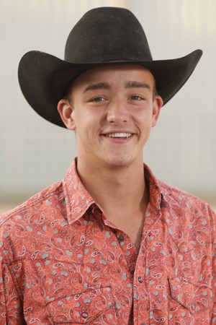
The Wyatt Cole Invitational

March 13 & 14, 2021
Central KY Ag/Expo Center
678 Wallace Wilkinson Blvd
LIBERTY, KY
Practice only: Friday, March 12
$5 per run, 60 second time limit, unlimited runs
POLE WARM-UPS: 7-8:30pm
BARREL WARM-UPS: 8:30-10pm

KENTUCKY & INDIANA HIGH SCHOOL & JUNIOR HIGH

SATURDAY 10:00 AM
SUNDAY – Cowboy Church 7:30 AM
Rodeo 9:00 AM
**MASKS REQUIRED**
- Negative coggins and health papers required
- All dogs must be on a leash

WWW.KYHSR.COM

CONCESSIONS
AVAILABLE

