

COUNTRYSIDE AT CUMBERLAND
2023 HOMEOWNER’s MANUAL
Updated March 2023

www.countrysideatcumberland.com



Countryside at Cumberland

Dear Countryside Resident,

We are excited that you have chosen to live in one of the best condo communities in Smyrna. Countryside at Cumberland was built in 1984 and consists of 212 condos. Your neighbors have diverse backgrounds, professions and personal interests with whom you share something in common – your residential community. We strongly encourage you to get to know your neighbors and become active in the community. We hope you are as happy with Countryside as we are.
By purchasing a residence at Countryside at Cumberland, you have automatically become a member of Countryside at Cumberland (the "Association"). Our Condominium Association is governed by the Declarations, By-Laws and this Homeowner Manual ("Manual"). As a member of the Association, each homeowner or resident is responsible for reading, understanding and abiding by these policies.
This Homeowners Manual is intended to be a handy reference for rules, regulations and guidelines to ensure that Countryside is a pleasant place to live. The Manual provides answers to the most frequently asked questions and concerns. This Manual summarizes the Association’s Declaration of Condominium and the By-Law. These documents are the final authority on rules and regulations.
The policies adopted by the Association as outlined in our official documents or in this Manual are designed to protect our property values, provide a safe community and insure comfortable living conditions for everyone in the community. These policies provide equity and equality of privileges, rights, protection, and safety for all homeowners and residents. These policies may be amended from time to time and amendments become effective upon publication to the homeowners. If you have questions about a policy or need to obtain copies of the Association’s documents, please contact Sharper Image Management Consultants, our property management company.
We realize that there is always room for improvement and the Board always welcomes your ideas. Homeowners and residents may contact the property management company or Board members as listed on the "Important Phone Numbers" page of this Manual.
Best regards,

The Countryside at Cumberland Board of Directors

Countryside at Cumberland Homeowner Manual Table of Contents

Letter from the Board Page 2

Important Phone Numbers Page 5

General Information
The Association Page 6
The Board Page 6
Association By-Laws and Declaration Page 6
Authority and Enforcement Page 7
Violations / Disputes Page 7
Annual Homeowners' Meeting Page 8
Newsletters Page 8
Community Involvement Page 8

Financial Affairs
Financial Reports Page 8
Association Fees Page 8
Special Assessments page 9

Property Management
Sharper Image Management Consultants, Inc. Page 10
Emergency Information Page 10
Regular Non-Emergency Page 11
Building Repairs Page 11
Gutter Cleaning Page 11
Pest Control Page 11
Plumbing Leaks Page 11
Roof Leaks Page 12
Termite Control Page 12

Insurance Page 12

Amenities
Access Key Page 13
Pool Page 13
Pool Rental Page 14
Tennis court Page 14

Architectural Standards
General Page 14
Decks / Patios / Screen Doors Page 15
Dishes – Satellite / Electrical Devices Page 15
Landscaping Page 15
Lighting Page 15
Window Treatment Page 16

Table of Contents (continued)

General Policies / Rules
Barbecue Grills Page 16
Condo Use Restrictions Page 16
Fireplaces / Firewood Storage Page 16
Fireworks Page 16
Heating of Units Page 17
Leasing Your Unit Page 17
Noise Nuisance Page 17
Parking/Vehicles Page 18
Pets Page 19
Security Page 20
Selling Your Condo Page 20
Signs / Bulletin Board Page 20
Storage Bins Page 20
Trash/Recycling Page 20

Maps

Emergency Water Shut Off Valve Map Page 22
Pet Walking – Designated "Dog Walking" Areas Page 23

Disclaimer: This Manual is intended to supplement the Declaration and By-Laws of the Countryside at Cumberland Condominium Association. Any conflict between those documents and this Manual shall be determined in favor of the Declaration and By-Laws in that order. Homeowners and occupants are advised to review those documents carefully and completely.

CONTACT INFORMATION & IMPORTANT PHONE NUMBERS

EMERGENCY | 911
Police Non-Emergency | 770.434.6666
Fire Non-Emergency | 770.434.6666
Poison Control | 404.616.9000 9287 (TTY)
Cobb Country Animal Control | 770.499.4136

UTILITIES
Atlanta Gas Light (to report gas leak) 770.907.4231 Georgia Power (to report outage) 888.660.5890

MANAGEMENT COMPANY
Sharper Image Management Consultants
P.O. Box 6188 PH: 770.973.5923
Marietta, GA 30065-0188 FAX: 770.973.5911
Website: www.SharperImageManagement.com

BOARD MEMBERS (as of 2023) |  | Advocate for Buildings:
Skyler Akins, President | 770.841.4409 | 6, 7, 8, 9
Justin “JZ” Ziegler, Vice President | 404-822-7967 | 5, 10, 11, 12
Larita Sprott, Treasurer | 770-436-1453 | 13, 14, 20, 21, 22
Robert Seith, Secretary | 770-331-2502 | 1, 2, 3, 4
Ryan Roussel, Member at Large 404-429-7067 15, 16, 17, 18, 19

ASSOCIATION’S INSURANCE
To obtain a copy of the Association’s Certificate of Insurance for your records, call Dreher Insurance at 678-205-0224 (effective July 1, 2006)

NEIGHBORHOOD
Cobb County Transit | 770.427.4444
US Post Office | 800.275.8777
Smyrna Public Library | 770.431.2860
Smyrna Community Center | 770.431.2842

PLUMBERS
Homeowners may use any plumber of their choice but the following plumbers are familiar with the property and are authorized to bill the Association should the leak stem from damage to an Association line. This plumber will require that you guarantee payment before they will come out but will bill the association if the leak/repair is an Association responsibility.
Hill Mechanical 770.792.1200
The Pipe Medic 770.733.3522

GENERAL INFORMATION

THE ASSOCIATION
Countryside at Cumberland Condominium Association ("Association") is composed of all homeowners at Countryside. Our goal is to preserve, protect and improve the community’s property values and image for the benefit of its members.

THE BOARD
The Board ("Board") consists of five homeowners from the community. Eligible homeowners are elected at the Annual Homeowners' meeting to serve two-year terms. Terms are staggered so that no more than three Directors’ terms will expire in any one year. Board Membership is a volunteer position and Board Members do not receive any financial compensation or reduction in Association fees for their contribution to the community.

The Board is responsible for managing the affairs of the Association in accordance with the Declaration(s) and By-Laws as well as stated rules and policies. The Board makes decisions related to the Association’s finances, awarding contracts, setting policies and goals as well as directing the property’s Management Company.

Board meetings are open to all homeowners and residents. However, you must provide seven (7) days’ written notice to the Association’s Management Company or contact a Board Member of you intend to address a specific issue. This will allow us to schedule the meeting location and agenda accordingly. A portion of the Board meetings may be limited to Board Members only for discussions of sensitive Association business and the financial accounts of individual homeowners. Board meeting minutes are available to homeowners upon request. The Board will provide updates on the business affairs of the Association through quarterly newsletters distributed to the homeowners and residents.

General maintenance and policy questions should be directed to the property Management company. Homeowners are welcome to contact Board Members if you have questions relating to the policies of the Association or the effectiveness of our property Management Company in addressing your concerns. Each Board Member has been assigned specific buildings to oversee and the Board member designated for your building should be contacted if you have any questions or concerns about the Association. Contact numbers and building assignments for Board Members can be found on the "Important Phone Numbers" page of this Manual. Board Members will make every effort to return calls in a timely manner. If your Board Member does not contact you in a timely manner, please feel free to contact another Board Member.

ASSOCIATION BY-LAWS AND DECLARATION
The Declaration and By-Laws are the governing documents of our Association. Homeowners may download a copy of Association documents from the community’s website – www.countrysideatcumberland.com. Homeowners may also obtain a replacement copy of the Declaration or By-Laws by requesting a copy through the Sharper Image Management Company website - www.SharperImageManagement.com

Please contact Sharper Image Management ("Management Company") 770-973-5923 or office01@comcast.net with any questions regarding the Association’s policies and rules.

AUTHORITY AND ENFORCEMENT
The Board has the power to impose fines against owners and their tenants or occupants that constitute a lien upon the unit. In the event of a violation, the Board will send written notice to the owner and/or tenant/occupant, if applicable, allowing ten (10) days to resolve the violation. If the violation is not resolved, the Board may impose fines, suspend parking privileges, and/or bring legal action against the homeowner to ensure compliance with the Declaration, By-Laws, rules and regulations of the Association.

Any homeowner may submit a written statement to the Board, requesting a hearing on the alleged violation. Requests must be submitted within 10 days of the notice of the violation. Homeowners will be given a block of time (approximately 15 minutes) to state their case. The Board will convene in Executive session to consider the Homeowners input and will provide written notification of the Board’s decision within 7 days.

VIOLATIONS / DISPUTES
If you wish to report a violation of Association rules of another homeowner or tenant, please submit the details in writing to the Sharper Image Management. Violations should be reported in writing to the Management Company, and include the following information:

- Unit number and/or name of person(s) in violation
- Description of the violation
- Parties involved in the violation
- Date(s) and time(s) of the violation
- Name, unit number, and telephone number of the person reporting the violation(s).

Anonymous reports of violations might not be acted upon. The Management Company is empowered by the Board to respond appropriately to all reported violations. Civil Violations, such as burglary, vandalism, trespassing, disorderly conduct, excessively loud neighbors or animal endangerment should be reported to the local authorities first, then followed up with written notice to the Management Company or member(s) of the Board.

Resolving Disputes with Neighbors – Many disagreements or concerns with neighbors can be easily resolved with respectful and effective communication. Residents who feel that a neighbor is disturbing them should approach the neighbor in a calm and reasonable manner or leave a note indicating their concern. The Board, via the Management Company, should only be called upon when there is an impasse. Resident(s) should submit complaints or concerns in writing to the Management Company who will forward it to the Board. After a review by the Board, and on behalf of the Association, the Management Company will, if necessary, send a letter to the person (homeowner and/or tenant) explaining the violation to them and any resulting consequences. Residents who feel they have been falsely accused or who dispute the allegation should submit, in writing, their rebuttal or concern. Residents can also attend Board meetings to state their cause during the open forum session of the meeting and ask the Board to review the matter. Even then, however, the matter may be beyond the authority of the Board to resolve.

ANNUAL HOMEOWNERS’ MEETING
The annual homeowners’ meeting is open to all homeowners and residents of the community. Held in the fall, this meeting serves as a forum to review projects completed, provide Financial Report and Budget of the association as well as discuss goals for the upcoming year. Board member elections are also conducted at this meeting. Notice of the meeting date and location will be sent to homeowners at least 21 days prior to the meeting. As per Article 1, Section 4 of the By-Laws, the Board may prohibit any homeowner from voting if he/she is shown to be more than 30 days delinquent in any payment due the Association or is found to be in violation of the Declaration, By-Laws or the rules and policies set by the Board.

E-NEWSLETTERS
The Board will send notices to the community of Association news via e-newsletters. Please make sure Shaper Image Management has your current e-mail to make sure that you receive these communications.

COMMUNITY INVOLVEMENT
Successful management of our community depends on the support of every homeowner and resident. Please notify the Board of any special interests and knowledge you possess which may be of benefit to the community. The newsletters may contain additional volunteer opportunities to consider. All homeowners should be aware of emergency phone numbers, including the phone numbers for homeowners in your building, and basic homeowner responsibilities (insurance coverage, Association policies, and restrictions, etc.

FINANCIAL AFFAIRS

FINANCIAL REPORTS
Upon request, the Association’s financial documents and records are available to any homeowner for review during normal business hours. Please forward requests to the Management Company to set a time to review these financial documents.

ASSOCIATION FEES
Association fees cover a wide variety of amenities and maintenance costs for the community and are based on the square footage of the condo unit. Association fees are due by the 1st day of the month. Payments are posted based on the address printed on your check. If the address on your check is different from your unit address, please note the unit address in the ‘For’ section of your check. Payment envelopes are distributed to homeowners prior to the beginning of each calendar year. If you have not received your envelopes or are a new homeowner, please contact the management company. For information on fees and where to send payment, contact the Management Company.

Any assessment payment not received by the 10th of the month will be considered delinquent. Actual receipt or a post office certificate detailing mailing date shall govern. A 10% late fee and interest in the amount of 10% per annum may be added. Assessments more than 30 days late may be brought to the attention of the Association's attorney and any consequent attorney fees and expenses will also be charged to the homeowner. Any homeowner more than a month behind in their dues will be provided with 1 courtesy call and a written notice. If homeowner fails to make payment or contact Sharper Image,

the homeowner’s right to park vehicle(s) on the property will be revoked and will result in their vehicle
being towed off the property.

The Board has the power to accelerate the budget assessment of any homeowner who is not timely and current in the payment of the monthly assessment. If accelerated, the budget assessment will become due and payable in advance for the entire fiscal year of the Association.

The following is a partial list of expenses that are covered by your Association fees, as well as a list of items that are the responsibility of individual homeowners. This list is intended for illustrative purposes only and may not be applicable in all situations. Homeowners should consult the Association’s Declaration and By-Laws for more information regarding costs covered by the Association versus homeowners.

Association Responsibility:
- Decks & stairs
- Exterior Building Surfaces
- Exterior spotlights/electricity
- Exterior trim of doors / doorways
- Gutters
- Insurance **
- Landscaping and Common Areas*
- Mailboxes
- Plumbing – common pipes ***
- Pool-maintenance, phone, furniture, etc.
- Roofs and Chimney caps
- Sewage lines
- Termite Bond
- Trash removal
- Water
Homeowner Responsibility:
- Air conditioner
- Chimney cleaning & inspections
- Doors, doorways – exterior surface, frame, hardware
- Dryer Vent Cleaning
- Heater
- Homeowner’s individual insurance policy
- Household appliances
- Interior ceiling, wall and floor surfaces
- Interior Pest Control
- Plumbing – pipes which provide service to your unit exclusively ***
- Screen doors****
- Water heaters
- Windows

- Common areas are defined as “all parts of the Condominium property not located within the boundaries of a Unit.”
** The Association’s insurance consists of general liability policy that covers the common areas; a policy covering property damage for the property and Directors and Officers Insurance. Homeowners are required to maintain a homeowner’s policy that covers the content of their home and Fire/Water Deductible on the Association Policy.
*** Plumbers listed in this Manual are authorized to bill the Association should the problem be the Association’s
responsibility. However, you do not have to use these plumbers and can use a plumber of your choice.
**** Must request and receive approval prior to installation.

SPECIAL ASSESSMENTS
When deemed necessary for capital improvements to the property or to address emergencies that will severely deplete our Reserves, the Board has the authority to impose Special Assessments against the homeowners in addition to the monthly Association fees. Without a vote by the Association membership, up to $200 Special Assessment per year can be levied at the Board’s discretion. An affirmative vote of at least 66% of the Association membership is required to have a Special Assessment of more than $200 passed in a calendar year. Due date and payment information will be provided to homeowners if and when a Special Assessment is passed. The Board makes every effort to plan so that Special Assessments will not be necessary.

Failure to Pay monthly Association fees, Special Assessment fees or late charges will result in the following:

- 10 days delinquent – courtesy letter or e-mail to homeowner stating account is delinquent
- 30 days delinquent - Two (2) courtesy calls placed to homeowner
- 60 days delinquent – Delinquency letter sent to homeowner. If no response in 7 days, suspension of on-site parking privileges and other community amenities. Homeowner’s or tenant’s vehicle will be towed off property at owner’s/tenant’s expense without further notice. Tow notice will remain in effect for 6 months and homeowner must remain in good standing or vehicle is subject to tow if account falls delinquent during the 6-month time frame. Furthermore, if the homeowner is routinely delinquent the board has the right to request dues for the remaining year to be paid in full within 7 days.

PROPERTY MANAGEMENT

SHARPER IMAGE MANAGEMENT CONSULTANTS, INC. ("Management Company")
Sharper Image Management is a professional property management company that has been retained since June 1998 to handle the management of our community. This includes bookkeeping, the securing and management of contractors, as well as supervision of ongoing maintenance contracts. The Management Company does not have the authority to make spending decisions for any projects on the Association’s behalf as this is the responsibility of the Board. The Management Company should be contacted regarding all maintenance and emergency situations. Regular office hours are Monday-Friday from 9am-noon and 1pm–4pm. Please contact Sharper Image for any of the following:

  - Request copies of or clarification on the Association’s Declaration, By-Laws, Homeowners Manual
  - Request copies of Association’s official documents and records – Board Meeting Minutes, Association Financial, Budget, etc.
  - Clarification of homeowners Association fees, special assessment fees (if any apply), how to pay fees, etc.
  - Requests or reports for general maintenance to the common areas of the property. Homeowner is responsible for maintenance fees for items inside unit but if these affect repairs overall building repairs or will impact others in your building, please advise Sharper Image.
  - Requests for parking permits or amenity keys.
  - Questions regarding violations or fees.
  - General questions regarding the property, your responsibility as a homeowner, amenities available, maintenance issues, etc.

EMERGENCY
Emergency situations should be reported by phone ASAP. A 24-hour service is provided to report emergencies (plumbing leak, property damage, injury, etc). Please call 770.973.5923 and a representative will contact you. In the unlikely event that your call is not returned within 30 minutes please try again. Please be aware that using this paging system outside of regular business hours for non-emergency calls will result in a $45.00 charge being assessed to your unit. Homeowners are responsible for securing the home, work, and emergency contact numbers of their neighbors in case of an emergency.

REGULAR (NON-EMERGENCY)
Regular requests for the management company should be made in writing which will allow us to track and respond to your request in the most efficient manner possible. Requests should be submitted via Sharper Image’s website on the maintenance request form as detailed below. Requests can also be mailed, faxed or e-mailed.
WEBSITE www.SharperImageManagement.com To complete and online request form:
- Visit website
- Click on blue door
- Select appropriate item on the left menu
- Click Forms for Maintenance/Violation type requests MAIL: P.O. Box 6188 Marietta, GA 30065-0188
FAX: 770.973.5911
E-MAIL: office01@comcast.net PH: 770.973.5923

BUILDING REPAIRS
In an effort to control costs, the Association completes general building repairs and improvements once a year. Emergency repairs, such as roof leaks, should be reported immediately to the Management Company and will be repaired on an “as needed” basis. Each spring, a notice is sent to all homeowners requesting that the homeowner inspect their unit and the surrounding area. Any requests for repairs should be indicated on the form provided and submitted by the designated date. This allows the Board and the Management Company to prioritize these projects and award the completion of these projects at a great savings to the Association. Each year we will complete as many repairs as the year’s budget allows. However, in the interim, homeowners should promptly report in writing to the Board or its Management Company any emergency defect or need for repairs where the Association is responsible for such repairs or maintenance. If in doubt, contact the Management Company.

GUTTER CLEANING
The current budget allocates finances to complete gutter cleanings three times per year. This work is generally performed in January, April and July.

PEST CONTROL
If inside the unit, pest control is the Homeowner's responsibility. If outside the unit, contact the Management Company for information/clarification as to responsibility.

PLUMBING LEAKS
If you are experiencing a plumbing leak, please contact a plumber listed on page 3 or a plumber of your choice. The plumbers listed are familiar with the property and are authorized to bill the Association should the leak stem from damage to an Association line. The plumber will require that you guarantee payment before they will come out but will bill the Association if the leak is an Association responsibility. Please notify your neighbors and the Management Company (or their answering service) if water must be cut off to your building to make a repair and provide the estimated time that water service will be restored. Homeowners should be aware of the emergency water shut off valve for your building (see Emergency Water Shut Off Valve Map, Page 22).

Homeowners should provide the Management Company with emergency contact numbers and a secondary contact that can act on your behalf should your unit experience water damage and you cannot be reached. In the event that no one can be reached and a plumbing issue in your unit is damaging another unit, a locksmith and a plumber will be contacted, and your unit will be billed for their services as well as additional management time for processing this emergency. You should keep the Management Company up to date with any contact phone information.

ROOF LEAKS
Roof leaks will be repaired on an “as needed” basis. For safety reasons, roof leaks cannot be repaired during a rainstorm and therefore do not constitute an emergency, so please do not use the paging service for this. Contact the Management Company to schedule repairs as soon as possible. Please keep in mind that the source of roof leaks is very hard to determine and it may require multiple trips from the roofing company to determine and correct the problem. As per the Association’s documents, the Association is not responsible for interior damage caused by water leaks provided that the Association does not act negligibly and fail to respond to correct the problem.

TERMITE CONTROL
The Association has a termite bond that treats outside areas of infestation at no cost to the homeowner. If you see or suspect termites, please contact Arrow Exterminators (770-732-0300). During the termite season you may experience delays in service from the termite company in excess of 30 days. Also please note that the termites that you may see flying are ‘swarmers’ that do not eat wood and die within a 24- hour period. If they become a nuisance, hair spray is a good remedy to rid you of these pests.

INSURANCE

The Association maintains an insurance policy that covers the common areas of the community. This policy includes coverage for fire and extended coverage for the amount of the full replacement value of all structures within the community. The policy includes liability insurance policies for worker’s compensation and death or injury as a result of incidents occurring in common areas. Officers/ directors liability insurance is also covered in the Association’s policy.
Homeowners are required to maintain insurance policies covering their unit and personal property. Every homeowner is required, pursuant to Article VI, Section 2 (f) of the By-Laws, to obtain and maintain at all times insurance covering the structural portions of his/her/their unit to the extent not insured by policies maintained by the Association. Every homeowner is required to obtain and maintain insurance covering consequential damages to any other unit or the common elements due to occurrences originating within the homeowner’s unit caused by (1) negligence of the homeowner, (2) the failure of the homeowner to maintain the unit, and (3) other casualty within the unit which causes damage to the units or common elements.
It is the responsibility of each homeowner to ensure that their policy covers the Association’s deductibles.
All homeowners should carry an additional policy (HO6) that covers personal property loss, liability, etc.

The Association is not responsible or liable for injury or damage to persons or property, including the interiors of residences, (a) caused by the elements or by any person; or (b) resulting from any utility, rain, snow, or ice, which may result in a leak or flow from any portion of the common elements; or (c) caused by any pipe, drain, conduit, appliance or equipment, even when the Association is responsible for its maintenance. When damage is being caused by any reason originating from the common areas, however, residents should promptly notify the Management Company so appropriate mitigating actions may be taken.

The Association's insurance coverage does not provide liability coverage to homeowners or residents for claims arising within individual units, or caused by the resident or resident's agents or invitees. It also does not provide hazard insurance for residents' personal property, or for improvements and betterments to units.

Due to the possibility of misinformation being distributed to the membership, neither the Management Company nor the Board will discuss insurance information. Homeowners must direct all questions and requests for certificates of insurance to the Association’s insurance agent Joe Dreher at Dreher Insurance 678-205-0224.

AMENITIES

ACCESS KEY
Each homeowner in good standing will be provided with one (1) non-reproducible key that opens the pool gate, pool restrooms and tennis court gate. This key is for homeowners and tenants only and is not to be provided to outside parties. In the event a key is lost, contact the Management Company for a replacement key. Homeowners will incur a charge of $25 for each replacement key.

POOL
Admittance to the pool area requires use of an access key. The pool is a common area amenity to be shared with other residents. To ensure safety and enjoyment of this area, please abide by the posted rules, as well as the policies listed below when enjoying the pool area. Violations to the stated rules can result in fines or suspension from use of the pool.
- Pool Hours 8:00 AM – 10:00 PM.
- Please keep pool gate locked at all times. Gate should never be propped open. If the Health Department observes this gate being unlocked or open, this can result in closing of pool.
- No lifeguard on duty – swim at your own risk.
- Four (4) guests per resident limit. Countryside residents must accompany their guest(s).
- Proper swimming attire required at all times. Cut-offs are not acceptable.
- Shower before entering pool.
- No alcohol is allowed in pool area per Cobb County Ordinance.
- No glass or breakable items permitted in pool area.

- Running, pushing or boisterous conduct is prohibited in the pool area.
- Loud or objectionable noise is prohibited.
- Please clean up all litter and arrange any misplaced furniture, before leaving.
- Children (12 years old and under) must have adult supervision at all times.
- No diapered children allowed in pool.
- No pets are permitted in the pool area. The presence of pets in the pool area could result in Cobb County closing the pool or imposing sanctions. If this happens, the pet homeowner will be held responsible for all resulting costs to the Association.
- If you open an umbrella, please close it before you leave to prevent possible storm damage and costly replacement expenses.

POOL RENTAL
Homeowners may rent the kitchen and a portion of the upper deck area for private parties at a cost of
$75.00. Rentals are restricted to five (5) hours and no rentals are permitted on holidays, to ensure that homeowners can enjoy the pool. Rentals are limited to no more than 40 guests. During private parties the pool deck area and restrooms must remain open for other Countryside residents’ use. In all cases, the renting homeowner will be held responsible for the actions of their guests and any damages that result. The renting homeowner is obligated to ensure that alcohol is not served. Regular pool and tennis court rules apply during any rentals.

TENNIS COURT
Use of the tennis court is restricted to Countryside residents and their guests. The court is restricted to tennis only (no rollerblading/skateboarding), and proper attire (tennis shoes only) is required. Please see sign at court for further information. Violations of these policies or posted rules will result in a fine of up to $100.00 for each infraction and suspension from use of the tennis court area.

ARCHITECTURAL STANDARDS

GENERAL
Patios, balconies, stairwells, walkways or any common or limited common areas open to general view are not to be used for storage of any kind, especially when such storage interferes with ingress/egress from unit.

No construction, alteration, addition or change of any kind shall be made upon any part of the property unless written plans detailing the nature, shape, dimensions, materials, color, cost and location are submitted to and approved by the Board. The Board has sixty (60) days to respond to the homeowner’s proposal.

Any approved architectural modification shall be the on-going maintenance and repair responsibility of the unit homeowner making the modification and his/her/ their successor-in-title to the unit. In the event these modifications interfere with the Association's maintenance on the buildings, it is the responsibility of the homeowner to remove and replace the modification when maintenance is completed.

DECKS / PATIOS / SCREEN DOORS
Residents shall keep their patios and decks clean and neat, so as not to cause a nuisance to their neighbors. Patio umbrellas must be under 6’ in a neutral color and not extend beyond the space of your patio. Only potted plants and furniture designated for outdoor use are permitted on decks/patios. All personal property such as trashcans, garden hoses, children's toys, bicycles, rafts, must be kept out of sight and inside the residence when not in use. Residents are responsible for ensuring decks/patios, sidewalks, entry passages and stairs remain free of obstructions, storage and trash. Storage/trash is not permitted in these areas and could result in fines being assessed against the unit. All items must be secured to prevent these items from falling and injuring another party. Homeowners will be held responsible for injury or damages caused by such incidents.

The Association maintains, as a common expense, all common areas. In addition, the Association maintains the following parts of the building, even when within the boundaries of a resident unit: exterior surfaces (including painting, roof shingles front doors), porches/decks, stoops, landings and steps.

Homeowners may install screen/storm doors on front entrance and deck doors provided they are white to match existing trim color and written pre-approval is obtained. Homeowners who had previously installed brown or black doors do not have to remove existing screen doors.

DISHES – SATELLITE / ELECTRONIC DEVICES
No satellite television dishes, speakers, or any other electronic or sound devices shall be installed on the exteriors of buildings, including decks and patios without prior written Board approval.

LANDSCAPING
The Association maintains all landscaping, trees and shrubbery in the common areas on the property. No changes to the landscaping around the buildings may be made without the Board’s prior written approval. Homeowners may be permitted to plant flowers in/around their units provided they seek board approval prior to planting. Any damage to common areas caused by homeowners' plantings is the responsibility of the respective homeowners.

No stones or other landscaping materials shall be used in the common areas without prior written approval of the Board. Among other concerns, stones might be picked up and thrown by lawn-mowing equipment.

LIGHTING
Individual porch lights and the maintenance of these lights (bulb replacement, loose fixtures, exposed wiring) are the responsibility of the homeowner. Any replacement fixtures that homeowners install must be consistent with the original fixture and are subject to Board approval. No colored light bulbs are permitted.

Photo sensors control street lighting throughout the complex and security lights on buildings. If you notice a problem with any of these lights, please advise the Management Company.

WINDOW TREATMENT
Decorative window treatments visible from the outside of units shall exhibit only a white or near-white color. No patterns, prints or plaids of any type should be visible from the outside of your unit.

GENERAL POLICIES & RULES

For the safety of the community and protection of the property, the Association has implemented rules and policies. Failure to respect these rules will result in a courtesy call to homeowner to remedy the violation and if infraction is not corrected, Association will impose fines against violating homeowner.
If there is some Bylaws violation by a Homeowner, Sharper Image will give that homeowner a courtesy call first, then if the Homeowner does not correct the infraction Sharper Image will follow up with a letter detailing the infraction action or fine to be imposed.

BARBECUE GRILLS
The City of Smyrna fire code prohibits the use of flame-producing grills within multifamily complexes. Propane and charcoal grills of any kind are not permitted. Electric grills that do not produce flames are permitted. Violations will be handled through citations and fines issued by the City of Smyrna. The use of unauthorized grills will result in the issuance of a fine of up to $100.00 against the offending owner/tenant. If you witness use of unauthorized grills, please advise the Management Company, in writing. If you witness a fire resulting from a grill, please contact the fire department.

CONDO USE RESTRICTIONS
Each unit shall be used for residential purposes only. No trade, profession or business of any kind may be conducted either as a primary or accessory use in or from a unit or any part of the condominium; provided however, a homeowner or occupant may conduct such business activities within the unit as long as (a) the existence of the business activity is not apparent by sight, sound or smell from the exterior of the unit, (b) the business activity does not involve persons coming onto the property who do not reside on the property, (c) the business activity conforms to all zoning requirements for the property, and (d) the business activity is consistent with the residential character of the development and does not constitute a nuisance or a hazard or offensive use, as may be determined at the sole discretion of the Board.

FIREPLACES / FIREWOOD STORAGE
Homeowners who use their fireplaces are encouraged to have annual chimney cleaning and inspections. If needed, you can contact the Management Company to obtain the name of a reputable contractor.

Firewood must be stored on commercial storage racks that keep firewood at least 3 inches off of any deck/patio, wall or wood surfaces. Firewood must be neatly stacked and should not exceed the height of the patio rail.

FIREWORKS
Fireworks are prohibited on Countryside property.

HEATING / AIR CONDITIONING OF UNITS
To prevent frozen pipes and resulting property damage, during extreme cold weather months (October – April or as weather dictates) thermostats within all units shall be maintained with the heat in an ‘on’ position at a minimum setting of 60° Fahrenheit. To prevent mildew, homeowner must set AC to 82° or lower during the months of May – September. Homeowners and occupants shall take all steps necessary to keep heating and air conditioning equipment in good working order and repair. The Association may fine any homeowner or occupant up to $500.00 as well as other remedies for any violations of this policy.

LEASING YOUR UNIT
To maintain the status of Countryside at Cumberland Condominiums as a non-investment community and protect overall property values, no more than 20% of our units can be leased at any one time. Any homeowner intending to lease their residence must provide notice to the Association via the Management Company or obtain permission to lease your unit. If the community has 20% already leased, homeowners name will be placed on waiting list for the right to lease and will be notified when the Association can grant the right to lease. This approval will only be granted when existing lease approved units change their status back to owner occupied due to the homeowner deciding to move back into their unit or by selling their unit to a new owner.

Upon approval to lease, homeowner must furnish $750 leasing fee, copy of the signed lease and contact information for tenant. $750 lease fee will be charged each time you change tenants.

It is the homeowners’ responsibility to maintain that Association fees and Special Assessments are paid in a timely manner. It is the homeowner’s responsibility to ensure that tenants/lessees are abiding by the rules and policies of the Association, including securing parking permits for any vehicle(s). Any violation will result in monetary fines, suspension of parking privileges, and/or legal action against the homeowner of the unit. Homeowners are responsible for forwarding correspondence to their tenants/lessees that pertains to the community.

NOISE / NUISANCE
All residents are entitled to the quiet enjoyment of their residences. We all live in close proximity to one another and common courtesy and good sense are the standard to be used with regard to noise. Noise at a sufficient level to disturb other residents in your area of the community is unacceptable. Homeowners should call the police for any noise ordinance. If the police issue a citation, and a copy of that citation is provided to Sharper Image, the Homeowner who was cited will be fined by the Association. Fines will be determined by the Board of Directors at the next applicable Board Meeting and will range from $25 -
$100 depending on the severity or frequency of the offense.

Noxious or offensive activities shall not be carried on in any residence unit or in the common areas. Each homeowner or lessee and his/her/their family, visitors, guests and agents shall refrain from any act or use of the property which could reasonably cause embarrassment, discomfort, annoyance or nuisance to other residents, or which could result in the cancellation of insurance on any part of the property, or which would be a violation of any law or governmental regulation. No odors shall be permitted to arise so as to render any portion of the property unsanitary, unsightly, offensive or detrimental to persons using the property.

Due to the subjective nature of noise and nuisance issues with neighboring condos, homeowners are instructed to contact the Smyrna Police (770.434.6666) who will issue a warning to the homeowner. If you wish to have the Board issue a warning and possible fine for a noise violation, a police report must be attached to your written request which you can mail or fax to the Management Company.

PARKING & VEHICLES (summery -see covenants for full details)
The following policies have been established to address a number of public safety and convenience concerns for the benefit of all homeowners and residents.

Speed Limit / Vehicle Operation - To ensure the safety of all residents, there is a 15-mph speed limit throughout the community which applies to all homeowners, residents and their guests. Violators will be fined up to $100.00 per infraction. If the violator is a guest, the fine will be levied against the homeowner.

Vehicles are not permitted to be operated or parked in any unpaved areas. No vehicles are to drive through the community with radios blaring in such a manner to create a nuisance for other residents.

Parking - Parking at Countryside is limited and residents are asked to be courteous and park to maximize parking in your parking area. Do not take up more than one space for your vehicle. To prevent damage to landscaping and other infrastructure, vehicles must be parked forward facing in parking spaces and should not be backed in. Parking spaces in front of each building are reserved for residents. Homeowners should direct their visitors to park their vehicles across from the building so as to not block your neighbor’s access to their residence.

Improperly parked (blocking fire lanes, walkways or obstructing traffic), disabled, or abandoned
vehicles may be towed at the homeowner’s expense as pursuant to Georgia Code (44-1-13).

Vehicle maintenance (unless an emergency nature) of any kind is prohibited on the property. This includes oil, battery and tire changes. Any homeowner whose vehicle damages common area property (including oil leaks damaging the pavement) whether directly or indirectly shall be held liable for the cost to repair the damages incurred.

Parking Permit - Two (2) parking permits are provided for each residence at Countryside. Vehicles must have a parking permit sticker to be parked on the property for more than 2 weeks.
  - 2 parking permit per homeowner will be provided
  - Permits can be requested to Sharper Image by logging into www.sharperimagemanagement.com and then go to forms, and then vehicle information form.
  - Homeowner is responsible for obtaining parking permits from Sharper Image and display permit on authorized vehicles within 7 days of receipt.
  - Homeowner must be in good standing with regards to all association fees and special assessments (if any) to obtain parking permit and parking vehicle on the property
  - Authorized vehicles must be well maintained, licensed with current tags, and must be moved a minimum of once every two (2) weeks, so as not to give the impression of an "abandoned" vehicle.

    - No advertising of any kind is permitted on homeowner vehicles parked in the community.
This includes “For Sale” and signs designating company vehicles.
    - If a vehicle is found on property without an authorized parking permit, the vehicle will be identified and the homeowner, if they can be identified, will be alerted. If no owner or resolution is found, a violation letter will be placed on vehicle and owner of the vehicle will have 7 days to contact Sharper Image with details to resolve the matter. If no response is received within 7 days, the vehicle will be towed.

3rd vehicle parking permit – Parking at Countryside is highly limited, and most spaces are reserved for homeowners or official guests. A homeowner in good standing may request a third vehicle under the following conditions:
    - 3rd vehicle requests will only be granted space permitting
    - 3rd vehicle requests can be made in January or July
    - The cost of a third vehicle is $100 per month, payable in full, in advance ($600) for 6 months, January through June AND July through December. Not prorated.
    - Homeowner must be in good standing
    - Automobile must comply with all conditions of all other vehicles parked on the property, as defined in the Bylaws and Declarations
    - If a 3rd vehicle remains on the property without renewal and payment after any 6-month renewal month, Sharper Image will first give a courtesy call to the homeowner. If the 3rd vehicle account is not brought current after the courtesy call, Sharper Image will issue a tow request.

Visitor Parking - Any vehicle parked on the property that does not belong to a homeowner, for over 7 days, must be identified to Sharper Image via email or website so that a visitor’s temporary parking pass can be provided by email and displayed in the vehicle.

Towing - The name and telephone number of the Association's authorized towing company is posted on the sign at the front entrance.

Motorcycles – Motorcycles are only permitted with written approval from the board of directors. And can be revoked at any time by the board of directors and for any reason. There will be an annual motorcycle permit fee of $300.00, non-refundable.

Permittable motorcycles must be quiet.

PETS
Homeowners are allowed to keep two (2) pets per household. Only animals recognized as domestic house pets will be permitted on the property. No animal(s) considered dangerous by the Board are permitted.
No animal of any kind that is for commercial use shall be kept on the property.

Pets are required to be on a leash when they are walked outside of a unit and should not be left unattended. Residents are prohibited from leaving dogs unattended and leashed on decks, front porches, or in common areas. Pets making an unreasonable amount of noise or who are deemed a nuisance to the community will not be permitted. To report a pet violation, contact the Cobb County Animal Control office (770.499.4136). Violation letters and additional fines from the Association will be issued upon Sharper Images receipt of a written complaint along with a copy of the Cobb County Animal Control citation. Fine will range from $25 - $100 depending on the severity or frequency of the offense.

There are "Designated Dog Bathroom Areas" indicated on the map on Page 23. Homeowners or caretakers are responsible for immediately removing their pet's waste from ANY and ALL AREAS. Violators should be reported, in writing, to the Management Company and will be subject to fines.

Upon written complaint by a homeowner, the Board shall determine whether a particular pet is a nuisance and shall have the authority to require the homeowner to remove the pet from the premises.

SECURITY
Countryside has no on-premises security service or ‘official’ neighborhood watch program. Everyone is encouraged to report suspicious activity to the Smyrna Police (770.434.6666) or call 911 in emergency situations. Please also notify the Management Company or a Board Member if you are a victim of a crime or report a crime on the property so that we can advise the other homeowners.

SELLING YOUR CONDO
If you are selling your condo, please notify Sharper Image of your intent to sell and when it sells. No signage is allowed on the property except open house sign on day prior to open house and removed after open house.

SIGNS / BULLETIN BOARD
Signs of any kinds, including “For Sale” signs, are prohibited on the property. This includes signs at the
community’s entrance and signs inside condo windows that can be viewed from the outside.
Homeowners in the process of selling their condo will be permitted to place “Open House” signs at the community’s entrance and at their unit on the day preceding and the day of the actual open house.
Illegally placed signs will be removed. Fines will be levied on repeat offenders.

STORAGE BINS
Countryside has a limited number of storage bins available on property for homeowners to rent. Located in the 900 and 1500 buildings, rental of these bins will be provided on a first–come first-served basis.
Should there be a waiting list for renting bins, priority will be given to the first homeowner on the list that does not already have a bin. The Association is not responsible for any items stored in these areas.
Failure to provide timely payment or unauthorized use of a storage bin will result in possible loss of any property contained in the storage areas. Contact the Management Company for additional information on storage area rental availability and cost.

TRASH COMPACTOR / RECYCLING
Use of the trash dumpster/compactor and recycling area is limited to Countryside residents. Items for disposal should be contained in tied plastic bags and placed inside the compactor and not left outside the compactor. Neatness around the compactor and throughout the community adds to the "curb appeal" and value of our property.

Compactor Operation - Each time items are discarded, residents are asked to run the compactor in order to maximize room in the dumpster, reduce our collection costs and prevent trash overflows. Please follow posted instructions to run the compactor. If the compactor is not operating, please advise the Management Company.

Some items should not be deposited in the compactor or left in the compactor area as they can cause the compactor to malfunction or damage it, leading to costly service calls. The following materials should not be deposited in or around the compactor:
- Paint
- Tires
- Motor oil
- Batteries
- Hazardous materials
- Appliances
- Very large boxes (i.e. appliance, moving)
- Carpet
- Construction materials
- Furniture, mattresses, etc
- Items too large to fit into a standard sized plastic bag

It is the responsibility of the resident to remove authorized waste from the property. If you need to dispose of these types of items consider donation to Goodwill, take to the Smyrna Recycling Center (3475 Lake Dr SE, Smyrna, GA 30082 ph: 770-431-2869) or take them to the county dump (1772 County Farm Road; Phone: 770-528-2500, M-F 7am-6pm, Sat 7am-5pm). You can also contact Buckhead Sanitation David Morrison (PH: 404-816-6753) to arrange pick up at your unit.

If you witness anyone disposing of unauthorized materials or leaving items at the compactor please report them to Sharper Image. You can provide a description of the auto and license plate. This will allow the Association to issue the appropriate fines to pass on costly services calls and collection expenses to the violator.

Trash may not be stored on decks, patios, around doors, in any common areas or on tops of cars. Homeowner will get a verbal warning from Shaper Image. If the trash is still there 24 hours after notice is provided, Sharper Image will issue work order to have trash removed cost for clean-up will be charged back to the Homeowner. This procedure will be in effect for the 1st or 2nd offense. Thereafter, the homeowner will be charged removal cost plus a $50 fine per incident.

Recycling Station – the recycling station located at the compactor area provides collection bins for various recyclable materials including – plastic, aluminum, paper and clean cardboard.

Countryside at Cumberland Building Water Cut Off Map

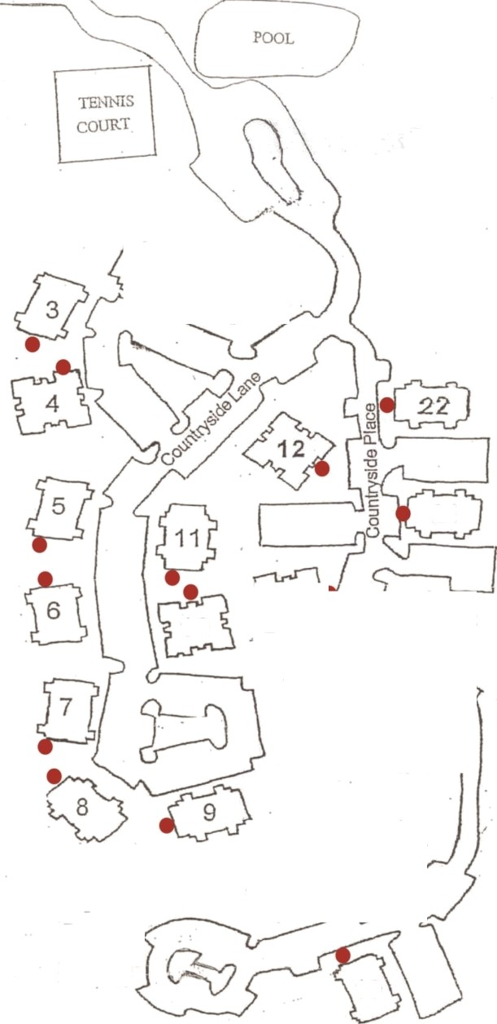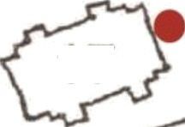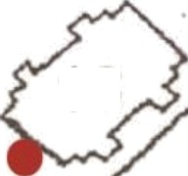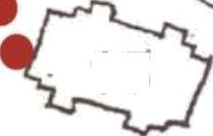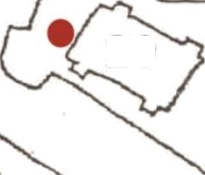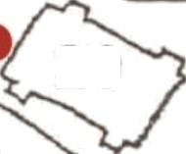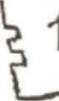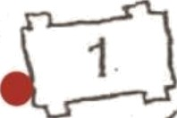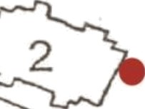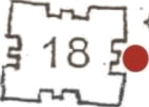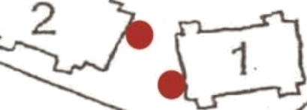Countryside at Cumberld Water Cut Off Locations
Bldg 1 - Near 101
Bldg 2 - Next to reflector on light Bdlg 3 - Gate near 301
Bldg 4 - Next to 408
Bldg 5 - Near 502
Bldg 6 - Next to 606
Bldg 7 - Next to 701
Bldg 8 - Next to 806
Bldg 9 - Near 906
Bldg 10 - Between 1001/1002 Bldg 11 - Near 1106
Bldg 12 - Parking tot side Bldg 13 - Front near street Bldg 14 - In fenced area
Bldg 15 - Next to storage area door Bldg 16 - Next to 1601
Bldg 17 - Next to 1706
Bldg 18 - Middle of front facing parking area Bldg 19 - Next to 1906
Bldg 20 - Next to 2006
21
Bldg 21 - Front side near street Bldg 22 - Next to 2201

1 0

19

Countryside at Cumberland Dog Walking Area Map

Wooded
Please walk pets in designated Walking Areas only. Homeowners/ pet caregivers are required to clean up after their pet. Grass lawns
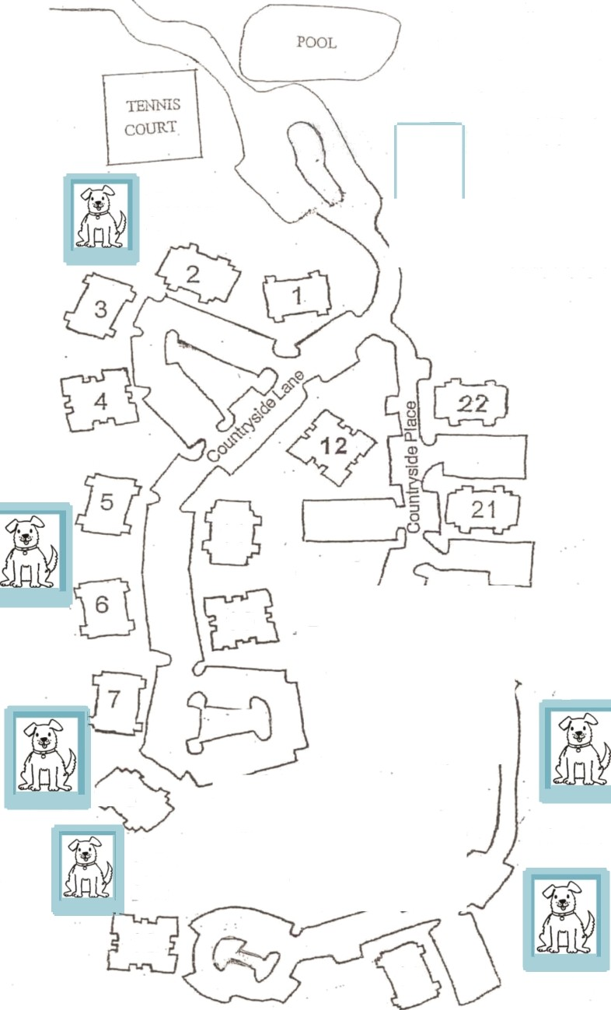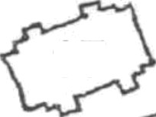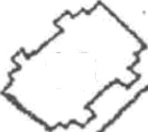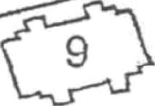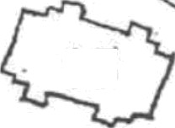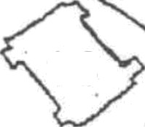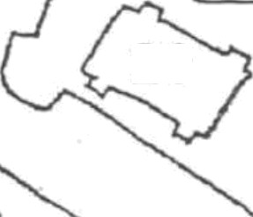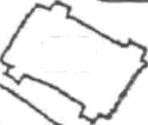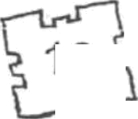and Islands are not to be used for pet walking areas.
’•

Pets are required to be on a

Area
Behind Pine
traw Area

leash when they are walked outside of a unit and should not be left unattended.

Kudzu Area

11

1 0

ï 8 9
Pine Straw Area
18
Pine Straw Area

19 Wooded Area

