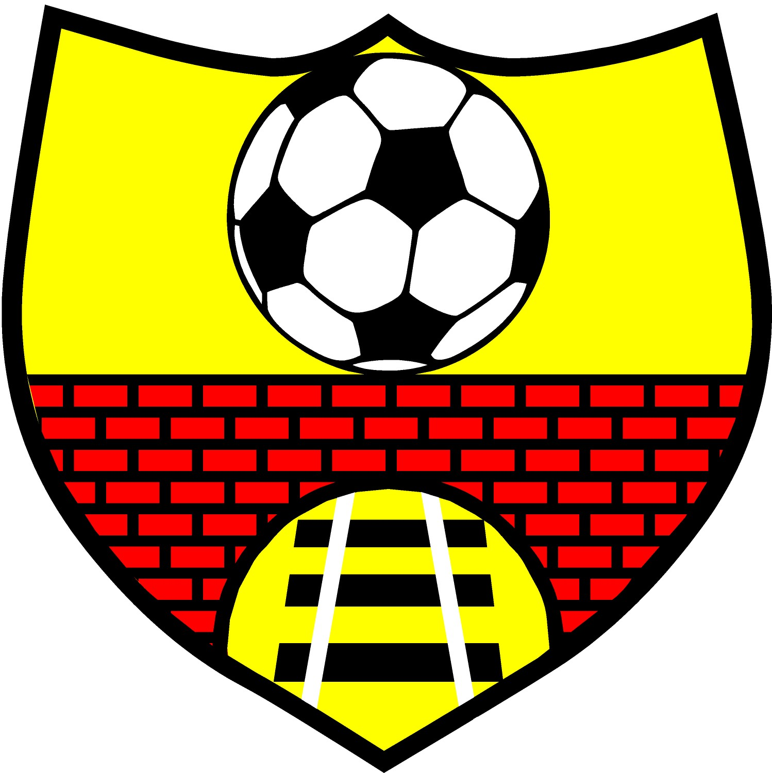

Clarbeston Road AFC (Charity Number 1163455)

Welsh Language Policy

ABOUT THIS POLICY

We acknowledge the fact that under the Welsh Language (Wales) Measure 2011, the Welsh Language has official status, and should be treated no less favourably than the English Language.

We believe it is good practice to provide services in the language of choice to those contacting or involved with Clarbeston Road AFC. It shows respect to our community and volunteers to encourage and facilitate the use of their chosen language when they are contributing to our activities.

We commit to making constant progress towards achieving this ambition, and this Welsh Language Policy sets our current commitment. The scope of our commitments in this policy should be interpreted reasonably. They reflect our understanding of the current numbers of Welsh speakers in our community and the extent to which we currently believe there is need within that Welsh-speaking community for the use of Welsh or bilingual services. To that extent, this policy will be kept under constant review to ensure that it continues to reflect the numbers of Welsh speakers in our community and their needs and aspirations.

OUR COMMITMENTS

• We will always seek to ensure that at least one Trustee is able to communicate in Welsh to volunteers and members of the community. In the event that this is not possible we will coopt a Welsh speaking member of community to the Management Committee to fulfil this function.
• We will continue to encourage the use of Welsh by our volunteers where this is relevant to the individuals that they are working with, so that others in the group will hear the Welsh language being used.
• Wherever possible communications received in Welsh will be answered in the same language
• We will appoint one member of the Management Committee to be responsible for implementing, championing and monitoring this policy (currently Ian Eynon).
• This policy will be available for our volunteers and for our community to read.

REVIEW

We will periodically review this policy and our performance and take any corrective actions, should these be necessary.

Policy last reviewed by Clarbeston Road AFC Trustees on 15th August 2023

