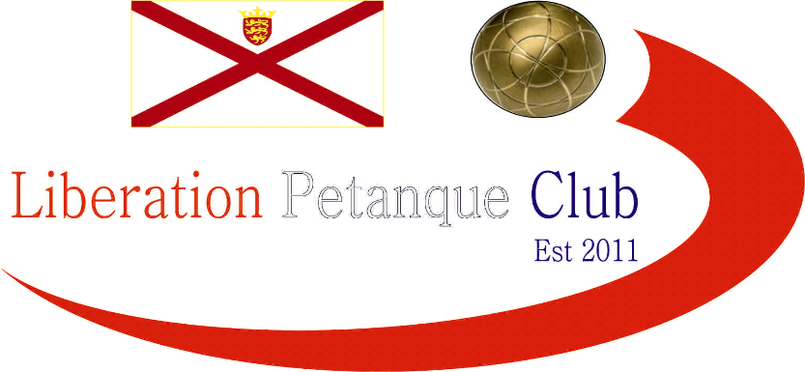

2016

Liberation Petanque Club

Singles Cup

24 players took part in this year’s competition saw the clubs best players playing 4 rounds under the Swiss system as with all Liberations competitions.

Round 1 saw a shock as Island & Liberation Singles Open champion Matt Buesnel lost to Cassie Stewart. 2015 champion Ross Payne just beat Mike Robinson 13 – 12. Matt Pinel handed Colin Myers a fanny certificate and Lorna Limbrick beat David Ibitson 13 – 12.

Round 2 saw the shocks continue as Brigitte Ibitson beat Andrew Bellamy-Burt 13-11 and Matt Buesnel lost again this time 13-12 to Joey Le Clech. David Ibitson regained form to beat Brian Harris and Toby Northern won two out of two beating Alice Ibitson 13 – 6.

Round 3 saw Paul Le Moine win three out of three handing David Ibitson a 13 – 2 defeat to guarantee a top 8 finish. Despite beating Andrew in Round 2 Brigitte could only score 1 point against Matt Pinel who conceded just 8 points in the first three rounds. 2015 Champion Ross Payne lost to Toby Northern 13-12.

The final round saw several players still in with a chance of making the top 8. Matt Pinel again only conceded 2 points beating Alice Ibitson to finish on 4 wins BHN 7 + 42, But it was Toby Northern who finished top of the rankings beating Paul Le Moine 13 – 4, 4 wins BHN 10 + 26.

Geoffroy Buffetrille lost 13-12 to Ellis Turmel a result that took Ellis through instead of Geoffroy.

Despite winning his last match Andrew Bellamy-Burt could only finish 13th with two wins. Brigitte Ibitson beat Ian Foster to finish 5th on 3 wins and Alice Ibitson finished 8th, the only player on 2 wins to make it through and Cup holder Ross made it through in 4th place.

The Quarter Finals were as follows:

Toby Northern v Alice Ibitson

Matt Pinel v Ellis Turmel

Paul Le Moine v Brian Harris

Ross Payne v Brigitte Ibitson

In a repeat of Round 2 Toby beat Alice again, but it was much closer this time, despite Alice Alice always playing catch up. Matt Pinel continued to destroy his opponents handing Ellis a beating, but a good performance from Ellis playing in his first Liberation Singles Cup.

Brian Harris turned the rankings upside down beating Paul Le Moine to make the semi-finals and Ross Payne just overcame Brigitte in a close match.

The semi finals saw Toby have to play another player again in Ross Payne, but despite just beating Ross 13-12 in the Swiss Rounds, ran out a much more comfortable winner meaning out of 4 years there would be 4 different winners. Matt Pinel would not let Brian Harris stand in his way making the final.

So the two finalists, both of who were the only players to win 4 out of 4 matches in the Swiss Rounds met in the final.

Matt started like every other match racing into a lead before being pegged back to 10 – 10 by Toby, but it was Matt’s day in the end running out 13 – 10 winner for a well-deserved cup triumph.

Congratulations to everyone who took part in another successful competition.

Thank you to everyone who helped prepare for this competition and the running of it on the day which takes a great deal of time and effort. If you like to help out at future competitions please let me know.

Kind Regards,

Chairman

Liberation Petanque Club

