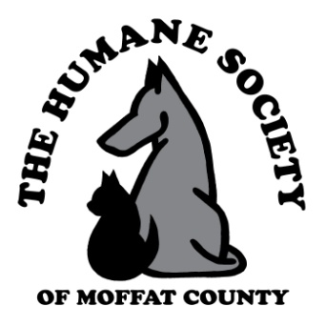5th ANNUAL
HUMANE SOCIETY OF MOFFAT COUNTY-
BANK OF COLORADO BOWLING FUNDRAISER
When: Saturday, September 22, 2018 from 6 - 8 p.m.
Where: Thunder Rolls Bowling Center, 990 Industrial Ave., Craig
Cost: $25 per bowler (or $100 per team) – Includes dinner, dessert & PRIZES!!
How: Register as individual, couple or team of 4. First come, first serve – only 16 lanes to fill.
Who: Contact Ann at annanderson165@aol.com or 970-620-2014. Go to our website www.humanesocietyofmoffatcounty.org. To print an entry form

