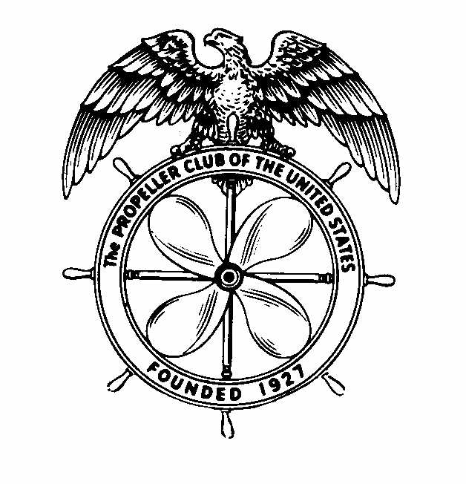

**THE PROPELLER CLUB OF THE UNITED STATES**

**PORT OF TACOMA**

**LELLI MEMORIAL SCHOLARSHIP**

**SCHEDULE OF EVENTS – APRIL 18, 2018**

**11:00 AM**

**REGISTRATION**

**11:30 AM**

**PROGRAM INTRODUCTION**

**11:45 AM**

**PORT OF TACOMA BUS TOUR**

**12:30 PM**

**LUNCH**

**1:00-3:00 PM**

**STUDENT PRESENTATIONS**

**3:30-5:00 PM**

**TOUR OF SPONSOR’S BUSINESS**

**5:00-8:00 PM**

**DINNER MEETING**

**GUEST SPEAKER**

**AND**

**SCHOLARSHIP AWARD PRESENTATION**