Hillsboro Homecoming & Festival
CAR SHOW
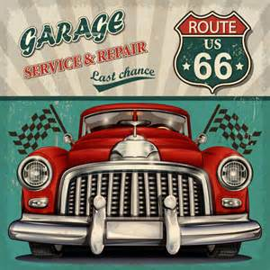
MAY 20, 2017
12:30PM – 4:00pm
Main Street & Business 21, Hillsboro, MO 63050
Registration begins at 12pm, following parade. (Rain or Shine)
If you wish to be in the parade please call the Chamber to register in parade.
ENTRY FORM
Name:
Address: City/State:
Phone: E-Mail:
Make: Model:
Color: Engine:

CLASS
(Circle One)
Pre-War – 1942 & Older 40’s & 50’s
60’s – 70’s & Newer Stock Muscle Cars
Street Rods Modifieds
Trucks Survivors-Unrestored
Additional Awards
Best of Show Mayor’s Choice Future Drivers Choice

$15 PRE-REGISTERED OR $20 SHOW DAY
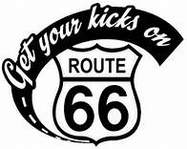
Mail or Email to
Hillsboro Chamber of Commerce
P.O. Box 225, Hillsboro, MO 63050
For more info 636-789-4920
21
chamberoffice@sbcglobal.net
www.hillsborochamberofcommerce.com

ENTRY NUMBER ___________ (JUDGES’ USE)

