**D R A F T**

EYEMED

Work Packages **WORK PACKAGE 6 (WP6)**

**Evaluation and Exploitation**

WP1 Project Management and Coordination

WP2 Communication / Dissemination

WP3 Content

WP4 EU Pilots

WP5 MENA Pilots

WP6 Evaluation / Exploitation

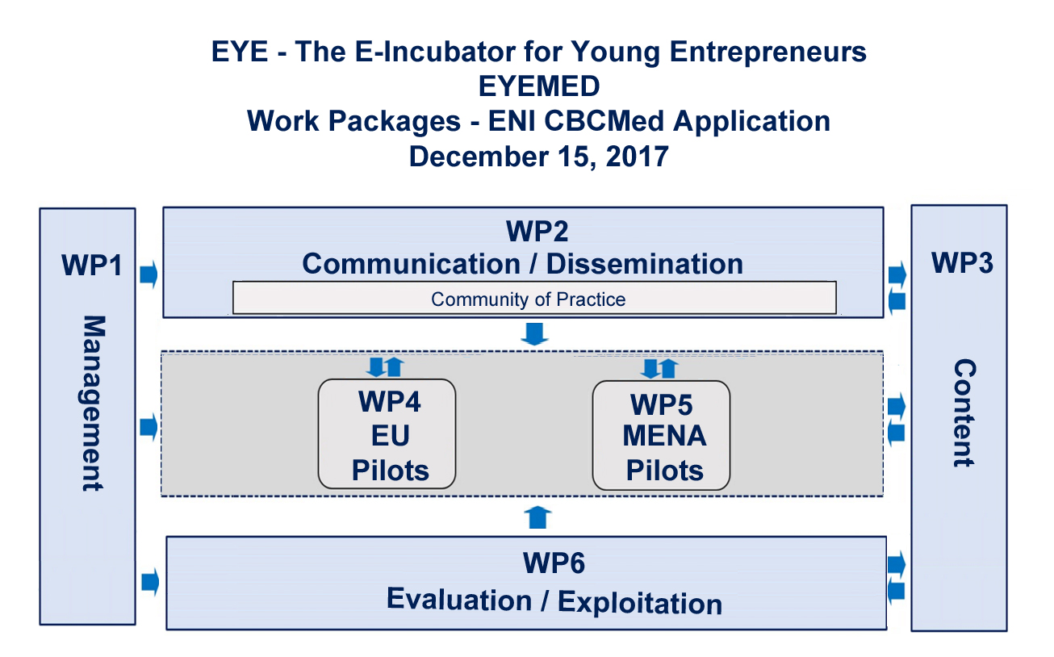

WP6 Partners:

WP Manager: PP6 Instituto Superior de Gestão

Participating partners: all

WP6 – Evaluation / Exploitation

The principal aim of this work package is to understand what impacts EYEMED could produce on the target groups, on the education and training sector, and on the field of interest – entrepreneurship. Additionally, it aims to evaluate how such impacts can contribute to developing a sustainable solution for combating youth unemployment and underemployment through entrepreneurship. Based on these findings, the final aims of WP6 are the development of an exploitation plan and a related business model for the EYEMED solution upscaling in the Mediterranean region.

Evaluation will be aligned with the Indicative Monitoring and Evaluation

(M&E) Plan articulated by the ENI CBCMed Programme 2014-2020, Annex 2.

The Result Based Management approach (RBM) will be applied to all phases of the EYEMED project, from planning, followed by implementation, evaluation and exploitation. The work packages related to the EU Pilots (WP4) and the MENA Pilots (WP5) must contain benchmarking with appropriate indicators to ensure results are being achieved. Evaluation phases at mid-term and completion provide valuable information for decision-making and lessons learnt for the future. The RBM identifies how progress toward the targeted objectives will be measured and thus provides the basis for the development and use of the monitoring system.

There are three main tasks in this work package:

* Impact evaluation;
* Cost benefit analysis;
* Exploitation strategy and plan.

OECD’s Framework for Addressing and Measuring Entrepreneurship guide could be useful in establishing parameters to measure the success of the project that includes the LOGIC model, quasi-experimental designs, descriptive research to produce useful assessment data, and other instruments recommended by WP6 manager for Evaluation / Exploitation, PP6 ISG. Possible instruments would include questionnaires sent to partners to investigate how EYEMED deliverables could be further exploited, including questions about the strengths, weaknesses, opportunities, and challenges to EYEMED’s main outputs.

Exploitation Sub-Plan: The Project Director together with the Partners will develop an Exploitation Plan for implementation during the last phase of the project (months xx – xx to be determined). The plan will outline the potential of EYEMED in light of the project’s accomplishments; assuring that the valuable knowledge attained during the lifetime of the project will be fully integrated and its achievements sustainable. According to the project’s results, the plan would detail trends and opportunities for new areas of development for the field, and will define potential activities and synergies to be followed up in the future. Efficacious exploitation and long-term sustainability of EYEMED results would be defined as some of the key objectives of the project. Specifically, the Exploitation Plan would outline: the results to be exploited, the stakeholders who will benefit from the results, the possible models of exploitation and a first analysis of the compatibility between results and the needs and requirements of the stakeholders, as well as the exploitation models to be employed. To attain these goals, each partner will be asked, by means of a questionnaire, to specify their own exploitation plan and to set out the ways in which their organization will be able to take advantage of both the knowledge acquired throughout the project as well as the tangible results. The partners’ individual contributions would be set out in the final Exploitation Plan. Due to the complex and stratified nature of the Project Partnership, we expect their results to spin off at local, regional, national, European, and/or international levels. Additionally, the plan could outline potential sectorial gaps that EYEMED addresses; proposing what needs to be enhanced and what needs refining in the field. The project’s strengths and weaknesses will be taken into account; matching key strengths with opportunities that could create capabilities that could evolve into competitive advantages.

WP6 elicits specific individual exploitation plans where each partner has identified potential re-use in their own work-flow. In the period immediately following the close of the project, partners will be encouraged to engage in exploitation to encourage targeted audiences to become aware of the results of the project. The target group for exploiting the project’s results will be carefully analyzed, including all possible stakeholders who might further exploit the successful outcomes of the projects. In addition, the Exploitation Plan will investigate how the main outcomes of the project will be assessed for adaptation into future European and international project calls.

**Roles and Responsibilites:** PP6 Instituto Superior de Gestão takes the lead as WP Manager for WP6. All partners will be engaged in WP6.