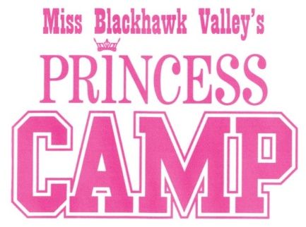
Script Information 2020
This information will be used in the production of the Miss Blackhawk Valley’s Competition. Please write or print legibly. This is a worksheet and will be seen only by the producer and director of the pageant. We may not use all the information you provide.

Princess Name

How do you want the emcee to introduce you? This will also be the way your name appears in the program book. First and last name? Use middle name? Write exactly how you want to be introduced.
______________________________________ __________________________________

How do you want your parents to be introduced? Usual is “Daughter of Dad’s first name and Mom’s first name, then the last name”. See a staff member if you have questions about this.
_________________________________ ___________________________________ ________________
Where do you go to school? What grade are you in? What is your favorite subject?
______________________________ _____________________________ _________________________
Do you have a talent? If so, what is it? Do you take lessons to improve your talent?
__________________________________________ ________________________________ _________
_______________________ __________________________________________ __________________
We would like to know one interesting fact about you that is not related to the pageant.
_____________________________________________________ _______________________________
Do you belong to any club or organization? Is so, give us some information about it.

Revised 9/2019

