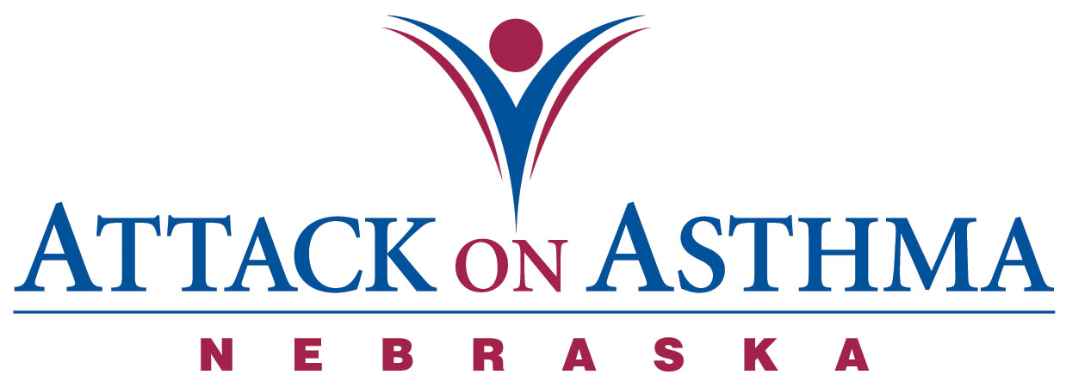

Characteristics of Individuals and Protocol Use in Nebraska Schools
2010-11

Data was voluntarily reported to Attack On Asthma Nebraska (AOAN) during and following the 2010-2011 school year. During this period of time there were 41 reported incidents of the Emergency Response to Life-Threatening Asthma or Systemic Allergic Reaction (Anaphylaxis) protocol being implemented. Schools submit data using a standardized form.

- The majority of the incidents occurred during the months of August, September, October, November (41%).

- Protocol administration was two-thirds female (61%) and one-third male (39%).

- More High School students (41%) were administered the protocol than Elementary School (32%) and Middle School (24%) students. There was one staff incident (3%) reported.

- The location of incidents is as follows: PE class, recess, and sports practice (39%) and classroom (39%). There were two incidents en route to or from school (5%), four incidents in conjunction with lunch (9%) and one incident reported in conjunction with art class (3%).

- Eighteen incidents were with an individual with a history of asthma (44%). Eighteen individuals reported no history of either asthma or allergy (44%) and nine individuals reported a history of allergy (22%).

- Over three-quarters (83%) received epinephrine as a correct usage of the protocol or the individual’s action plan.

- Of the eighteen individuals with no history of asthma or allergy, eleven (61%) returned to school with an action plan.

- Of the eighteen individuals with a history of asthma, only seven (39%) had an action plan on file.

- Out of eleven individuals with a history of asthma and no action plan on file, seven individuals (64%) returned to school with an action plan after protocol administration and one individual returned with quick-relief vs. controller medication.

- Only two (22%) of the nine individuals reporting a history of allergy had an action plan on file.

- Four individuals (44%) with a history of allergy and no action plan on file returned with an action plan. Four individuals (44%) with a history of allergy and no action plan on file returned without an action plan. One individual (11%) with a history of allergy and an action plan on file returned with a new action plan.

- Ten (24%) of the 41 incidents were allergic reactions (anaphylaxis).

- There were seven incidents (17%) in which only nebulized albuterol was administered.

- Ten individuals (24%) self-carried medication and three (30%) of these individuals did not have their medication with them at the time of the incident.

- One individual (2%) did receive rescue breaths as a component of CPR.

- Emergency Medical Services (EMS) was summoned 88% of the time. Of the five incidents in which EMS was not summoned, three incidents (60%) were treated with nebulized albuterol only.

- Thirty individuals (73%) were transported to a medical facility via the Emergency Medical System. Seven individuals (17%) were transported to a physician’s office or medical facility by a parent or were signed off by a parent.

- Twelve school districts reported the 41 incidents.

- There was one school district which reported two incidents with the same individual during this school year.

- Each school district had access to or has a school nurse.

NOTE: Action plans on file at school may or may not include prescribed medication(s).

