August 24, 2015 – Alumni Committee Meeting

Secretarial Minutes taken by Becky Miller
Alumni Stacy Warner Rachel Sauvola Todd Dorr
Attendance: Charlie & Anna Strabel Terry Dorr Daryl Garness
Dave & Becky Miller Terry Miller Shawnee Holte

We had guest speaker Paul Mayer and Tim O’Brien from the New Richmond Area Community Foundation talking to us about their Foundation and how this could benefit our FFA Group.

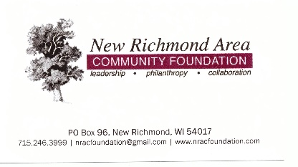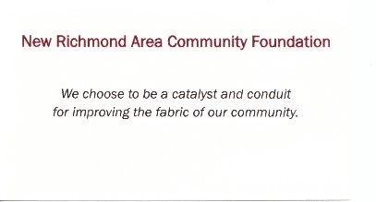

Treasury Report was read and approved.

Secretary Report was read and approved.

Old Business
Next insurance installment is due September 15th - $396.00

Tractor Pull Sled/Food Trailer: Meeting on Wednesday, August 26ht at Terry Dorr’s at 6:00 p.m. to work on sled with Steve Olson and John Gillis before next tractor pull. Mr. Kerr will meet with us also to see about a new window put in for our food serving purposes, outside ledges and an inside counter top for the roasters. Still need to purchase “easy up” awnings, garbage cans (3 more) before next tractor pull.

Ongoing documentation with what all is needed to put on an alumni event to make it all successful and easier for a new person to come in and help with food booth, registration, etc….

Farm To Table Discussion – Leslie Svacina and Rachel Sauvola went to the “Hungry Turtle” in Amery and Kristen is willing to help out with suggestions/resources for us.

New Members is ongoing.

Rimoe Ranch Event was a slower paced event on August 16th for us and the Food Stand.

Old Folks Home Tractor Ride had a wonderful afternoon. There were 12 people/tractors that participated. Around noon on August 16th they paraded over to the Health Center first and enjoyed a welcome dinner put on by the Health Center and then they paraded over to the Deerfield facility.

Cindy from the health center is writing an article about the plow day and busing for the residents. Discussed a little about maybe having a fall plow day along with the spring plow day.

New Business

Rachel Sauvola
Officer Retreat – Goals/Plan for the year.
Membership hand book – Shawnee Holt discussed this with the alumni committee.
Partners with businesses.
Feed my starving children – goal group thing.
Petting Zoo/Crafts at Deerfield.
Fire Department – tie blankets
Food Drive for the community food shelf.
Farm Tours
Farm City Days at the Neu-View Acres (The Neumann Family) went great.
Ag. Newsletter is good.
Happy Kids Back Packs.

September
13th - The welcome picnic 3:00 p.m. – 6:00 p.m.
21th – Monthly FFA Alumni Meeting at 7:00 p.m. Will need to have a custodian open up for us.
Dairy Expo is in September
FFA Convention – 3 students are attending

Rachel Sauvola - Presentation on What is FFA, Who am I, and Farm & Fork Concept.
Big contributors who help to reach our $50,000 goal for barn will have name laser’d onto a plaque.

Voted on becoming an Affiliated Chapter - Charlie Strabel made a motion to accept being an Affiliation Chapter for $1,000 as the Alumni’s share and Anna Strabel seconded it. All were in favor. The Affiliated Chapter at the present time is only for kids - Wisconsin FFA Alumni hasn't yet made the decision to offer this type of membership. Plus the cost for affiliation goes by number of students in the classes, which leaves us with an approximate cost of $2000 on the high end.
Name Change was agreed on - New Richmond FFA Family, Friends and Alumni.

Discussions for all FFA Members who wish to receive funding from the Alumni, you need to help out at the scheduled events in order to make applicable funding work for you. Your hours are documented at these events. Trying to get out a calendar/events in writing by the September FFA Picnic so both Parent and child know this and are accountable for helping at the alumni events throughout the year.

Fundraiser Reminder – Selling Engine Heater timers ($20.00) to local agricultural producers. Taking orders between September 1 and October 23, 2015.

Important dates for the year:
Sunday, Sept. 13 from 3-6 in classroom - Welcome Picnic - We need you here for parent recruitment into our group.

Sat. Sept. 26 - Heritage Day Tractor Pull behind McDonald's

Sat. Dec. 5th - 8 a.m. to 1 p.m. - Breakfast with Santa at Farm and Home - Will need a few volunteers to supervise the students as I am out of town.

Sat. Dec. 12th - Farm and Home - Bake sale

Fri and/or Sat - Feb. 5 and 6th - State FFA Alumni Convention in Madison and World's Toughest Rodeo in St. Paul

Mon. and Tues. March 14 and 15th - Awards Judging in my classroom

Sun Apr. 10 - FFA Banquet at NRHS - Will need help with food, awards, dessert auction, etc. - Will start at 10:30 a.m.; eat at 1 p.m. and program at 2 p.m.

Sat. June 4th - Dairy Day

