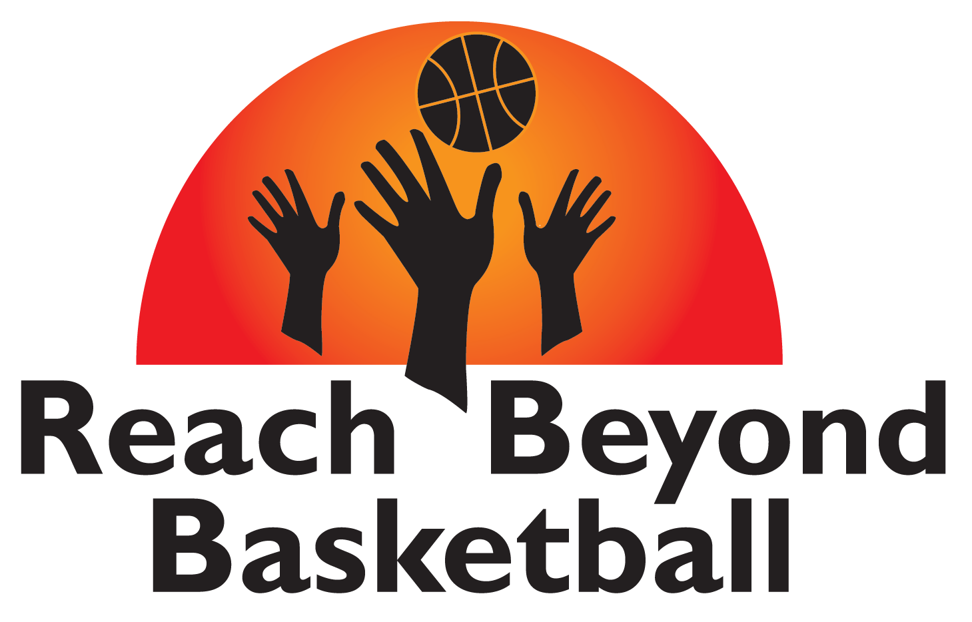

2003 Hickory Hill Lane, Silver Spring, Maryland 20906

Dear Local Business Owner/Patron:

My name is Lenny Myers, founder of Reach Beyond Basketball Inc, a 501(c)(3) Nonprofit organization based out of Silver Spring, MD with programs throughout Montgomery County Maryland. I have an opportunity for you or your business that you do not want to miss!

After 10 years of successful camps and programs, we expect our 2020 Summer Camps and programs to our biggest ever. Reach Beyond Basketball/Mentorship program is designed not only to teach kids basketball, but also emphasizes developing life skills through character building activities that we have incorporated into all of our programs.

Many of our camp participants are from lower income households who do not get the opportunity to participate in basketball camps due to the expensive prices. In an effort to accommodate these kids, we offer a reduced camp admission and sponsor others to attend for free. Through our mentorship program, and incorporating the 4 C’s – Character, Commitment, Consistency and Confidence, Reach Beyond Basketball has made a huge impact in the community. Our campers are successful in sports and in academics and many are now attending college.

In order to continue providing this essential service to our youth, we need your help! As a Donor you will feel a sense of purpose by joining our cause. Donations are tax deductible and are a great way to give back to the community. If you choose one of the donation options enclosed, you will receive a thank you letter from the camper(s) that you provide admission for. We also have opportunities for your business to become a Sponsor. As the fastest growing youth sports program in the area, we can provide your business with exposure that can be greatly beneficial. Your business will also be recognized by our community as a business who cares about our youth, the importance of mentoring, and the importance of fitness. Monetary contributions will help provide scholarships for campers and you will receive thank you letters from those campers. Contributions of goods are also welcomed and appreciated.

Enclosed, you will find more information about our donation/sponsorship program. Please visit our website at www.reachbeyondbasketball.org to learn more about the program. If you have any further questions, please feel free to contact me by telephone at 240-330-3441 or email info@reachbeyondbasketball.org. We look forward to your support in making a difference in the lives of our youth.

Sincerely,

Lenny C. Myers, Founder
Parent Testimonial:
My son attended the Reach Beyond Basketball Camp and had a special experience he will never forget. One that gave a tremendous boost to his self-confidence and self-esteem. He enjoyed the coaching and the daily drills which improved his basketball skills. He felt that everyone was really nice and friendly. Most importantly he returned from camp everyday not only talking about basketball but about the relationships he was building with other campers.
Robert B., Parent
REACH BEYOND BASKETBALL SPONSORSHIP PACKAGES

PRESENTING SPONSOR—$10,000- (Package A)
- Limited to 1 sponsor.
- Name of company will be headlined with all Reach Beyond Basketball publications and programs for 2020 including summer camps, fundraisers and clinics throughout the year, and more. Example: Reach Beyond Basketball Summer Camp presented by “your company”.
- 20 free scholarships to any Reach Beyond Summer Camp session in 2020 for family, employees, or clients.
- Display of signs or banners at our spring and summer camps, clinics, and fundraisers that your company provides. Headlining Company name or logo on all Reach Beyond T-shirts in 2020 (worn by staff and given to all participants.).
- Company name on 2020 Summer camp flyers and fundraiser promotions which are distributed throughout Montgomery County and surrounding areas. Company logo/advertisement on quarterly mailings that reach hundreds of people in our database and on fliers that reach thousands of people across Montgomery County Maryland and surrounding areas for 1 year.
- Company name, logo, AD, and website link posted on www.reachbeyondbasketball.org for 1 year.

PREMIER SPONSOR—$5,000- (Package B)
- 10 free Scholarships to any Reach Beyond Summer Camp session in 2020 for family, employees, or clients.
- Display of signs or banners at our summer camps, clinics, and fundraisers that your company provides. Company name or logo on all Reach Beyond T-shirts in 2020 (worn by staff and given to all participants.).
- Company name on 2020 Summer camp flyers and fundraiser promotions which are distributed throughout Montgomery County and surrounding areas.
- Company logo/advertisement on quarterly mailings that reach hundreds of people in our database and on fliers that reach thousands of people across Montgomery County Maryland and surrounding areas for 1 year.
- Company name, logo, AD, and website link posted on www.reachbeyondbasketball.org for 1 year.

COMMUNITY SPONSOR—$1000- (Package C)
- 5 free scholarships to any Reach Beyond program in 2020 for family, employees, or clients.
- Company name/logo on Reach Beyond T-shirts in 2020 (worn by staff and given to all participants), flyers and fundraiser promotions which are distributed throughout Montgomery County and surrounding areas.
- Company logo/advertisement on quarterly mailings that reach hundreds of people in our database and on flyers for 1 year.
- Company name, logo, AD, and website link posted on www.reachbeyondbasketball.org for 6 months.

CONTRIBUTING SPONSOR—Amount of your choice- (Package D)
- Company name, logo, AD, and website link posted on www.reachbeyondbasketball.org for 6 months.

CONTRIBUTING SPONSOR--- In-Kind Donation (Donation of goods or products)- (Package E)
- Company name, logo, AD, and website link posted on www.reachbeyondbasketball.org for 6 months.

REACH BEYOND BASKETBALL SPONSORSHIP/CONTRIBUTION FORM

Yes, I would like to be a Sponsor for the Reach Beyond Basketball/Mentorship program and I am selecting the package listed below:

___Package A ___Package B ___Package C ___Package D ___Package E

I am enclosing a check in the amount of $_____________ payable to Reach Beyond Basketball Inc.
I am going to make an online payment on the www.reachbeyondbasketball.org website in the amount of $____________.
I am contributing an In-Kind Donation of the following goods or product(s) __________________________
Yes, I would like to make a donation to the Reach Beyond Basketball/Mentorship program for the amount of:
___$220 (sponsor 1 camper)
___$440 (sponsor 2 campers)
___$660 (sponsor 3 campers)
___Other Amount: $________

Name/Contact Person/Title: ____________________________________________________________________________

Name of Business/Corporation: _______________________________________________________

Address: __________________________________________________________________________

__________________________________________________________________________________

Telephone Number: _________________________________________________________________

Website/email: _____________________________________________________________________

Signature: _________________________________________________________________________
Please send to: Reach Beyond Basketball Inc
2003 Hickory Hill Lane
Silver Spring, Maryland 20906
Thank you –We appreciate your contribution!
You will receive a receipt of your contribution for tax purposes to the email address that you provided above.

