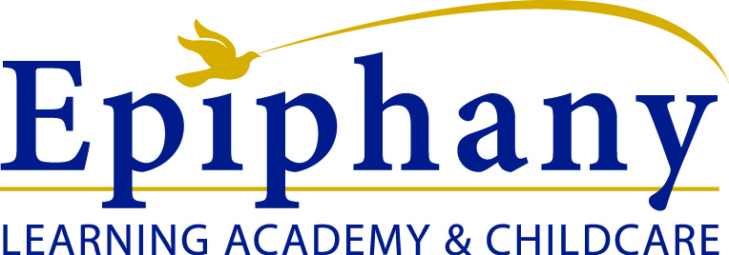

Epiphany’s 4K Wrap Around Program
(Only Students Entering Kindergarten Are Eligible)
Our Kindergarten Wrap Program follows Roosevelt’s Kindergarten schedule
Morning Session: 8:30 a.m. – 12:30 p.m. {$28 day/$135 a week}
Afternoon Session: 11:00 a.m. – 3:00p.m. {$28 day/$135 a week}
$50 enrollment registration

Curriculum
Curriculum will be planned according to a weekly theme. Our curriculum, together with small class sizes, will provide our students with a firm foundation to grow and develop the skills necessary for early childhood learning. In addition, by utilizing multi-sensory and cross curricular learning strategies, our students will be able to access and connect with information through their various modes of intelligence.

Transportation
We will walk to/from Roosevelt Elementary to pick up/drop off your child.
We do not have a bus service at this time.

Meals/Snacks
We will provide based upon your selection of care.

Morning Session
Breakfast 8:30 a.m.
Snack 10:30 a.m.

Afternoon Session
Lunch 12:00 p.m.
Snack 2:30 p.m

BEFORE & AFTER SCHOOL CARE
AM Only: 6:30 – 8:30 | $70.00/ week
PM Only: 3:00 – 6:00 | $120.00/ week
Both AM & PM | $170.00/ week

- Children in AM program may bring in their own breakfast.
- Children in the afternoon program will receive snack once they arrive.

