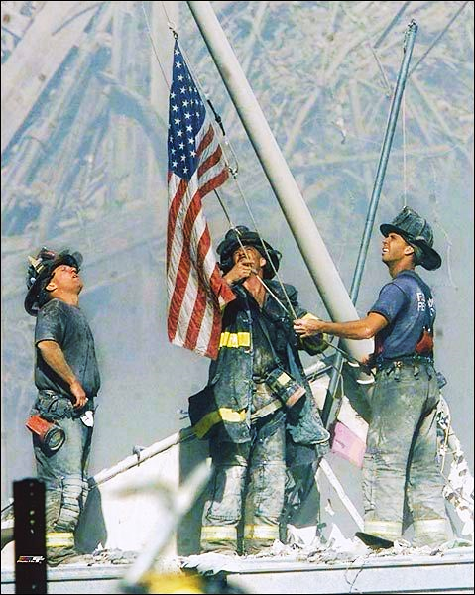
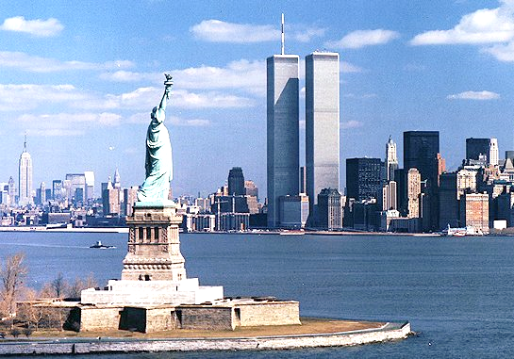

Farmington Cities 18th Annual
Patriot Day Ceremony
Wednesday September 11, 2019 6:00pm - 7:00pm
Location: Walter Sundquist Pavilion at Riley Park
Downtown Farmington Center

We honor the memory of the nearly three thousand
citizens and first responders who died as a result of
the terrorist attacks on September 11, 2001.
We are also honored to recognize our own local heroes
who serve our community every day.
We encourage the community to attend and show their support.
Officer of the Year honors will be presented
to Police Officers, Public Safety Officers and Fire Fighters
from Farmington and Farmington Hills.
Light refreshments will follow the ceremony.
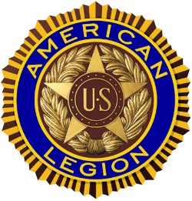
Minimal seating available, please bring your lawn chairs.
Groves-Walker American Legion Post 346
31775 Grand River Ave. Farmington, MI 48336
248-478-9174 GrovesWalkerPost346@gmail.com
www.americanlegionpost346.org

