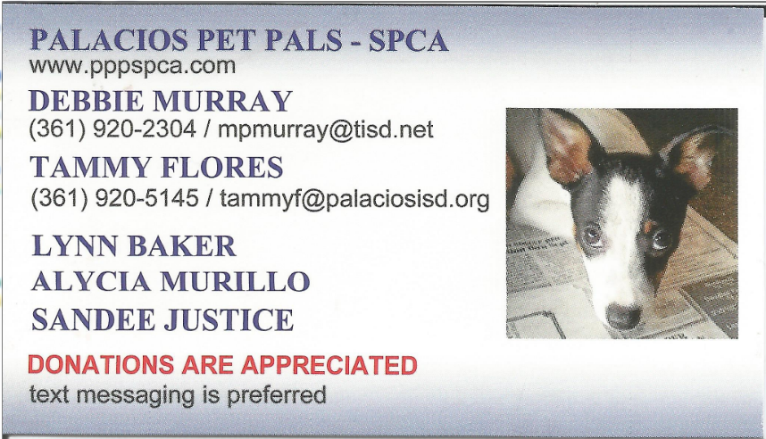 | 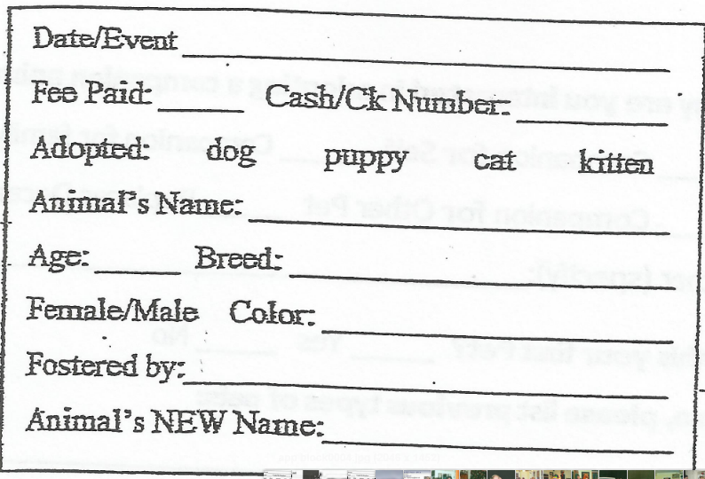

ADOPTION APPLICATION
Name: _______________________________________________
Mailing Address: ______________________ City, State: ____________________ Zip: _____________
Home Phone: __________________ Cell Phone: ________________ Work Phone: _____________
Employer: _________________________ Work Phone: _____________________
Email Address: ______________________________ Texas DL: ____________________________

Residence Information:
Type of Residence: ___Own ___Rent ___House ___Town Home ___Apartment
Number of People in Household: Total__________
Number of adults: ___ Number of Children: ___ Ages of Children: ____________

Current Veterinarian’s Information:
Name: _________________________________
Address: __________________________________
Phone: _________________________ Fax: ____________________________

Is this your first pet? ____Yes ____No
If no list previous types: __________________________________________________________
Do you currently have other pets? ___Yes ___No
If yes, list current pet(s) and how long you have had them: ______________________________________________________________________________

Please provide at least 3 references and their current phone number, not family members:
Name Phone Number/Email Relationship
- ________________________________________________________________________

- ________________________________________________________________________

- ________________________________________________________________________

- I certify that the information I have provided is accurate and honest.
- I certify that all companion animals in my care are routinely kept current on all vaccinations.
- I further certify that I have never been charged with or convicted of animal cruelty in any form.
- I give my permission for PPP Representative to contact References and Veterinarians listed above.
- I understand that my adoption donation is a tax-deductible donation given to further the work of PPP and, as a donation; it is recorded on the organization’s IRS Form 990 and is therefore non-refundable.

Signature: _____________________________________ Date: ___________________

