Kennedy High School
Advisor: Barry Wilson
4545 Wenig Rd. NE, Cedar Rapids, IA, 52402
319-784-7697
bwilson@cr.k12.ia.us
Jamie Voorhees, Grade 12, Driver/Crew Chief
John Tedesco, Grade 10, Crew Chief
Molly Sullivan, Grade 12, Documentation Writer
S30 Car: August 23, 2017 – January 23, 2018
Car’s get rebuilt every three years, and the car getting rebuilt this year is the 30. Since the beginning of the school year, Jamie has been doing lots of research leading to the designing of her car. Planning and drawings went on for many months as she waited for parade season to be over so that deconstruction on last year’s car could begin. This was a setback as she was not able to begin building as soon as she wanted. Since December, Jamie has finalized her drawings, cut her jigs, and started laying out her car. The problems she has encountered are mainly due to waiting for a welder to get parts tacked in place. Soon, she will also have another personal difficulty after going in for a second surgery on her wrist. John will take over while she is gone and continue the work on their car, along with whatever help he can get from others in the class.
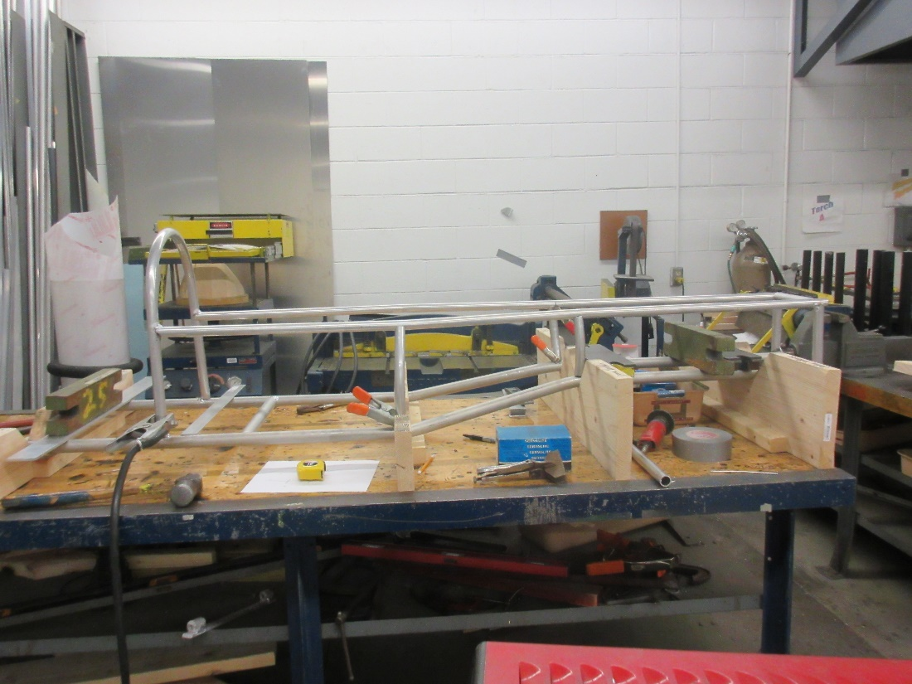

Kennedy High School
Advisor: Barry Wilson
4545 Wenig Rd. NE, Cedar Rapids, IA, 52402
319-784-7697
bwilson@cr.k12.ia.us
Derek Severson, Grade 11, Crew Chief
Molly Sullivan, Grade 12, Driver/Documentation Writer
A40: August 23, 2017 – Jan 23, 2018
Once parade season ended, Derek was faced with making at least two major modifications to his car. He spent some time planning them, and once all shows and parades were done, started the required deconstruction. The frontal impact and roll bars were redesigned to allow a better field of vision for the driver. Because of this, the canopy had to be redesigned as well as a few components moved. The emergency shut off and potentiometer were relocated partially due to the new frontal impact bar and as part of the initial plans to make entrances and exits easier on the driver. Body panels are starting to go on the car, although they still need to be painted. The only problem that has occurred so far is making sure the driver (and their large helmet) fit in the car within specifications. This was only a problem with the frontal impact and roll bars, but was quickly solved by making a few adjustments. The next steps are painting the panels and getting some test runs in before the first race.

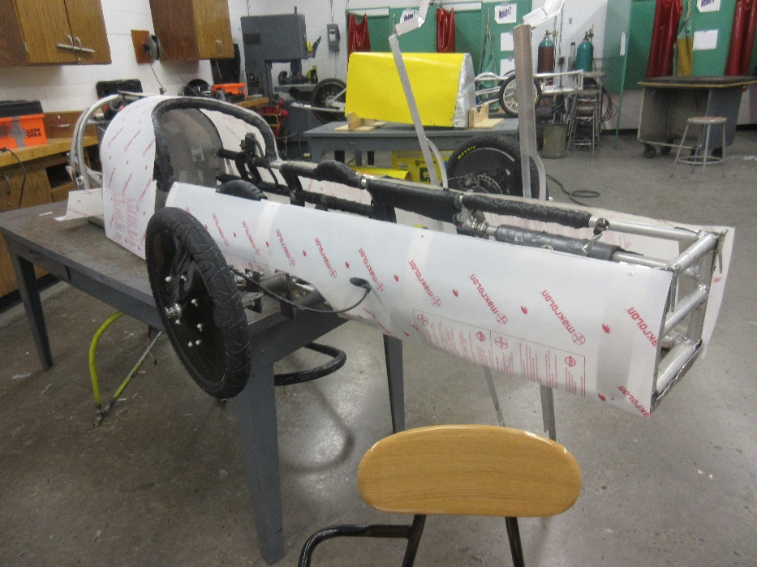

Kennedy High School
Advisor: Barry Wilson
4545 Wenig Rd. NE, Cedar Rapids, IA, 52402
319-784-7697
bwilson@cr.k12.ia.us
Natalie McAllister, Grade 12, Driver/Documentation Writer
Noah Matthews, Grade 12, Crew Chief
Lillie Wood, Grade 11, Maintenance
S50: August 23, 2017 – January 23, 2018
This car was originally built last year as a fourth car, but it never made it to any races. Because of this, there hasn’t been much to do with it, as no modifications needed made nor did it receive any damage. The team’s goal so far has been to redesign the tail. Lillie spent the first few months of the class filling a previous years’ tail with foam so that it could be vacuum formed for a new tail this year. While this was going on, the car itself was being used as a dyno for battery testing. Unfortunately, it did take some beating during that process due to a lack of carefulness from the batteries team. The problems were all minute and fixed. We have since gotten the tail mold back and more planning about how to make it work for this year is taking place.
