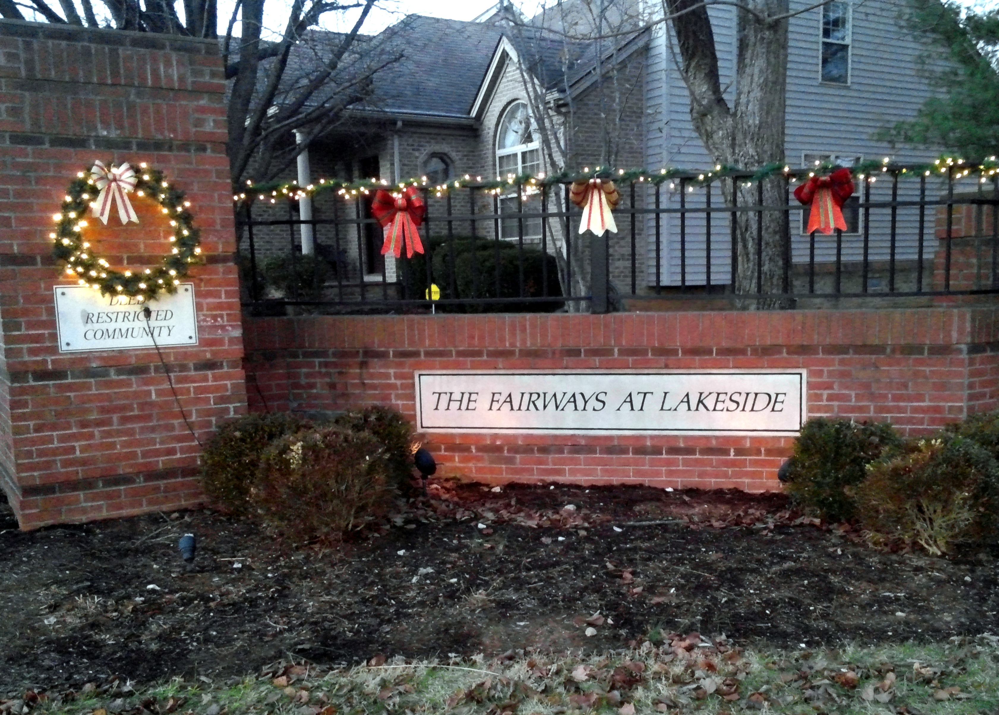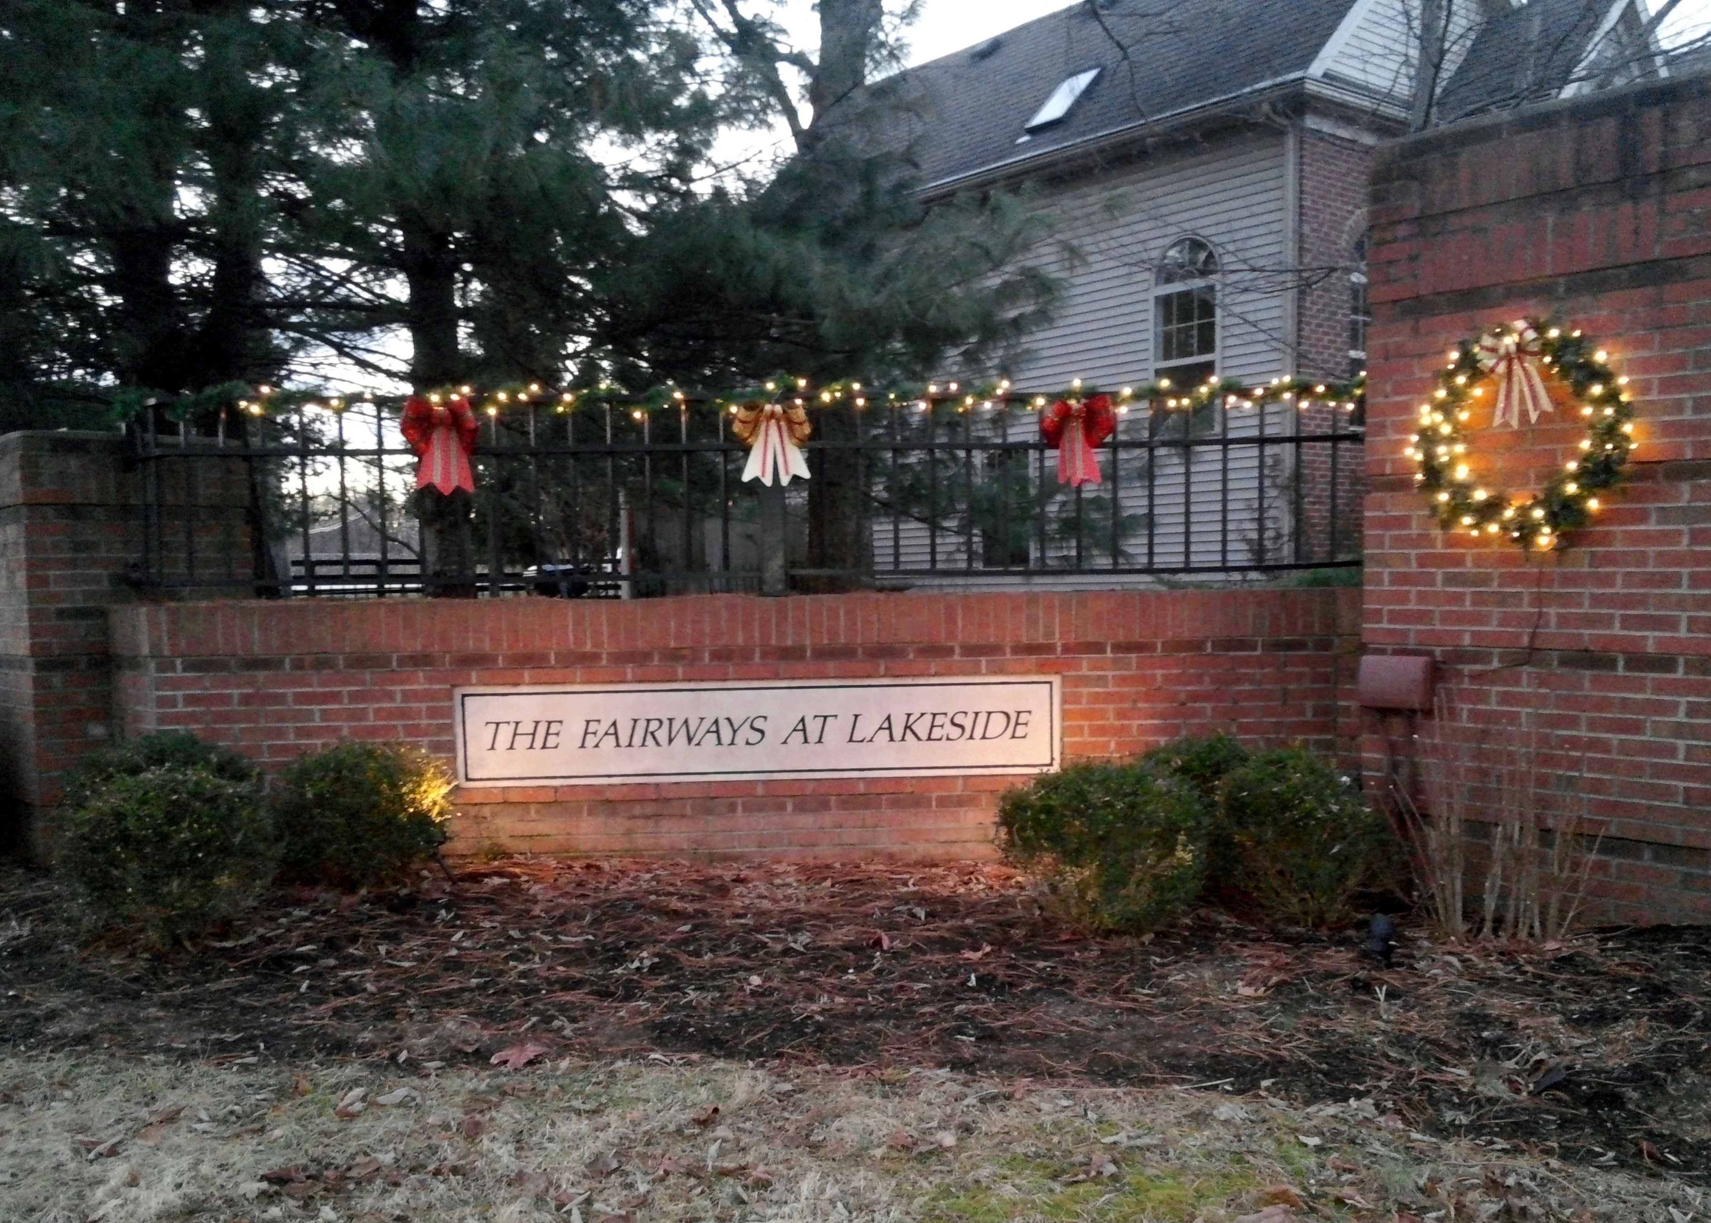
Fairways at Lakeside Community Association Newsletter
January 2020

A Word from Our President

Happy New Year 2020!! It is hard to believe that we are closing out another decade and starting another new year.

I want to send a BIG THANK YOU to Jonathan Groth, Kevin Wilder and Tiffany Compton for their time serving the community on the Board or as an officer. Your presence and input will be missed. However, we may ask that you help again in the future.

Thank you to Gary Renner, John Kreitzman, Jennie Hale, and Marty Surbaugh for agreeing to continue on the Board or as an Officer.

Finally, thank you to Jeremiah Hale, Ron Helm and Fritz McWilliams for stepping up and filling the Board and Officer positions for 2020 and beyond.

I cannot express enough my thanks to each person who participates in keeping our community functioning.

Robin C. Gall
President

Treasurer’s Report

As of December 4, 20199, John Kreitzman reports the following FALCA account balances:

Checking Account: $16,272.90
Certificate of Deposit #1: $ 6,178.12
Certificate of Deposit #2: $ 4,265.50
Certificate of Deposit #3 $ 5,204.72
Total FALCA Funds: $30,624.00

John reminds us that Annual Fees are due by January 31, 2020. Your fee invoice is enclosed with this newsletter.

2019 Association Annual Meeting Recap

The 2019 Association Annual Meeting was held on December 5, 2019 at Lexington Public Library East Branch. We had 11 homes represented (14 people) at the meeting.

Robin Gall reviewed the Board’s activities in 2019 and John Kreitzman presented the 2019 Treasurer’s Report and 2020 Proposed Budget. After discussion, the Association approved the 2020 Budget.

Robin Gall was elected to a complete the 1-year remaining on Tiffany Compton’s Board position, Ron Helm and Fritz McWilliams were elected to 3-year Board positions. The following officers were voted in for 2020:

Robin C. Gall President
Gary Renner Vice President
John Kreitzman Treasurer
Jeremiah Hale Secretary

Thank you to everyone who attended and participated in the meeting. We welcome any and all homeowners to join us for our monthly meetings. Please see the 2020 Board Meeting schedule listed in this newsletter or the website.

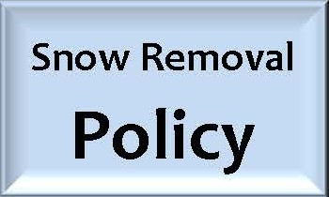

Just a reminder, our Snow Removal Policy is to have our community automatically added to the snow removal contractor’s list if 4 or more inches of snow are projected at one time. If less than 4 inches is projected, the Board will still require 3 or more Directors to approval snow removal.

Please be sure to shovel your sidewalks in addition to your driveway. LFUCG ordinances requires homeowners to clear sidewalks.

2020 Fee Notices are included with this newsletter. Please be sure to make your payment before 1/31/20 to avoid late fees.

As a reminder, please do not park your vehicles or allow guests to park their vehicles in front of mailboxes. The postal service will not deliver mail when there is a car parked in front of the mailbox.

Thank you to Gary Renner for putting up all of our decorations at the entrance to the community over the past year. The lights, wreaths and bows sure brighten up our entrance. Thank you for all your work in keeping our community festive.

2020 Board Meeting Schedule

The following is the proposed Monthly Board Meeting Schedule for 2020. Dates are subject to change. If you would like to come to meetings or be advised of changes please contact Robin Gall at rgall30539@aol.com.

January 21, 2020 7:00 pm
February 18, 2020 7:00pm
March 17, 2020 7:00 pm
April 21, 2020 7:00 pm
May 19, 2020 7:00 pm
June 16, 2020 7:00 pm
July 21, 2020 7:00 pm
August 18, 2020 7:00 pm
September 15, 2020 7:00 pm
October 20, 2020 7:00 pm
November 17, 2020 7:00 pm
December 15, 2020 7:00 pm

Meetings are held at Robin Gall’s home, 3693 Park Pointe.

All non-resident homeowners, please notify the Board when you rent your home by emailing your renter’s information to rgall30539@aol.com. Renters are subject to the same rules as homeowners. It will help the Board to reach out to renters if we know their names and contact information. We will only contact renters if there is a problem or if there is a neighborhood emergency.

Do you have a management company taking care of your property? Please let us know this information as well.

FALCA Homeowner Alerts

Are you part of the emergency alert email system we have established for the neighborhood? This past year we had 3 Homeowner Alerts issued due to robberies in and near the neighborhood and a lost dog. Please be sure to complete and return the annual homeowner information sheet and let us know if you want to be included. All contact information is held in confidence by the Board and is not released to other homeowners without your permission.

New Property Modification Request Form

If you would like to make a change to the outside of your home, a significant change to your landscaping or remove/replace a tree, you must request and receive approval from the Board before starting your project. The Board adopted a new request form in 2019 to make the submission of requests more uniform. The form can be found on the website or be contacting Robin Gall at rgall30539@aol.com.

Did you know…

- If a holiday occurs or is observed on a Friday, trash pickup is the Wednesday before the holiday!!
- The Fire Department’s Fire Prevention Office will come to your house and install smoke alarms for FREE. Call 859-231-5668 to make an appointment.
- Contact LexCall 311 with request for special garbage collection needs, dead animal pickup, to report potholes, to contact the Mayor’s office or Council Office.
- The Fire Department has a Car Seat Education Program. Call 859-455-7928 to schedule a class on correctly installing a car seat.

Contact information for Officers and Board Members: Please always feel free to contact a Board Member or Officer when you have a question or concern. The Board and Officers will do their best to resolve any issues or answer questions that are brought directly to their attention. It is hard to know how to handle situations that we hear about indirectly. Please remember that your Board Members and Officers are volunteers who give freely of their time to help keep our neighborhood a wonderful place to live. We need your input and your support.

Director/President: Robin C. Gall 806-8843 rgall30539@aol.com
Vice President: Gary Renner 264-0069 garyrenner@windstream.net
Treasurer: John Kreitzman 272-1524 johnbkreitzman@gmail.com
Secretary Jeremiah Hale 351-3510 jhale777@yahoo.com
Director: Jennie Hale 327-9621 jennie.hale02@gmail.com
Director Marty Surbaugh 278-8728 msurbaugh1@gmail.com
Director: Ron Helm 396-6666 rh3664@yahoo.com
Director: Fritz McWilliams 797-6278 fritz617@yahoo.com

