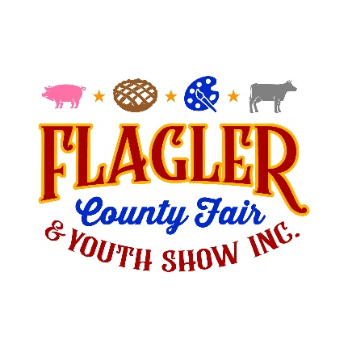

1st Annual Apple Pie & Pecan Pie Contest
*This contest is open to the public*
*Entrants will bring their favorite homemade Apple Pie and/or Pecan Pie to the Flagler County Fair Grounds on April 8th, 2024 from (4pm-6pm). Judging will take place on April 9th, 2024.*
*The winners will be announced Friday, April 12th, 2024 at the Livestock Auction*
Rules & Regulations:
The contest is open to any amateur baker wishing to bake an Apple Pie and/or Pecan Pie. No professional bakers may enter this competition.
If you have any questions, please contact Penny Buckles (386) 931-6597 or Catie Jones (386) 279-9792.
- Pies must not require refrigeration before serving and may not contact raw/uncooked eggs (whites or yokes).
- Apple pie crusts must contain at least a bottom crust and must be made from scratch, not store bought - Top crust can be a traditional pie crust, a lattice or a crumble topping.
- Bake pies in a disposable 9” pie plate. Pies and pie tins will not be returned.
- Pies must be prepared and baked by the individual submitting the pie entry for judging.
- Pies must be dropped off on Monday, April 8th, 2024 from (4pm-6pm). Your recipe must accompany your pie. All recipes must be typed with the ingredient list, instructions and contestant’s name.
- Pie MUST be cool when submitted.
- Please do not write your name on the pie tin. Your entry will be assigned a number when delivered for judging - this allows for anonymity during judging.
- *Please note: No professional bakers may enter this competition. (A professional is defined as someone who works for a bakery, works or owns a catering company and/or sells pies).
- Apples must be the predominant fruit baked into the pie for the Apple Pie Contest - Contestants must use 60% real apples for the filling.
- All rules apply for the Pecan Pie Contest as they do for the Apple Pie Contest.
- Pecans must be the predominant nut baked into the pie for the Pecan Pie Contest – Contestants must use 60% real pecans for the filling.
- There must be a minimum of 3 entries for both Apple & Pecan Pies
Judging Criteria: TOTAL POINTS = 100 points
Appearance:10%
Crust: 20%
Filling: 20%
Overall Flavor/Taste: 50%

Appearance:
- Pre-Sliced Pie: Basic eye appeal
- After Sliced: Pie should have generous, well distributed fruit and /or nuts and should have good color and definition.

Crust & Filling:
- Pies will be evaluated and judged on two components - individually and then as a combined entity.
- Pastry crusts should be flaky and delicate but not fall apart too easily. Crust should melt in your mouth with a mild, pleasant tase that complements the filling. Crust should be a light golden color, baked throughout and an even thickness across the side and bottom. The crimp should seal thoroughly all the way around the pie.
- Fillings should have a nice aroma, pleasant and uniform flavors. All ingredients should taste fresh and are well balanced as well as a complimentary use of spices and seasonings that is not overpowering.

Overall Flavor:
- This is the judges final chance to rate the pie overall. Here is a brief guideline for what traditional wisdom makes a good pie.

- Crust: Should be flaky, melt in your mouth consistency that has a mild, pleasant flavor and is baked evenly throughout to a light golden color. The crust should have a tight seal around the edges.
- Filling: Filling should be smooth uniform components with pleasant aroma and flavor, appealing color and a nice aftertaste. Fruit and/or nuts used in quality pies should be well defined, good size, evenly distributed and have a firm but not overly crisp texture.

Apple Pie & Pecan Pie Contest

2024 Entry Form

Entry forms accepted on Monday, April 8th, 2024 from 4pm-6pm.
No late entries will be accepted!
No e-mailed, faxed or mailed entry forms will be accepted.
The fair reserves the right to not accept incomplete or late entry forms.

Please print information:
Name: ________________________________________
Address: _______________________________________ _______________________________________
Phone: ______________________________
E-Mail: _______________________________________

Age Class:
Adult – 18 years (out of high school) and over

Please circle your entry/entries (Limit one of each pie):

Apple Pie Pecan Pie

I, (we) hereby agree that the Flagler County Fair Association, Inc. and the County of Flagler will not be responsible for the loss or damage to property, or for personal injury which is the result of my participation in the Flagler County Fair & Youth Show. Upon signing this statement, I as an adult, guardian or parent, release the Flagler County Fair Association, and the County of Flagler, and accept complete responsibility. Any exhibits entered in the Flagler County Fair & Youth Show may be photographed and used by the Flagler County Fair Association, Inc., for advertising.

____________________ ______
Exhibitor Signature Date

