THE EARTH & MOON CHAINS

**by**

**Marguerite dar Boggia**



Pythagoras referred to a Monad as a spark of the Boundless Life. It is a consciousness center.1 In the book *"The Secret Doctrine*" by H. P. Blavatsky, we are told that there are seven Earths, seven of each of the planets, including the Sun and Moon.1a A brief process of the journey of the seven classes of Monadic Life Waves are as follows:

            The first Life Wave enters globe A on the Lunar (Moon) Chain. When the life wave has made seven gyrations of the seven root-races on globe A, that is considered one GLOBE round. Then the 2nd class of Monads enters Globe A. Meanwhile, the first class of life wave passes to globe B in the Lunar Chain. This passing of the descending Monads continues until seven classes of Monads have passed all around the seven globes of the Lunar Chain. This is considered the first CHAIN ROUND. The same procedure follows through all the seven chains of the ten planetary Schemes.

The Earth chain will be, but has not been formed yet. When a planetary chain is in its last Round, its globe A, before finally dying out, sends all its energy and "principles" into a neutral center of latent force, a "laya center" and thereby informs a new NUCLEUS of undifferentiated substance or matter. (A "laya center" is a point in space, which suddenly becomes the center of active life). It calls it into activity or gives it life. Globe B of the lunar chain sends its energy into globe B of the Earth chain. Then, globe C of the lunar chain, creates its progeny sphere C of the Earth chain; then the Moon (our Satellite) pouring forth into globe D, our Earth -- all its life, energy and powers; and, having transferred them to a new center becomes virtually a DEAD PLANET, in which rotation has almost ceased since the birth of our Earth globe. The Moon is now the cold, residual quantity, the shadow dragged after her new body, She now is domed for long ages to be ever pursuing the Earth, to be attracted by and to attract her progeny. Constantly vampirized by her child, she revenges herself on it by soaking it through and through with the nefarious, invisible and poisoned influence which emanates from the occult side of her nature. For she is a DEAD, yet a LIVING BODY. The particles of her decaying corpse are full of active and destructive life, although the body which they had formed is soulless and lifeless. Therefore its emanations are at the same time beneficent and maleficent -- this circumstance finding its parallel on earth in the fact that the grass and plants are nowhere more juicy and thriving than on the graves; while at the same time it is the graveyard or corpse emanations, which kill.2 The same transferring process follows for all the globes on the Moon chain.

When the Earth chain is in its last round it will transfer all of its life to the next chain, which is the fifth chain. When we get to globe G of the Earth chain we should be demi-gods!

The first three of the ten Schemes: Uranus, Neptune and Saturn, signify the three aspects of Deity, which are called by the Christian religion, Father, Son, Holy Spirit and called by the Hindu religion, Brahma, Vishnu and Shiva.

All trinities express through a septenate.**3**  Just as the three primary colors: red, blue and yellow, express through the seven colors of a rainbow. The seven planetary Schemes of the seven Planetary Deities, are: Vulcan, Mercury, Venus, Earth, Mars, Jupiter and exoteric Saturn.

The following diagram shows the seven chains of one planetary Scheme.

. 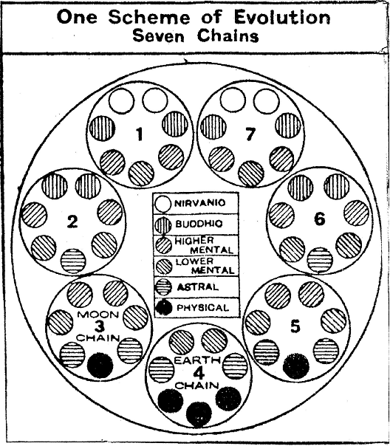

NASA claims that many civilizations have lived on our Moon. David Wilcock4 in his book, "The Ascension Mysteries" says that NASA has found on the Moon clear glass-looking obelisks, pyramids, mushroom shaped buildings, and much more. Their technology was far advanced than ours. An aluminum compound was used to create the transparency. In the future we will be using that aluminum compound for various purposes that require strength.

The Ageless Wisdom teaches that a mystery is connected to the failure on the Moon. The civilization had to be destroyed.

There are two parallel kingdoms in the world: the human kingdom and the deva kingdom in their varying grades. The two evolve through interaction with each other. They are only parallel in the three worlds of human endeavor. On the four spiritual planes, they are a unity in the body of our Heavenly Man. He is a Hermaphrodite.5 The devas are the Builders. They are the vehicle for the divine purpose. They mould matter upon a particular plan. These Builders evolve the forms out of their own nature and substance.6

Devas are endless in number, size, in variety, in degree of consciousness and evolution. They belong to Hierarchies of great Beings, which Hierarchies fill endless space. The whole cosmos is **guided, controlled** and **animated** by an almost endless series of Hierarchies of sentient Beings, each having a mission to perform7.

In the esoteric studies we learn of great Devas, that take the energy of a Sun or Galaxy and distribute the energies to their proper destinations, i.e. Suns and/or to the planets.

On 10/15/12 NASA produced a picture of an angel-shaped object . Its size was estimated by NASA to be twice the size of the earth. It moved directly to the sun. The following is the picture taken by NASA:



We are told that a great Deva, if it wishes, can become a planetary Deity.

Through universal education, the mental ability of humanity has manifoldly increased to the point where they see the folly of pollution, war and global and economic domination by the few of the many. That means we soon will be ready for the destined Golden Age, when once again, all of the great Masters and their disciples will live with us on earth, including the present World Teacher,8 the Lord Maitreya, whom the Occidentals call the 'Christ'. Great devas will also live with us. They will teach us how to heal and how to obtain food from the ethers9

**∆ ∆ ∆**

*Marguerite dar Boggia* formerly served as Membership Secretary for ISAR, the International Society for Astrological Research. She was past Secretary and Director of ISAR and Publisher of Kosmos, the ISAR journal. She was a co-founder of UAC and its past Secretary and Director. Her goal is to serve humanity and the spiritual Hierarchy of our planet.  To that end, she offers **free, online**, **three pages weekly** of the Esoteric Teachings as was known by **Pythagoras**. **It prepares us for discipleship**. To receive these studies, she can be contacted at her website [**www.FreePythagorasTeachings.com**](http://www.FreePythagorasTeachings.com) which website she created at the age of 90.

References:

1Blavatsky, H.P. *The Secret Doctrine*, Theosophical University Press, 1963, p. 179

1aIbid, 152

2Ibid, 155-156

3Bailey, Alice A. *Esoteric Astrology*, Lucis Publishing Company, 1951, p. 595.

4Wilcock, David, *The Ascension Mysteries*, Dutton, Penguin Random House, 2016, pp.280-283

5Bailey, Alice A., *A Treatise on Cosmic Fire* Lucis Publishing Co. p. 666

6Ibid, p.447

7Ibid. Blavatsky, S.D.I. p. 295

8Ibid, Cosmic Fire p. 211 under footnote: the World Teacher."The Buddha held office prior to the present World Teacher, and upon His illumination, his place was taken by the Lord Maitreya whom the Occidentals call the Christ."

9dar Boggia, Marguerite *The Forthcoming Golden Age,* [**www.FreePythagorasTeachings.com**](http://www.FreePythagorasTeachings.com) under Articles