Easylegal Online

Probate?


A guide for clients considering their options

Introduction

Administering an estate often takes a considerable amount of time and work and the decision to act as executor should not be taken without giving the decision careful consideration.

Your choices

Remember you have a number of options open to you.

1) Professional help
You can appoint a professional knowledgeable in Probate Law to take all the responsibility and liability away from you. Some people find this lifts a great weight from their shoulders.

2) Part yourself and part professional help
Do some of the work yourself and enlist a professional for some of the trickier legal issues.

3) Full D.I.Y
You can do it all without professional assistance. Remember if you go down the D.I.Y route, you may be personally liable for any mistakes or if things go wrong.

To get an idea of how much professional assistance would cost please do not hesitate to call us on 0800 043 1369 for a no obligation quote.

We hope the following guide will help point you in the right direction, but remember if you are unsure at any stage please call us on 0800 043 1369 and we will be happy to try and help you.

Winding up an estate

This summarises the more usual aspects of administering an estate. It has been prepared to help you know what to expect or do and what work is involved at different stages in winding up the estate. Not all of it may be relevant in every case. Please do not hesitate to contact us for further information. 0800 043 1369

- Collect all of the deceased’s papers

This is the first thing which needs to be done.

- Find out if there is a Will

If there is, find the original and check for any funeral directions.

- Register the death

This has to be done with the Registrar of Deaths in the area in which the death took place and should be dealt with as soon as possible, as funeral arrangements cannot be finalised until this is done.

- Who winds up the estate?

If there is a Will, its executors should administer the estate, or a professional appointed to act on their behalf. If there is no Will, we can advise on the persons (called ‘administrators’) who should wind up the estate and who will inherit. In this Guide, ‘executors’ is used in all cases unless the distinction is important.

- Probate checklist
A useful checklist is included later but in summary:

In order to administer the estate properly, it is essential to have the following:

- as many copies of the Registrar’s copy of the death certificate that are available;
- full details and supporting evidence of assets and liabilities, e.g. pension book, passbooks, bank statements, share certificates, any relevant references and addresses;
- full details (including addresses and references) of the deceased’s professional advisers;
- full details of the executors together with identity from them;
- full details and addresses of the beneficiaries, together with identity where there is no Will.

- Verifying

Once all the appropriate papers and necessary information has been collated:

- notify the appropriate authorities of the death, e.g. bank, building societies, DSS.
- verify the extent and value of the assets and liabilities, obtaining valuations where necessary.

- Frozen Assets

It may take no time in one case, several months in another, to collect the information needed. It depends on the type of assets and liabilities involved. During this time all assets are frozen, with the exception of joint accounts, which can be immediately transferred to the surviving co-owner on production of a death certificate.

- Probate

Once the necessary information has been gathered, prepare the ‘probate papers’ for the executors to sign and swear and, once signed and sworn, apply to the Court for the Grant of Probate (in the case of a Will) or Letters of Administration (if no Will). ‘Probate’ is used in this Guide to cover all cases, unless the distinction is important.

- Financing Inheritance Tax and Probate court fees

When preparing the probate papers, consider how to finance any inheritance tax liability payable (a) when applying for probate and (b) later, and any Probate Court fees payable when applying for the grant.

- Planning for the payment of debts, legacies and interim distributions

Before applying for probate, also plan ahead for paying any debts and legacies and, if appropriate, making an interim distribution to the ‘residuary beneficiaries’, so that these steps can be taken once probate is received.

- Advertising for Claims [Trustee Act notices]

If executors mistakenly pay money to the wrong people (e.g. because they did not know of a debt or a legacy under a later Will or codicil), they must usually pay the right people out of their own pockets and then try to recover the money from the person who had been wrongly paid. The law allows executors to advertise for claimants and, provided certain conditions are met, then to distribute the estate. This only protects the executors in that capacity, however, and so if anyone has a valid claim against the estate he can still pursue this against the beneficiaries direct. Sometime executors may feel it is not appropriate to advertise for claimants, as this may invite burglary of an unoccupied property but, in others, that it is more important. Generally, executors can advertise immediately after death, but administrators should only do so after obtaining Letters of Administration.

- Registering probate

Once probate has been received, official copies are then sent to relevant organisations, together with signed forms prepared at step 10 above, carrying out the executor’s instructions to close accounts and sell/transfer assets etc.

ESTATE ACCOUNTS

Estate accounts should be prepared and copies sent to the executors for approval. Inheritance tax clearance must first be obtained before winding up a taxable estate. Once the executors have approved the final estate accounts, it can then be wound up and what remains distributed to the residuary beneficiaries or trustees of any continuing trust arising on the death.

The accounts must include a summary of the estate and in particular should show the following:

Assets at the date of death
Liabilities at the date of death
Income received during the administration
Administrative expenses incurred
Distribution of the estate to the beneficiaries

You should keep all paperwork for at least 12 years following the final distribution to the beneficiaries.

You should be careful if considering distributing the estate before 6 months has elapsed following the issue of the Grant of representation. Claims can be made under Inheritance (Provision for Family and Dependants) Act 1975. A claim might be made perhaps by a family member who feels he or she has not been properly provided for in the will. It is for this reason that it is often wise not to distribute the estate until the 6 month period has passed. If such a claim is made, the executors should seek professional help.

TAX

Inheritance Tax

An estate liable to inheritance tax will normally take several months longer, and sometimes years longer, to wind up than a non-taxable one. Whether an estate is taxable, and if so the amount payable, can depend on a number of factors including whether the deceased:

- had an interest under a trust or settlement at any time during the seven years prior to death
- had made lifetime gifts

and the executors must fully investigate these points.

There are numerous inheritance tax exemptions and reliefs. In general, taxable lifetime gifts would be those made not more than seven years before death, certain small gifts made each tax year being disregarded.

The delays in winding up taxable estate may be due to the time taken to:

- obtain final clearance from the Capital Taxes Office (CTO);
- negotiate asset values with the CTO, because some asset values cannot be fully determined at the date of death;
- agree the income tax/capital gains tax position at the date of death. The inheritance tax position (which is dealt with by a completely different part of HM Revenue & Customs) cannot in turn be agreed until this has been done.

- Income tax and capital gains tax of the deceased

Income tax and capital gains tax returns of the personal representatives are prepared to the closure of the administration
- Information needed:

As you may appreciate, the executors are obliged to account to the appropriate Inspectors of Taxes for income received and capital gains made during the period of administration. They also need to provide certain information to that Inspector for each residuary beneficiary who receives income from the estate, including his full name and address, tax district, reference and national insurance number.

- Distributing income during the administration period

The income which is received from an estate counts towards the person’s total income for the purpose of calculating whether he pays income tax and, if so, whether at the basic rate or the higher rate. Under the present income tax regime as it affects executors and beneficiaries, it is important (so far as practicable) for the executors to distribute income to the appropriate beneficiaries within the tax year in which it arises. Failure to do this by accumulating income may cause ‘bunching’ of a beneficiary’s income in a given tax year, incurring an avoidable higher rate tax liability. The risk of this occurring will depend on whether, in a given tax year, a beneficiary’s existing income and the amount of income from the estate to which he is entitled places him close to the higher rate income tax threshold.

- Advice to beneficiaries receiving income during the administration period

A beneficiary should, whenever receiving a distribution of income (whether as part of a distribution comprising capital as well) receive an income tax deduction certificate form R185E. He should immediately send it to his tax adviser, if any. Failing this, if he completes annual tax returns or claims, he may either send the form to his Inspector of Taxes immediately, or when next submitting a tax return or claim, declaring the net income received in the appropriate section of that return or claim form.

Probate

Estate of

No. | OVERVIEW OF PROBATE | NOTES | TICK
1 | Register the death and obtain Death Certificate.
2 | Attend to the funeral, burial, cremation, etc.
3 | Find Will or establish who is entitled under intestacy.
4 | Establish who the personal representatives are.
5 | Obtain the requisite forms.
6 | Secure the house and/or property; insure the house, car and other valuable property.
7 | Organise for valuing assets; keep financial records. Open executor’s bank account.
8 | Write to financial and business organisation.
9 | List the deceased’s assets and liabilities. Is probate necessary?
10 | Is the estate worth more than £325,000?
11 | Fill out probate forms.
12 | Attend the Probate Registry.
No. | OVERVIEW OF PROBATE | NOTES | TICK
13 | Pay Inheritance Tax at time of application and arrange for instalments payments.
14 | Receipt of probate.
15 | Send copies of probate to financial institutions.
16 | Advertise for creditors if necessary.
17 | Respond to any queries from HMRC.
18 | When assets are collected, pay liabilities.
19 | Request HMRC Income Tax return or repayment form.
20 | Ask HMRC for IHT30- clearance certificate.
21 | Check that no potential claims under Inheritance (Provisions for Family & Dependants) Act 1975.
22 | Once all liabilities paid, distribute legacies and residuary estate. Obtain receipts.
23 | Prepare estate accounts for approval.
24 | When cheques cleared, close executor’s account.
25 | Administration of the estate is now complete. Keep accounts for 12 years.

Asset and Liabilities

Estate of
Date of Death (DOD)

Assets
Property or % share in property
Property address % share owned Value @DOD
£
£
£
SUBTOTAL | £
Bank/Building society accounts
Name of bank A/C No. Type % share Value @DOD
/building society of a/c owned
£
£
£
£
£
£
£
£
SUBTOTAL | £
Shareholdings
Name of shareholding No. of Unit price ¼ up Value @DOD
shares @DOD price*
£
£
£
£
£
£
£
£
SUBTOTAL | £
Personal chattels & jewellery
Type Value @DOD
£
£
£
£
£
£
£
£
£
Personal chattels & jewellery
Type Value @DOD
£
£
£
£
£
£
SUBTOTAL | £
GROSS ESTATE (Add together subtotals) | £
Liabilities
Funeral, mortgage, credit cards, loans
Type Value @DOD
£
£
£
£
£
£
£
SUBTOTAL |  |  | £
NET ESTATE (Assets less liabilities) | £

How An Estate Is Distributed When There Is No Will

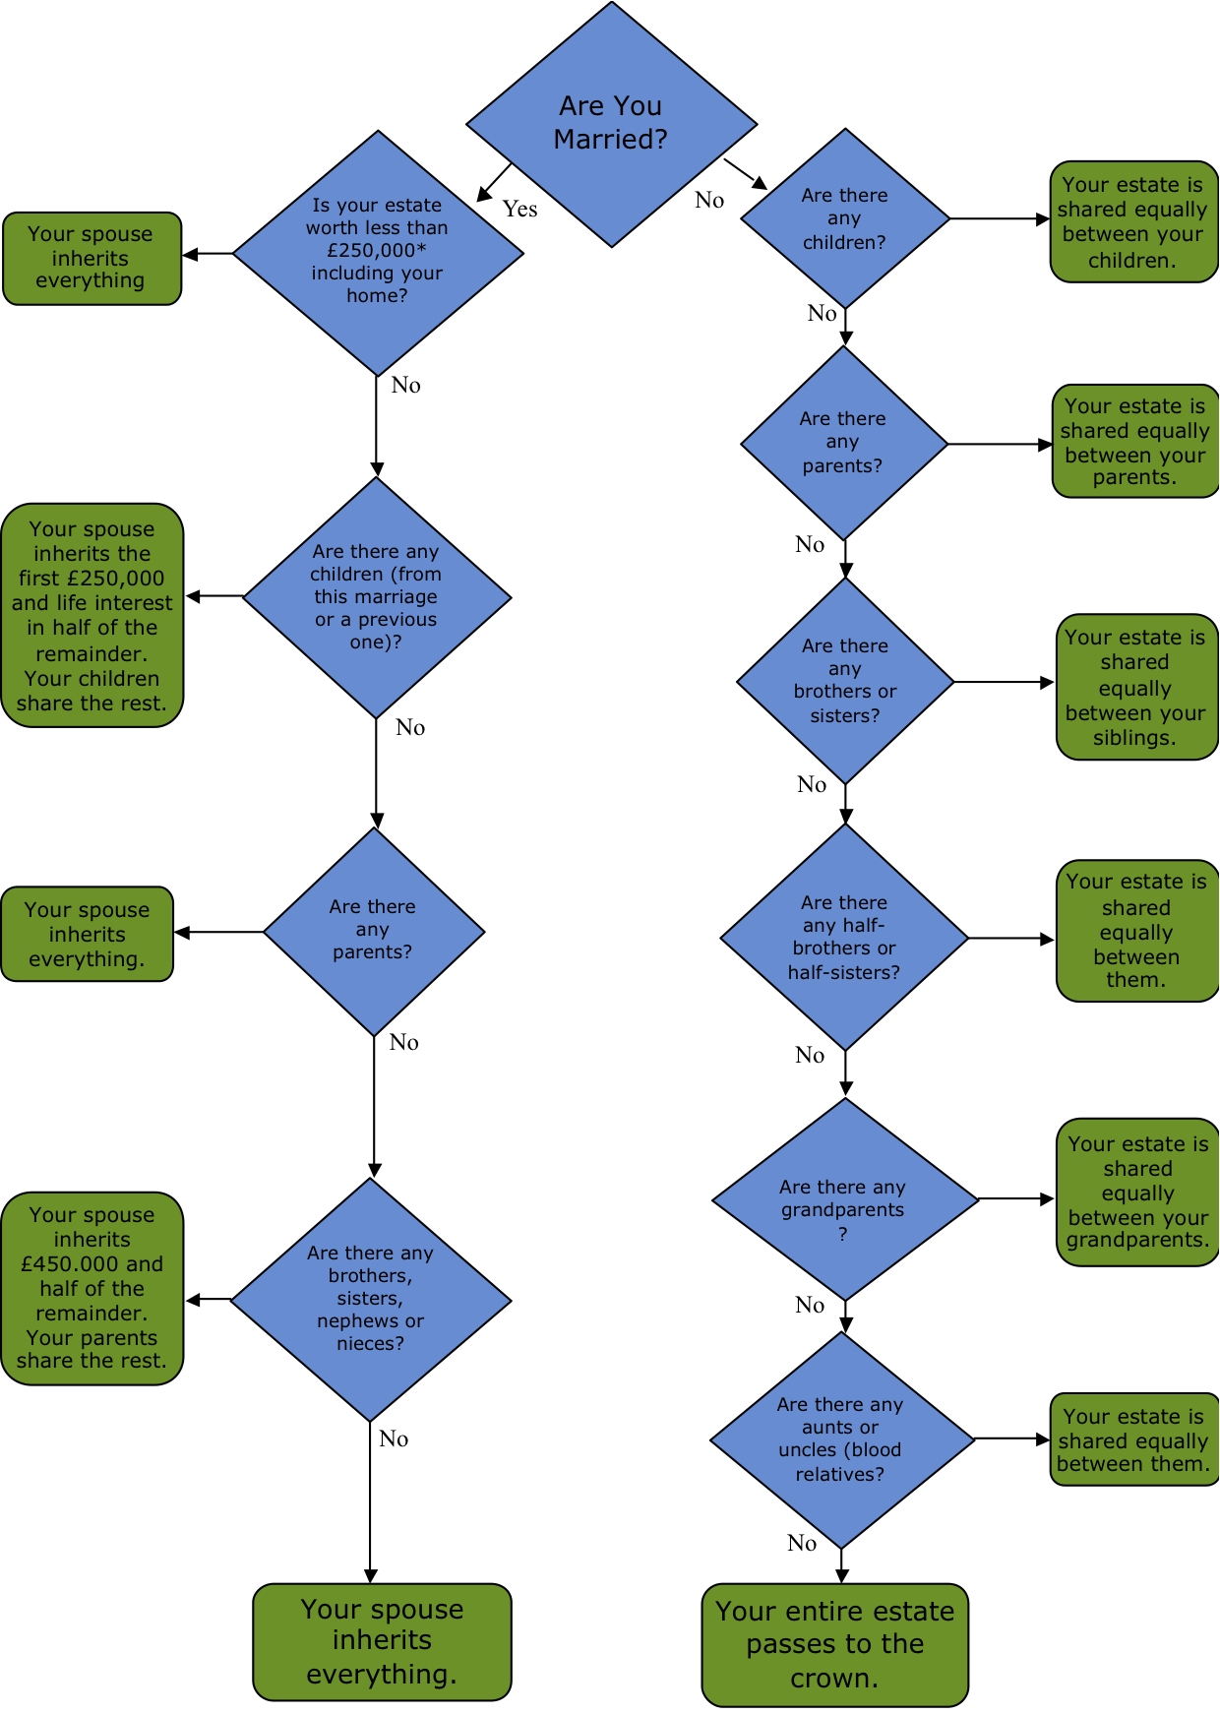

Some legal terms explained

Administration period
The period between the date of death and the date of the final estate accounts.

Administrator
A person responsible for winding up the estate of a person who has died leaving no Will or the executors of whose Will are unable to unwilling to act.

Appropriation
The transfer of an asset instead of its sale proceeds on account of a legacy or share of residue.

Attorney
The appointment of a particular person to act on behalf of the executor or administrator in dealing with the estate.

Codicil
A legal document by which a person amends his Will.

Contingent gift
A gift that requires something to happen before it can be made. e.g. a beneficiary reaching 21.

Estate Accounts
Accounts recording the financial transactions during the administration.

Executor
A person appointed by a Will or Codicil to administer the estate.

Grant of Representation
The court order authorising a person to deal with the assets of the deceased. If a Will is proved by executors, it is more precisely called a Grant of Probate; otherwise, a Grant of Letters of Administration (with or without a Will annexed).

Intestacy/Partial Intestacy
Where a person dies without making a valid Will or without making a Will that fully disposes of all his assets. The administration of ‘intestate’ estate is largely governed by the Administration of Estate Act 1925.

Legacy / bequest / devise
A gift of chattels/money/other assets by Will.

Personal chattels
Basically means personal effects more precisely defined in the Administration of Estate Act 1925, section 55(1)(x) as including:
Carriages, horses, stable furniture and effects (not used for business purposes), garden effects, domestic animals, [silver] plate articles, linen, china, glass, books, pictures, prints, instruments and apparatus, wines, liquors and consumable stores
but excluding
any chattels used at the date for business purposes, or any money and securities for money.

Personal representatives
An executor or administrator.

Power reserved
Where a named executor declines to act immediately, but reserves the right to do so at a later date.

Renouncing probate
Where a named executor signs a legal document which cancels his appointment from the start.

Residual beneficiary
A person or company that inherits part or all of the Residuary Estate (see below).

Residuary estate
What remains of the estate after the payment of all debts, legacies and all taxes and expenses.
Bereavement Care

The need to grieve for close relatives and friends of someone who has died is not widely recognised. Bereavement typically involves a process from disbelief of what has has happened through to acceptance. This can take about two years, sometime much more.

During this period, you may at times find it difficult to cope. If so, it is wise to seek help, rather than tell yourself that you should be able to cope. If any of the necessary processes involved in bereavement is not worked through, it is probable that the end of the bereavement process will be delayed.

Useful links

The following websites may prove helpful in the period after someone dies
DirectGov
Government advice on what to do after a death
Web: www.direct.gov.uk/en/Governmentcitizensandrights/Death/WhatToDoAfterADeath/index.htm
Department of Work & Pensions
Web: www.dwp.gov.uk/
Citizens Advice Bureau
Advice on handling wills and estates
Web: www.adviceguide.org.uk
Cruse Bereavement Care
Emotional support, counselling, advice and information
Tel: 0844 477 9400
Web: www.crusebereavementcare.org.uk
The Bereavement Advice Centre
Support and advice for people about what they need to do after a death
Tel: 0800 634 9494
Web: www.bereavementadvice.org
Bereavement Services Portal
Information and support
Web: www.bereavement-services.org
The Grief Journey
Help for grieving people
Web: www.griefjourney.com
Probate & Inheritance Tax Helpline
Inland Revenue service offering advice on probate and inheritance tax
Tel: 0845 30 20 900
Web: www.hmcourts-service.gov.uk/infoabout/civil/probate/helpline.htm

We hope that you have found this Guide useful,
and would welcome your suggestions as to any improvements.

Important.

This guide may not be reproduced in any way without the written permission of Northwood Banks & Co d. No responsibility is taken for persons relying on its contents who are not clients of Northwood Banks & Co Limited who are also using its services in the context of this guide.

