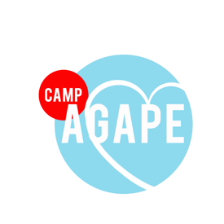
- I give permission for my child to visit and stay on Camp Agape Campus between one or more specific camping sessions.

- I understand that my child must have the permission of the incoming Director to stay on campus.

- In the case of a medical emergency, I will be responsible for the cost of any medical services deemed necessary for my child during or associated with their stay on campus.

- I understand Camp Agape staff and volunteers will not provide constant supervision for my child during this visit, and my child is responsible for all conduct and decisions made while a guest on our campus. Visiting persons are fully accountable for their behavior as it pertains to all applicable state and federal laws.

- I understand actions my child takes while on Camp Agape’s campus may influence decisions for being used as staff members in the present and future.

- I hereby agree to release, indemnify, and hold harmless Camp Agape and/or The South Carolina Church of God of Prophecy, its agents, volunteers, employees, directors, and officers, for and against any and all liability and responsibility for any claim or cause of action, including claims based on negligence on account of any personal injury, accident, damage, expenses, or other loss caused, suffered, or incurred by my child or any other persons or property during, arising out of, or in any way associated with my child’s visit to Camp Agape.

Name of Student__________________________________ Date of Stay_________

Name of Parent/Guardian___________________________________________________

Signature of Parent/Guardian______________________________Date______________

Please initial an option below:

_____ I give my child permission to leave campus with (Full Name) _________________ during their stay. I understand that Camp Agape / South Carolina Church of God of Prophecy will not be held responsible for any incidents resulting from leaving campus.

_____ I DO NOT give my child permission to leave campus during their stay at Camp Agape.

*Please see Camp Policy on the reverse side.

- No student/worker/volunteer may stay over without express permission from the incoming Director.

- The only individuals allowed to stay, with permission, must be working the upcoming camp.

- The pool may not be used during this time.

- No food will be provided.

- All female and male staff must stay in designated areas (labeled on campus) during each overnight stay.

- The Hunter Auditorium will be inaccessible.

- The curfew will be strictly enforced at 8:00pm. No vehicles are allowed on/off campus after this time.

- Students/workers/volunteers may not leave the campus (between camps) without written parental permission.

