ORDER FORM
Please complete and save it to your computer. Email order form and send payments to stepitupdanceco@gmail.com
Orders are due by November 15 and they will be completed by December 15. Pick up arrangements will be made once orders are done.
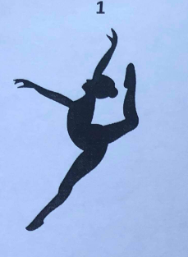 | 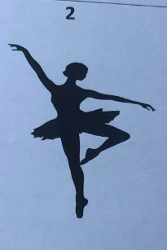 | 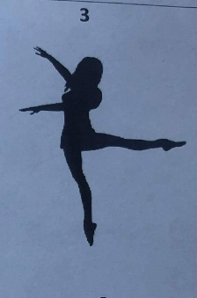

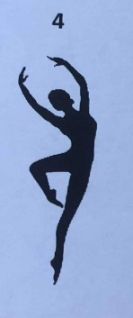 | 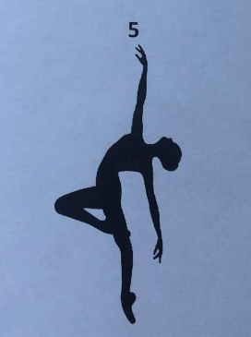 | 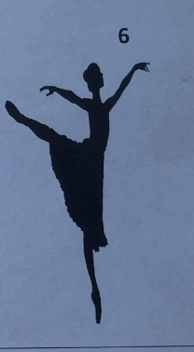

Size of Frame: 5x7 ☐
8x10☐
Silhouette #: Click or tap here to enter text.
Name of Dancer (optional):Click or tap here to enter text.

Purchaser’s Name:Click or tap here to enter text.
Purchaser’s Email:Click or tap here to enter text.

