Texas History with Mr. Brown Name ____________________ Period _____

Exploring Primary and Secondary Sources
LEARNING the Skill
Primary sources are eyewitness accounts of events. Letters, diaries, autobiographies, speeches, paintings, artifacts, and interviews are all examples of primary sources. Primary sources are collected and used, along with other facts, to form secondary sources. Textbooks, newspaper articles, movies, and biographies are examples of secondary sources. Bookstores, libraries, archives, and the Internet contain both types of sources. Both primary and secondary
sources can be unreliable, so be careful.
To explore primary and secondary sources, use the following steps:
• Determine if a source is primary or secondary. Ask yourself if the author was present at the event or if the description is secondhand.
• Identify the author and date of the source. Verify that the information is reliable by confirming details in other sources. If two or more sources agree, the information is more likely to be reliable.
• Summarize and draw conclusions about the primary and secondary sources you are exploring. Look for information they agree on.
• Decide which type of source provides the information you need. Then use the sources that best meet your needs.

PRACTICING the Skill
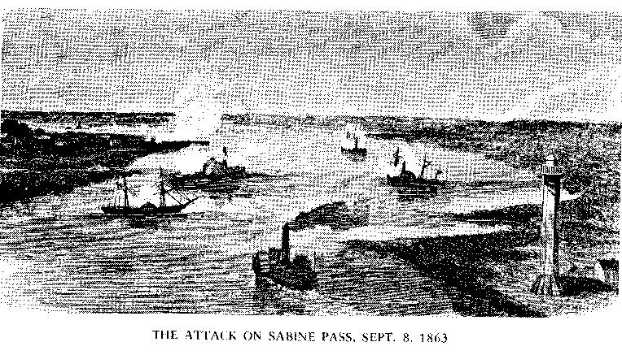
Read the following excerpts about the Battle of Sabine Pass.
On Monday morning, about 2 o’clock, the sentinel informed me the enemy were signaling, and, fearing an attack, I ordered all the guns at the fort manned, and remained in that position until daylight. . . . They remained all day at work, but during the evening were reinforced to the number of twenty-two vessels of different classes.
Lieutenant Richard Dowling, report

Signal lights blinked constantly across the water, and dawn revealed well over a dozen federal gunboats and transports riding at anchor off the bar. . . . All day they stayed there. A great many more signal lights were seen that night, and when daybreak revealed a fleet of twenty-two warships off the bar it was clear that the brunt of the invasion would fall on Dowling.
James L. Haley, Texas: From the Frontier to the Spindletop

1. What details reveal that the first passage is an example of a primary source?

2. What events being described in both passages can be verified by other sources?

3. What other types of primary and secondary sources might verify the details of both passages?

4. How do the two sources effectively verify key details in each other?

